# VISITING THE ZOO: BIODIVERSITY, ZOOLOGY AND WORLD BIOMES

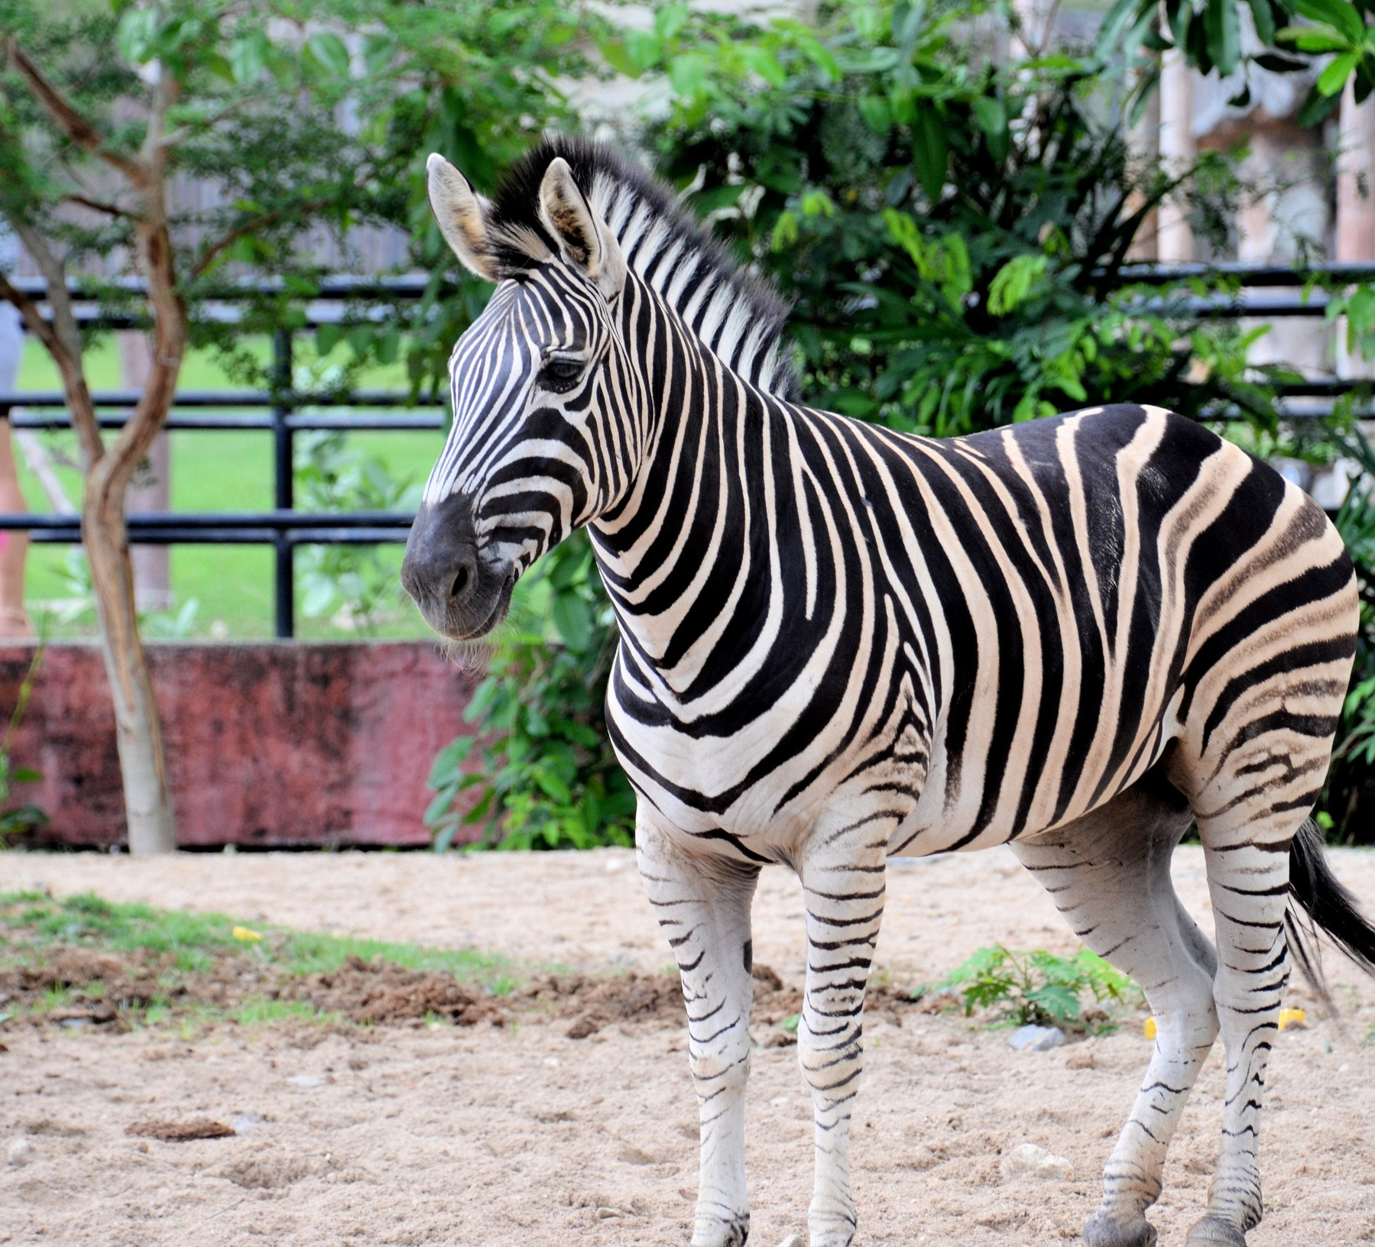**Introduction**

## In today’s world it is getting harder for people to enjoy nature in the wild. With the human population growing at a remarkable rate, increasing habitat destruction and disappearance of many

plant and animal species, zoos are the only place you can see many species. Zoos offer a chance for the public to connect with nature. In many zoos you can come within inches of an animal and observe it; whereas, in the wild you would never be able to see the animal at all. For some species of animals zoos are the only place they exist because their natural habitat has been destroyed or they have become extinct in the wild.

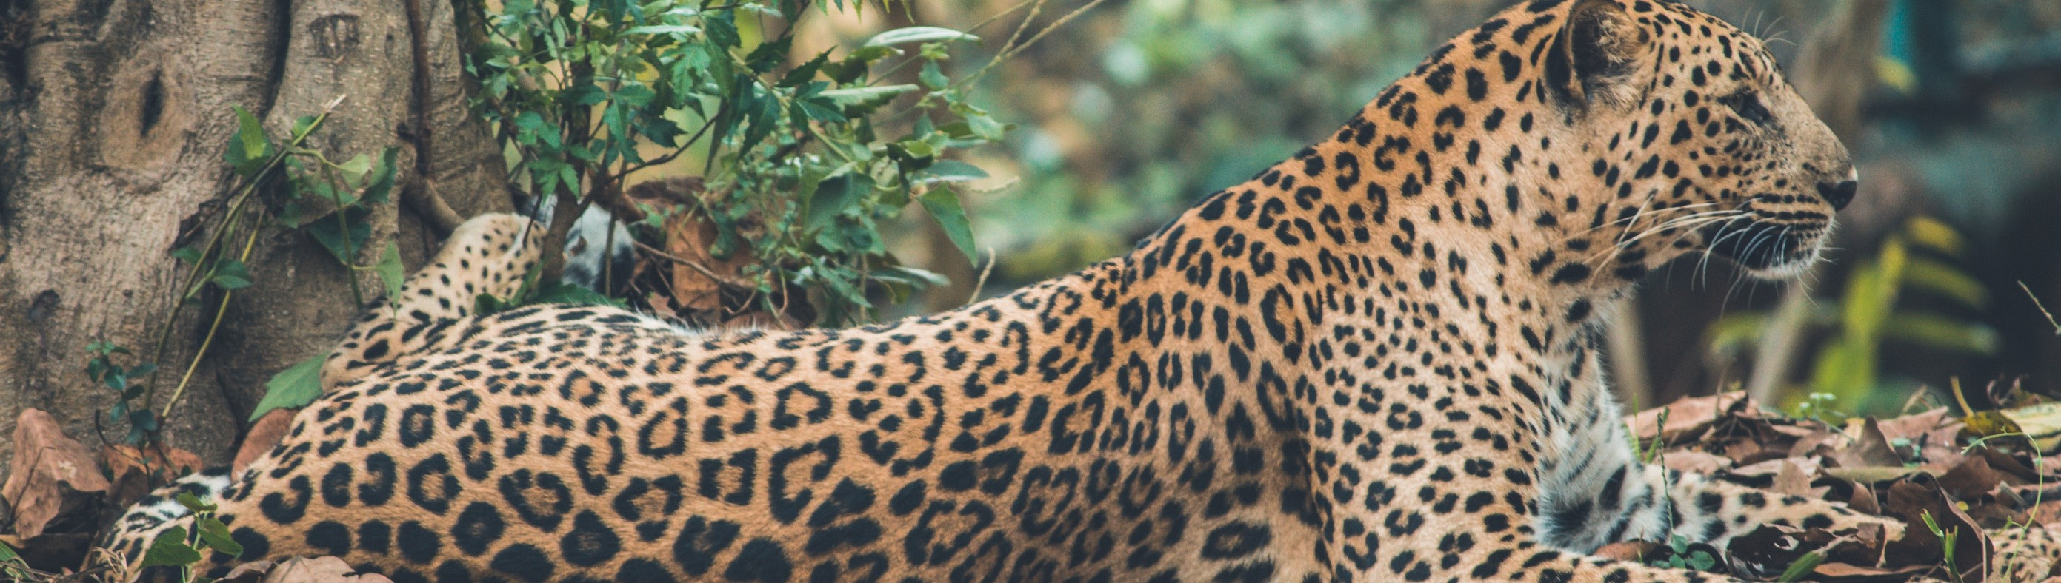

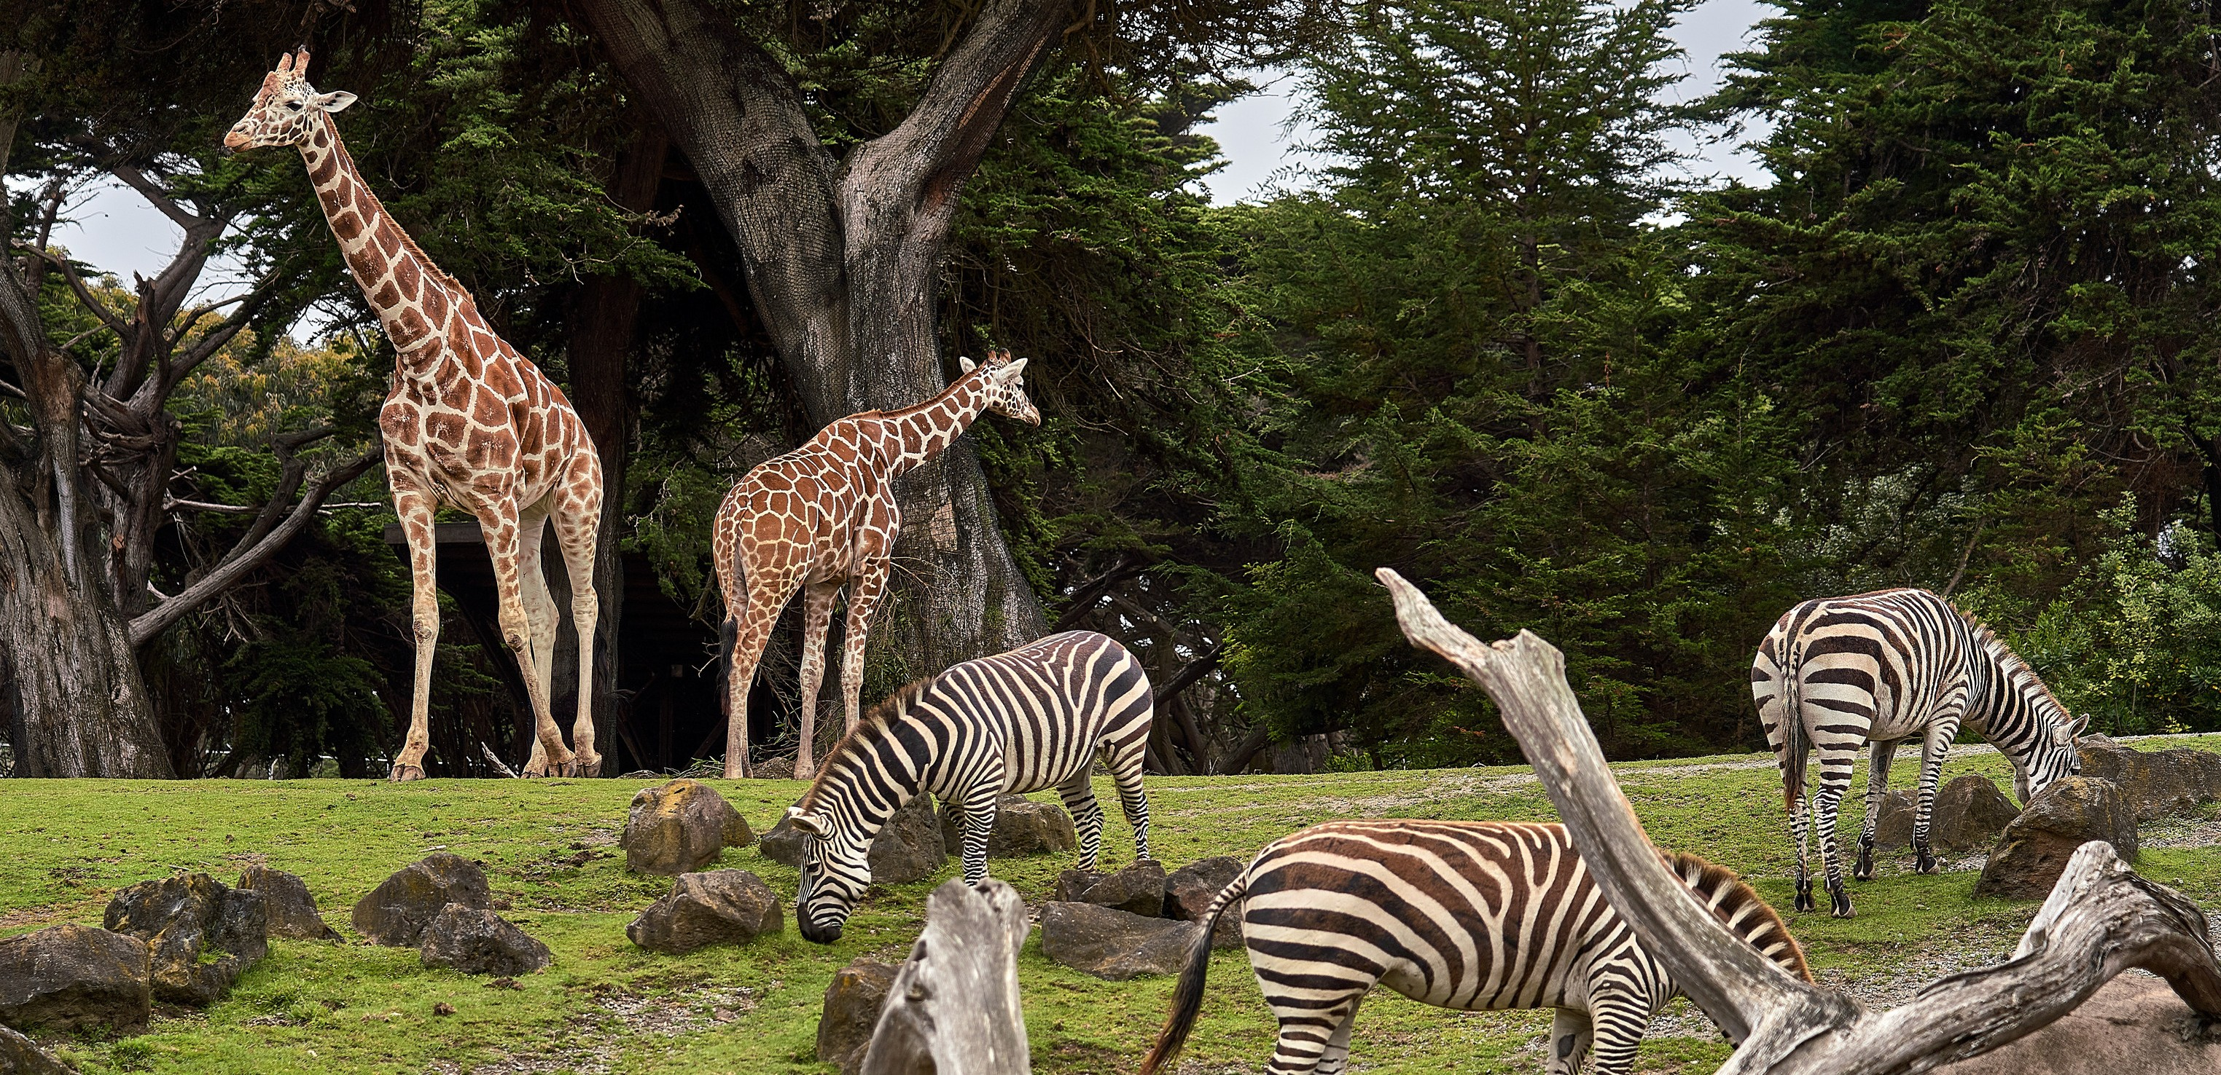The Tulsa Zoo is a member of the Association of Zoos and Aquariums (AZA). Zoos that are members of the AZA participate in conservation programs to help preserve species in the zoos and the wild. Groups within the AZA that help manage the captive collections are the Taxonomic Advisory Group (TAG) and The Species Survival Plan (SSP). The Taxonomic Advisory Group help evaluate the care of captive species and the parameters for the living areas of the animals. Also TAGS prioritize projects the help animals in the zoos and in the wild and supervises the Species Survival Plan. The Species Survival Plan helps zoos coordinate research, husbandry and management plans to protect the gene pool of animals that are threatened or endangered.

New Biotechnology is also helping to preserve animal species. Frozen zoos collect DNA, sperm, eggs, embryos and live tissue and store the tissues at very cold temperatures (-196 degrees C). These tissue can be used for artificial insemination, cloning or in vitro fertilization. The San Diego Zoo, The Audubon Center for Research of Endangered Species, The Frozen Ark managed by the Zoological Society of London, the Natural History Museum and University of Nottingham are just some of the facilities participating in genetic research to preserve animal species.



The leading cause of today’s animal’s extinction is habitat destruction along with climate change, pollution and overharvesting. Animals have evolved to live in certain types of habitats and climates such as temperate forest, deserts or Arctic Tundra. These areas are called biomes and are characterized by climate, rainfall, sunlight and vegetation. The zoo exhibits some of these biomes which displays the animals that live in the biomes.

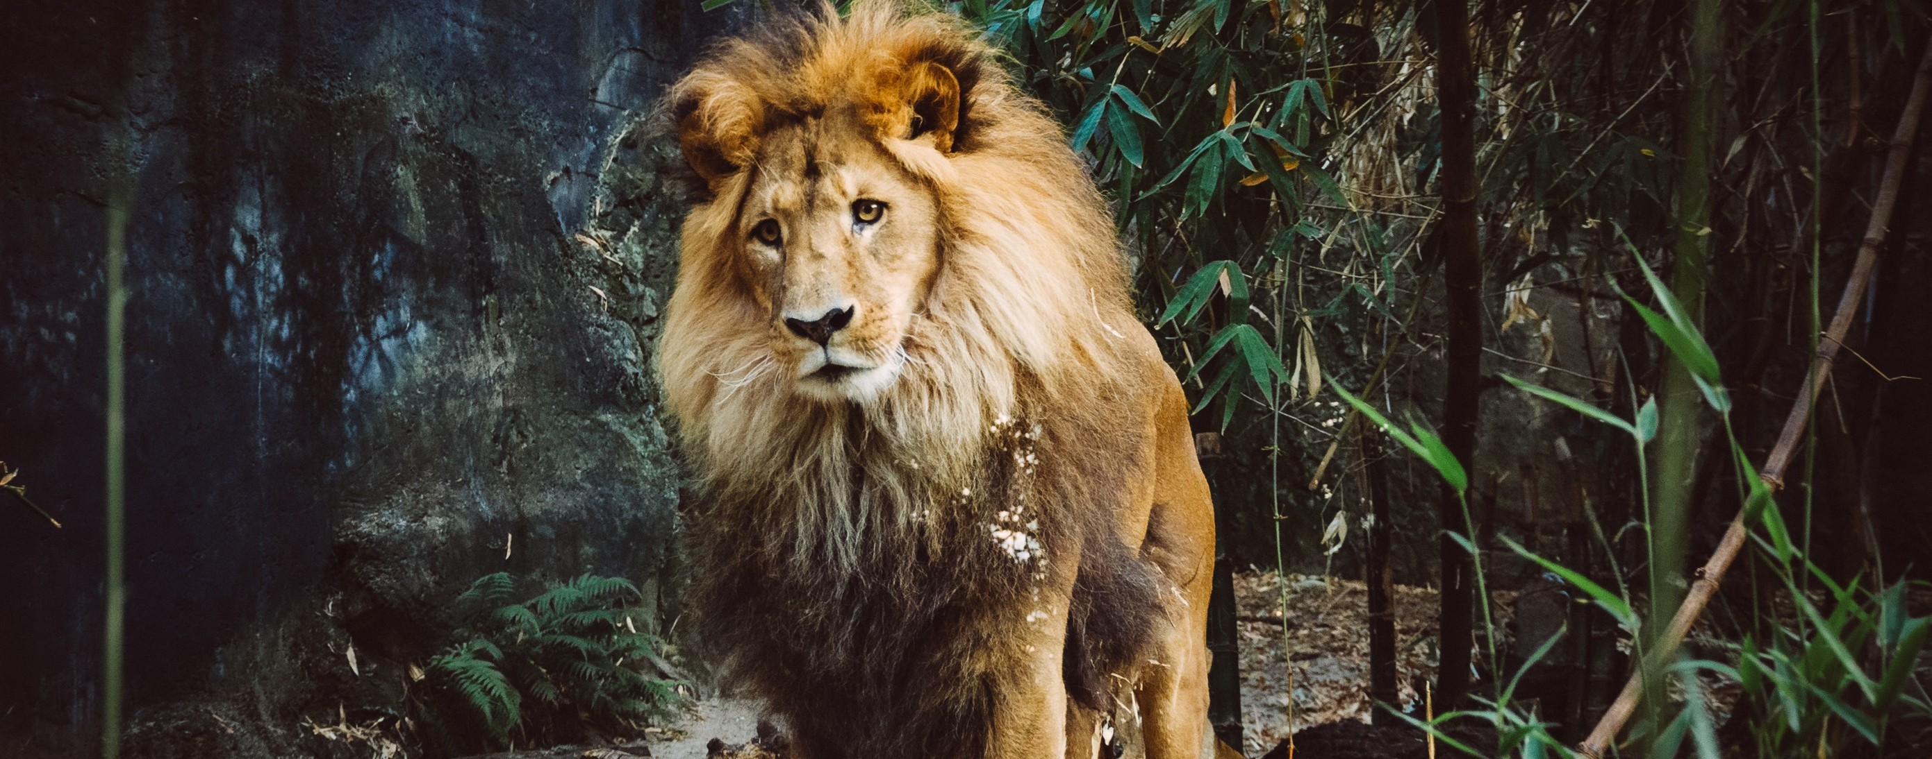

Notice some of the evolutionary traits that the animals must have to live in these biomes. Such as coloring of fur, hibernation, ability to swim or

climb trees. These biomes have biotic (living factors) and abiotic (nonliving factors). The biotic factors include the plants, food availability and disease. The abiotic factors include temperature, light, water and shelter. Look for these traits the animals have that help them survive when you observe them today.

# PRE-LAB QUESTIONS: WORLD BIOMES

Read about different biomes. Use the internet or you text book to fill out the following table. Alternatively, go to Berkley World Biomes https://ucmp.berkeley.edu/glossary/gloss5/biome/

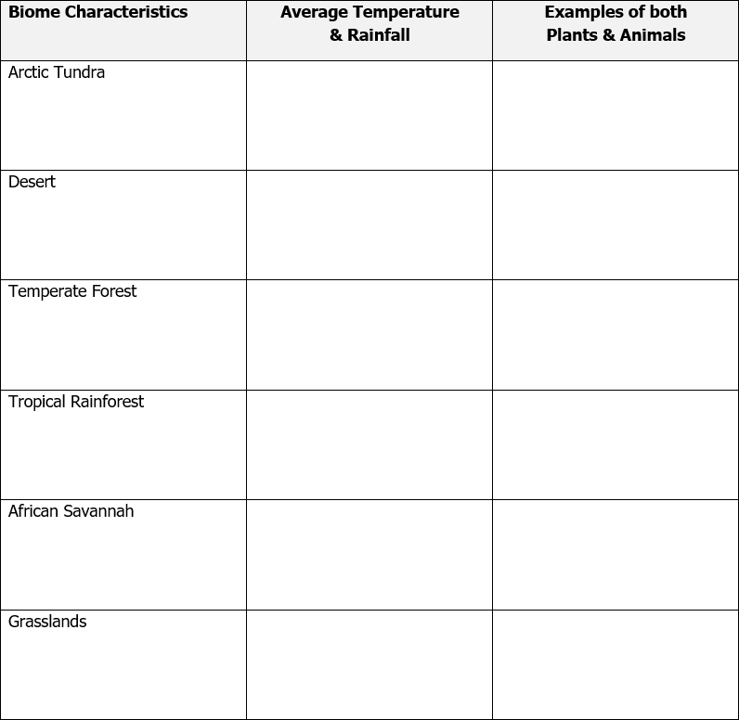

* What Ecoregion is Tulsa County? EPA://[www.epa.gov./wed/pages/ecoregions.htm](http://www.epa.gov./wed/pages/ecoregions.htm)





**LAB EXERCISE**

For this lab, don’t forget to:

Bring your cell phone or camera to take pictures. Have fun while you are learning

at the zoo!

# INSTRUCTIONS:

* You will need to bring your camera or your smart phone to take photos of the following animals and/or habitats referenced in the questions below. You MUST include yourself in each photo.
* Download these zoo photos onto your computer.
* Create a PowerPoint or Prezi with the photos and the answers to the questions. For example, for Question #1 you will need a picture of yourself and the Artic Fox. If the Artic Fox is not out in their habitat that day, you will need to take a picture of you with their habitat. You should try to include the habitat sign in the photo. You will place that photo onto the PowerPoint slide or into the Prezi along with the answers to the questions.

Please note: As a student, you have free access to PowerPoint. You can access Prezi here: https://prezi.com/login/

* First Slide: Name, Class, and Section #
* Second Slide: World Biome Pre-Lab Chart with Information
* Slide #3 - #27: Picture of the plant/animal including you and answer to the question(s)
* Submit the PowerPoint or Prezi link to your instructor via Blackboard by the due date in your schedule.

# LAB QUESTIONS:

1. Describe adaptions that aid in an animals survival in cold seasonal climates.

Discuss how coloration is an adaption for the survival of the Arctic Fox. Discuss how hibernation is an adaptation for the survival of many species.

1. Describe behavioral adaptions that help organisms survive in the desert.

Animal Behavioral Adaptation Plant Behavioral Adaptation

1. Name a venomous snake and lizard that can be found in the desert.
2. 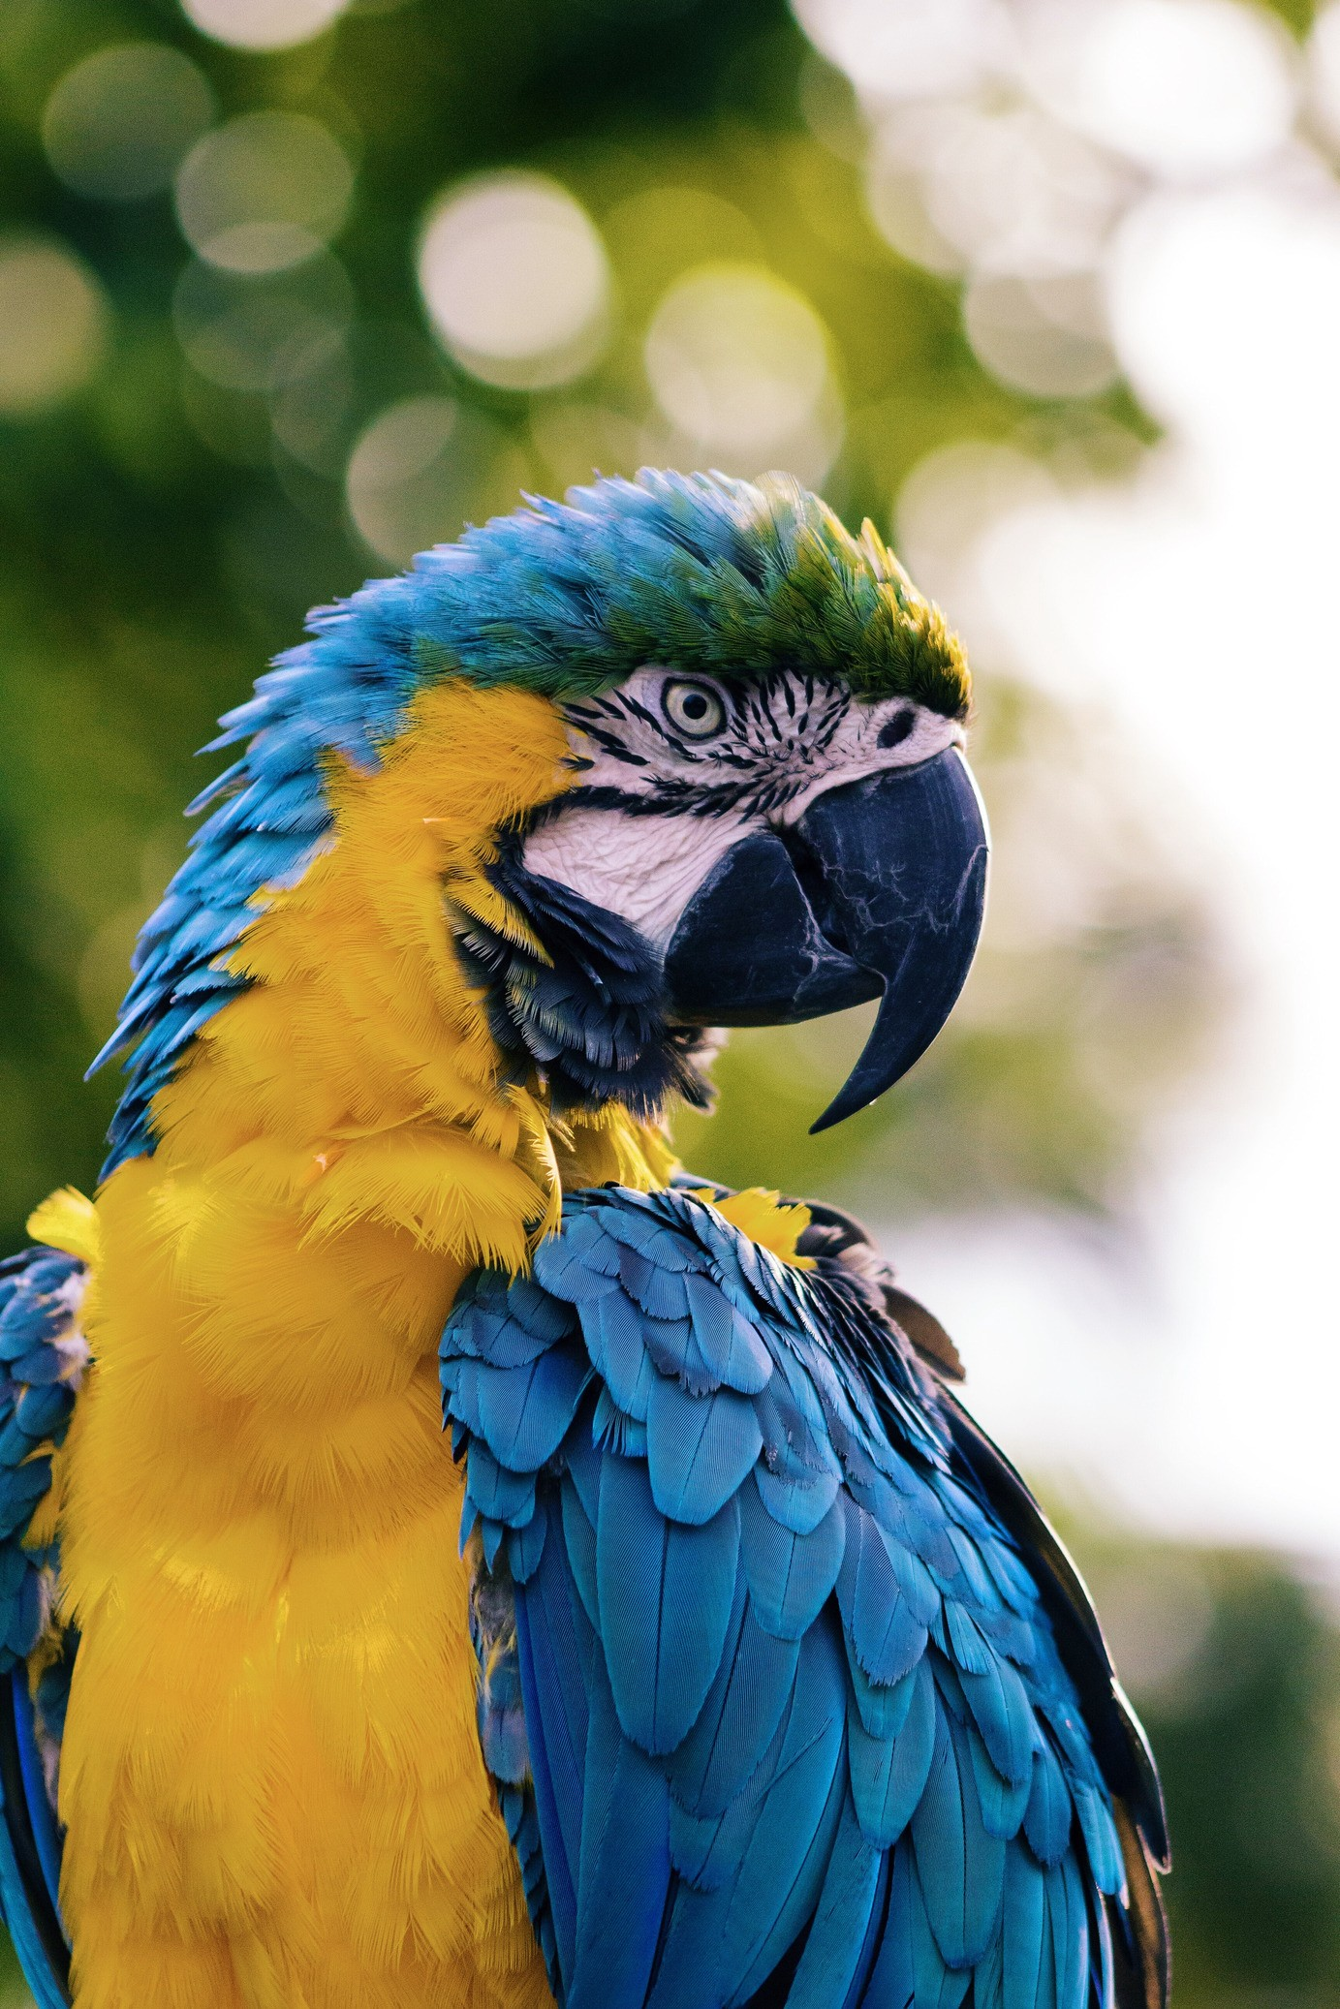Describe a physical and behavioral adaptation that help animals survive in a temperate forest.
3. Name one type of Crocodilian.
4. Do the animals living in the temperate forest have different adaptations for survival than the animals living in the desert? Explain.
5. Describe a physical and behavioral adaptation that help organisms survive in a tropical rainforest.

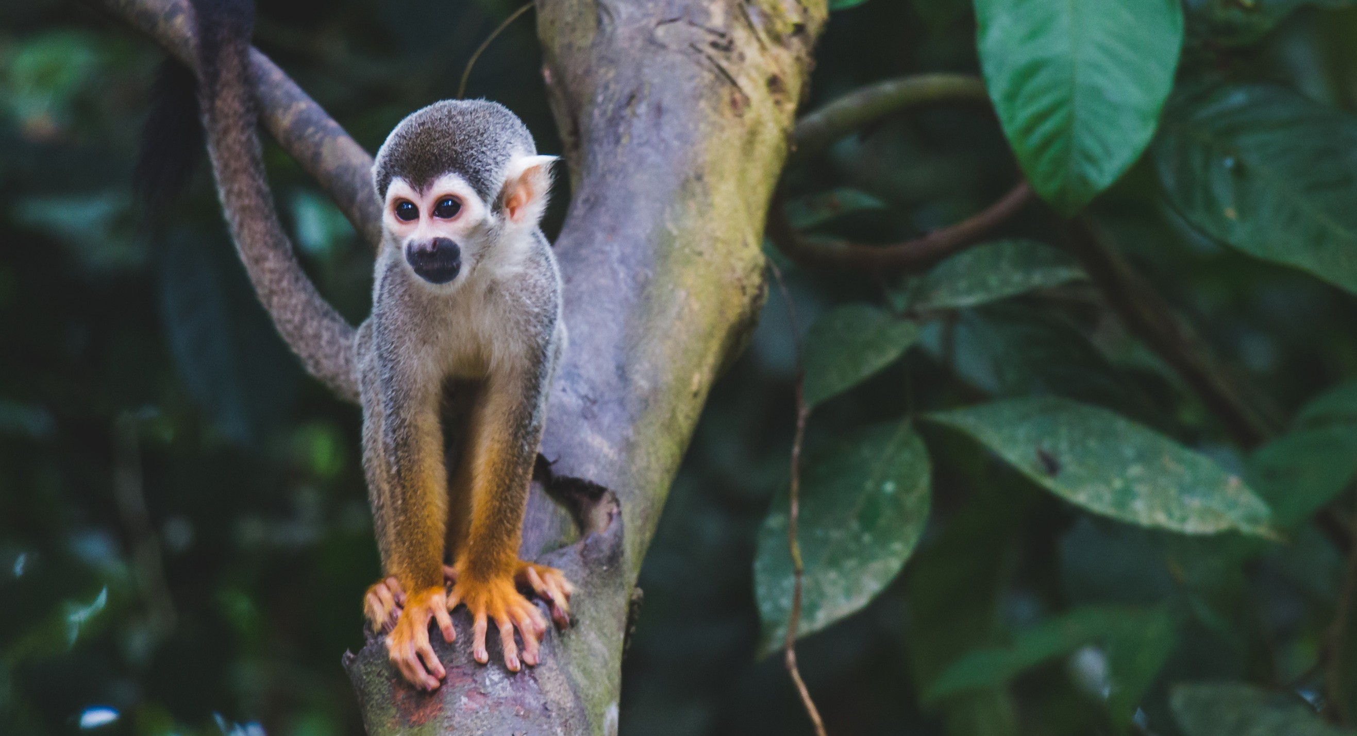

1. What do the bright colors indicate on animals in the tropical rain forest?
2. How do animals protect themselves from predation in the rainforest?
3. Name an amphibian in the rainforest.
4. Name a rainforest primate.
5. What is the sloth related to?
   1. Howler Monkey
   2. Spectacled Owl
   3. Anteater
   4. Raccoon
6. How do flamingos get their pink coloration?
7. Could the evolution of penguins and sea lions be used as an example of divergent or convergent evolution? Explain.
8. Name an animal that uses brachiating for locomotion.
9. How many vertebrate do giraffes have in their neck?
10. What is the rhino horn made of?
11. What do rhinos use the horn for?
12. How do elephants cool themselves using their ears and trunk?
13. Classify the Asian elephant using the 8 levels of the taxonomic hierarchy in the correct order.
14. Observe the chimpanzees for 10 minutes. Do they have any behaviors similar to humans? Describe the behaviors you observed.
15. Name two birds with black and white coloring.
16. How do Zoos help protect endangered species from becoming extinct?
17. Did you enjoy the zoo? Explain.



*"Science admires and bows to nature." ~Pawel Strzelecki*

# CREDITS AND ATTRIBUTIONS

["Visiting the Tulsa Zoo: Biodiversity, Zoology and World Biomes" by Mark Swanson, Tulsa Community College is licensed under CC BY-NC-SA 4.0](https://creativecommons.org/licenses/by-sa/4.0/)



Unsplash Photos:

Photo by Jeffrey Eisen on Unsplash

Photo by Himesh Kumar Behera on Unsplash Photo by Nikolay Tchaouchev on Unsplash Photo by Marko Blažević on Unsplash

Photo by Tom Skarbek-Wazynski on Unsplash

Photo by Jay Wennington on Unsplash Photo by Diego Guzmán on Unsplash Photo by Andrew Pons on Unsplash Photo by Damian Patkowski on Unsplash