## INTRODUCTION TO TAXONOMY

### Introduction

Because the diversity of life on Earth is so vast, biologists use a general system of classification and naming organisms (taxonomy) to track and organize species based on evolutionary relatedness. The broadest taxon is the domain; organisms belong to one of the three domains (Bacteria, Archaea, and Eukarya). Within the domains are increasingly specific taxa, usually following the order in the table below.

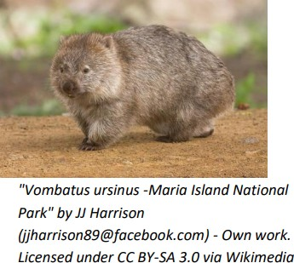and species of an organism give its specific scientific name. These names are usually derived from Greek or Latin, and therefore must be italicized when written. The genus is to be capitalized and the species is lower case. For example, the scientific name of a common wombat (bottom) is *Vombatus ursinus*. Let us compare the wombat to a similar species, a quokka (top).

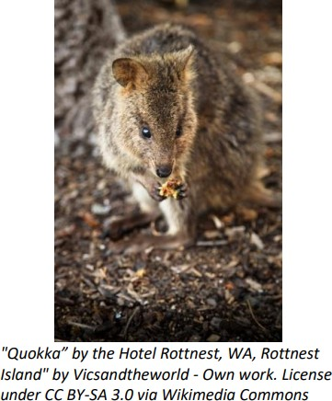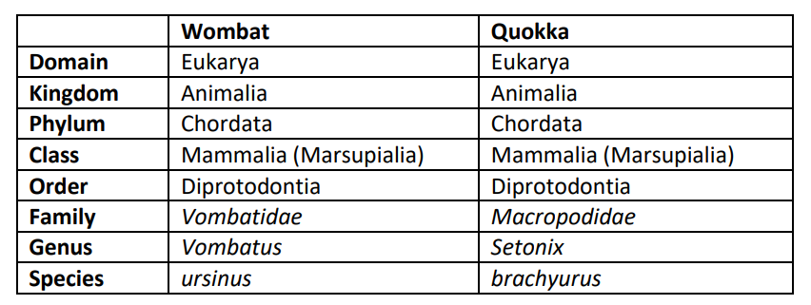

The scientific name of an organism is given using binomial nomenclature; the genus

Note that both animals differ only when we reach the family level. If you knew that a kangaroo was in the same family as a quokka, would you assume the quokka was more closely related to a kangaroo or a wombat? Scientific names might seem confusing, but are useful for several reasons. Common names tend to vary according to region (crawfish, crayfish, mudbug, crawdad), but the scientific name is always the same.

## QUESTIONS:

1. Llamas, alpacas, and camels are all in the same family: *Camelidae*. Therefore, it is reasonable to assume that these animals will also be in the same...
2. The scientific name of the brown-throated three-toed sloth is named *Bradypus variegatus*. What is the genus of the organism? The species?

**PART 1 : A SIMPLE DICHOTOMOUS KEY**

A dichotomous key is a tool used to determine the identity of species that have been previously described. You can think of it as a series of questions in which each question only has two possible answers.

In the table below, you have been given a list of creatures and their descriptions. The different characteristics, behaviors, and habitats of the creatures can be used in the dichotomous key to differentiate among them.

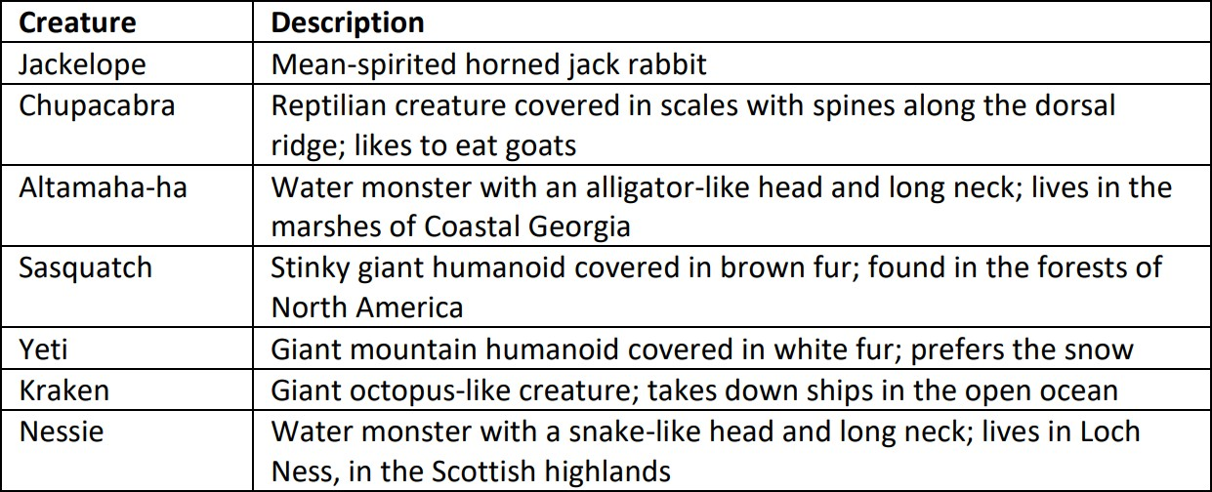

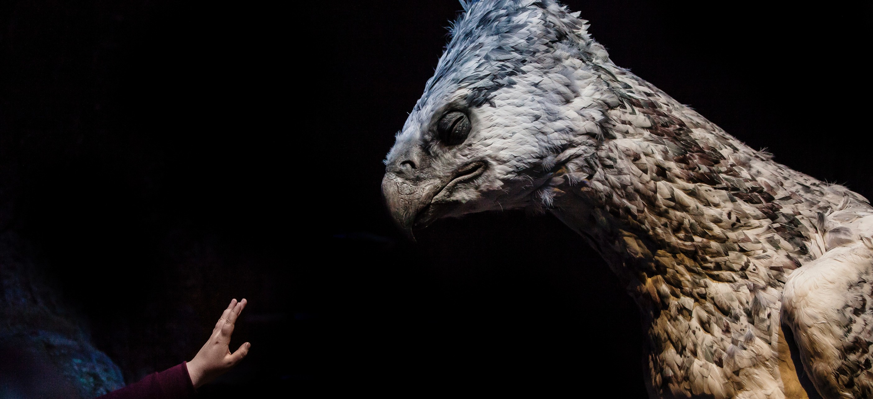

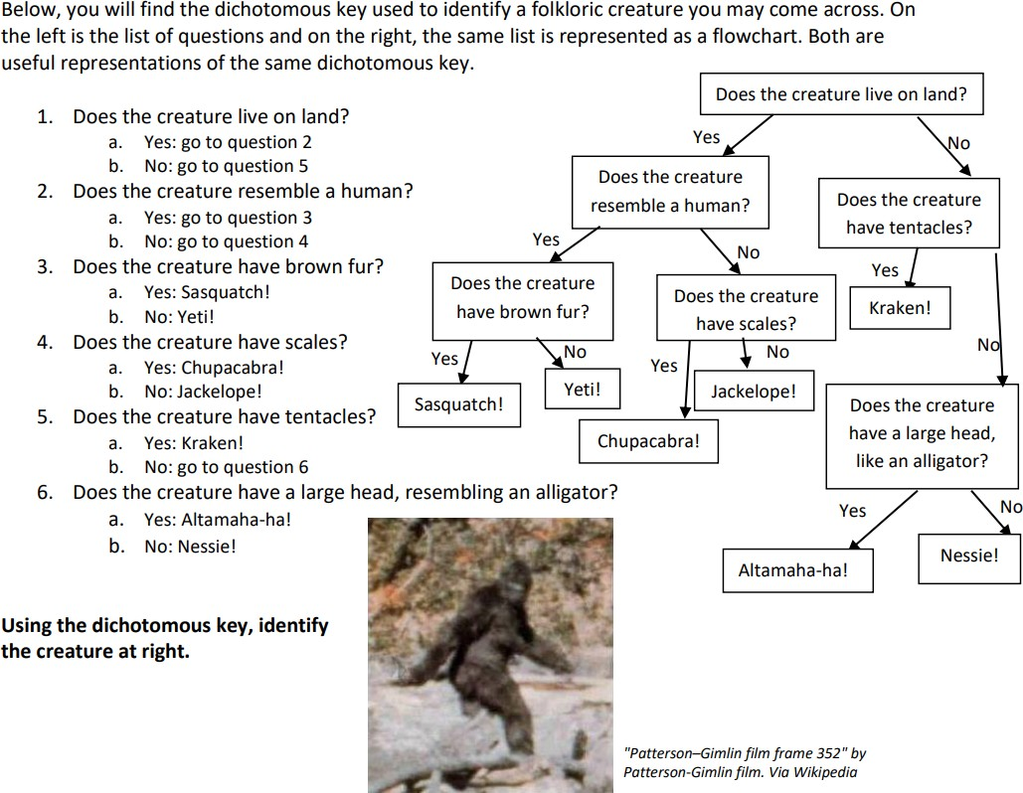

**THE CREATURE IS:**

**PART 2: BUILDING A DICHOTOMOUS KEY**

In the table below, there are several different foods. Your job is to build a dichotomous key that would help distinguish among them. There is space in the table to write out a description of each food, if necessary, as well as a name for each. Record your question series in the space on the next page.

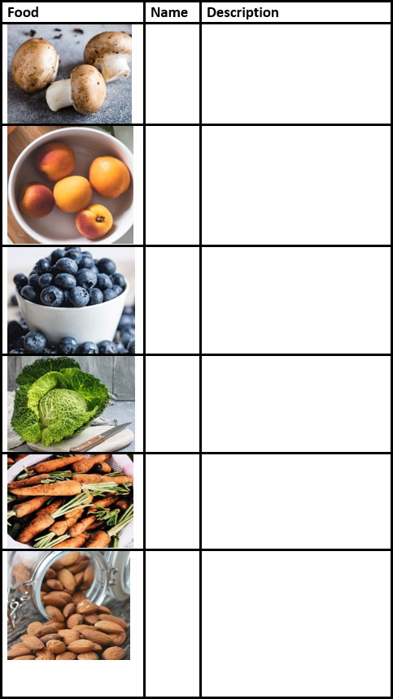

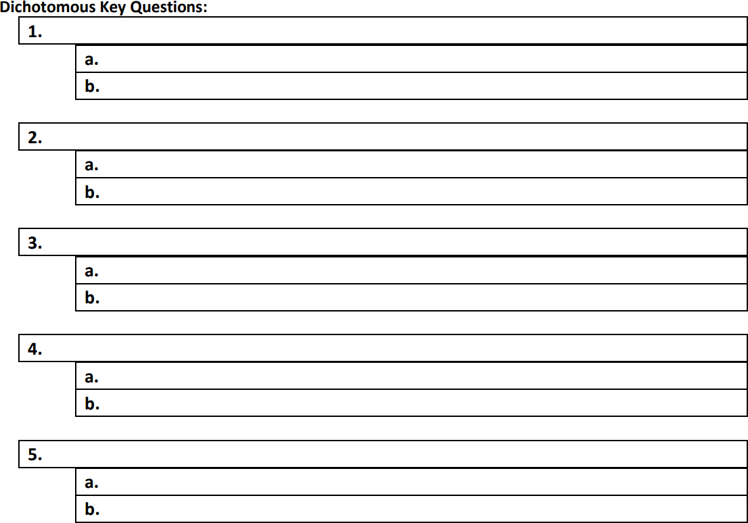

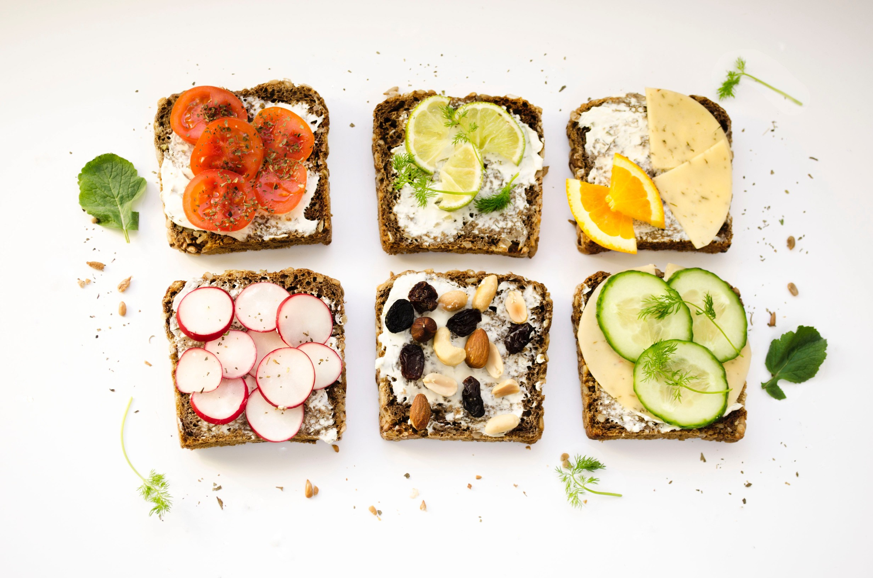

# PART 3:USING A

**DICHOTOMOUS KEY TO IDENTIFY TREES**

In this section, a dichotomous key will be used to identify tree species.

Find the Identity of a Mystery Tree!

Try your hand at identifying a tree genus using a dichotomous key.

Click onto one of the mystery trees to reveal a tree description, complete with photographs and text describing the characteristics of a particular tree. Then, connect with the dichotomous key to try to identify the tree's genus and species.

After carefully making choices in the dichotomous key, you will reach the name of a genus and click on it to receive a description of that genus.

At the bottom of the genus description, there will be a prompt that will connect you to a species page; you will be led to a page with descriptions and pictures of the species within that genus that are native to the Pacific Northwest. One of them will be your mystery tree!

After reaching a species you think matches your mystery tree, you can click back to the mystery tree page. You can then link to the solution page to find the answer to your mystery tree.

Find the identity of all eight mystery trees: https://oregonstate.edu/trees/mystery_tree.html

*"Science is a way of thinking much more than it is a body of knowledge."*

*-Carl Sagan"*

## MYSTERY TREES

### [Tree 1:](https://creativecommons.org/licenses/by-sa/4.0/)

**Tree 2:**

**Tree 3:**

**Tree 4:**

**Tree 5:**

**Tree 6:**

**Tree 7:**

**Tree 8:**

**CREDITS AND ATTRIBUTIONS**

[This lab is adapted from Intro to Taxonomy from Dalton State College and licensed under a Creative Commons Attribution-ShareAlike 4.0 International License.](https://creativecommons.org/licenses/by-sa/4.0/)



Photo Credits:

Photo by Christine Siracusa on Unsplash Photo by Joanna Kosinska on Unsplash Photo by LUM3N on Unsplash

Photo by Thomas Gamstaetter on Unsplash Photo by Monika Grabkowska on Unsplash Photo by Tetiana Bykovets on Unsplash Photo by Rhii Photography on Unsplash Photo by OLA Mishchenko on Unsplash