# THE SCIENTIFIC METHOD: HANDS-ON

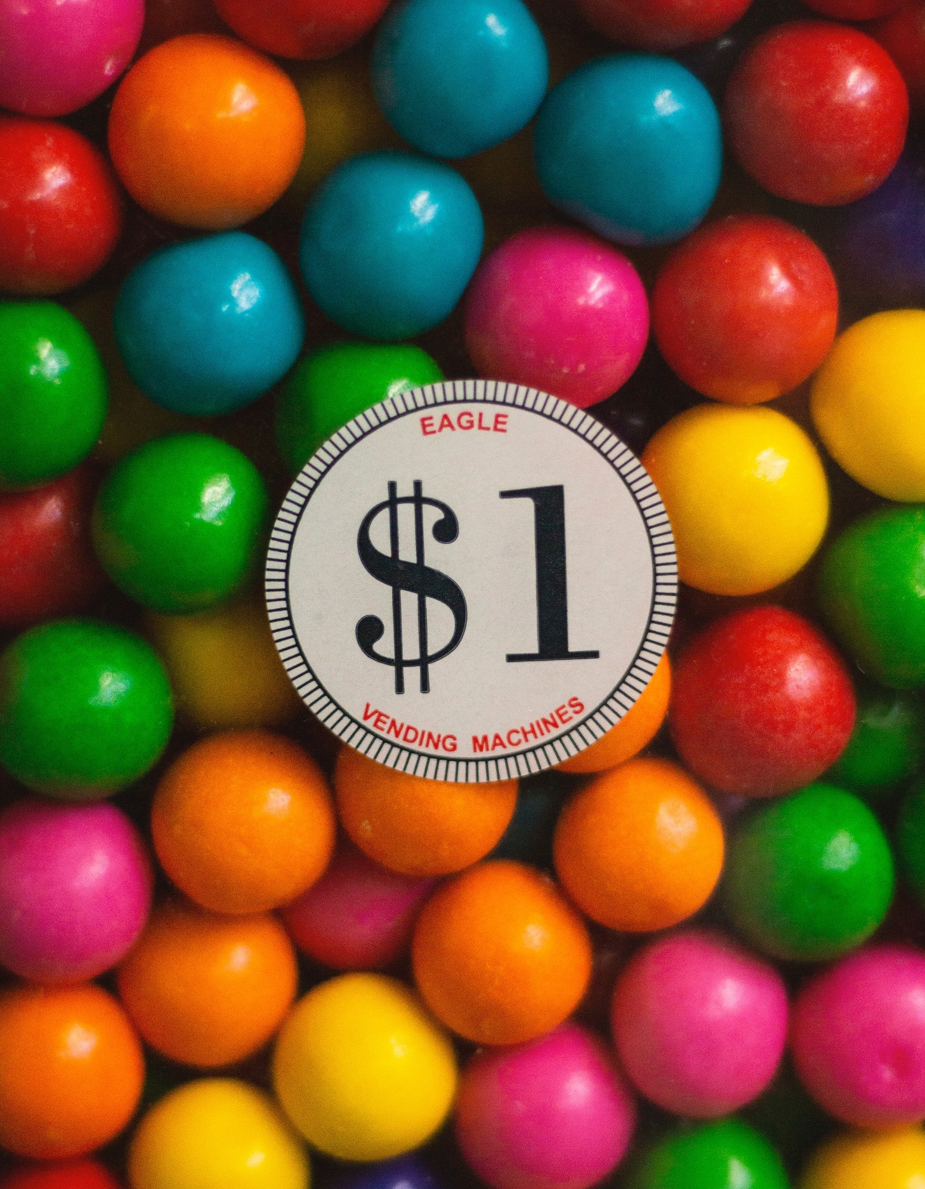**Introduction**

The scientific method is central to the study of biology: it is a process of acquiring and verifying information through experimentation. The general steps of the scientific method are depicted in the figure below. The hypothesis, or suggested explanation for the observation, is the basis for setting up experiments. Good experimental design is essential to the scientific method.

A few keys to good experimental design include effective use of controls, reproducibility, a large sample size, and multiple trials. In an experiment, in order to determine that any changes that occur are due to investigator manipulation only, there must be some basis for comparison. A control group is necessary to establish this basis of comparison. In the control group, everything is kept the same as the experimental group except for the independent variable. The experimental group is actually being experimented upon. For example, in a drug trial there will be a group that receives the drug (the experimental group) and a group that receives a placebo (the control group). The drug itself is considered the independent variable and any change(s) that occur because of the drug are considered the dependent variable. In order to ensure that it is only the drug causing changes, all other variables must be tightly controlled (such as diet, exercise, smoking, etc.). These are referred to as controlled variables.

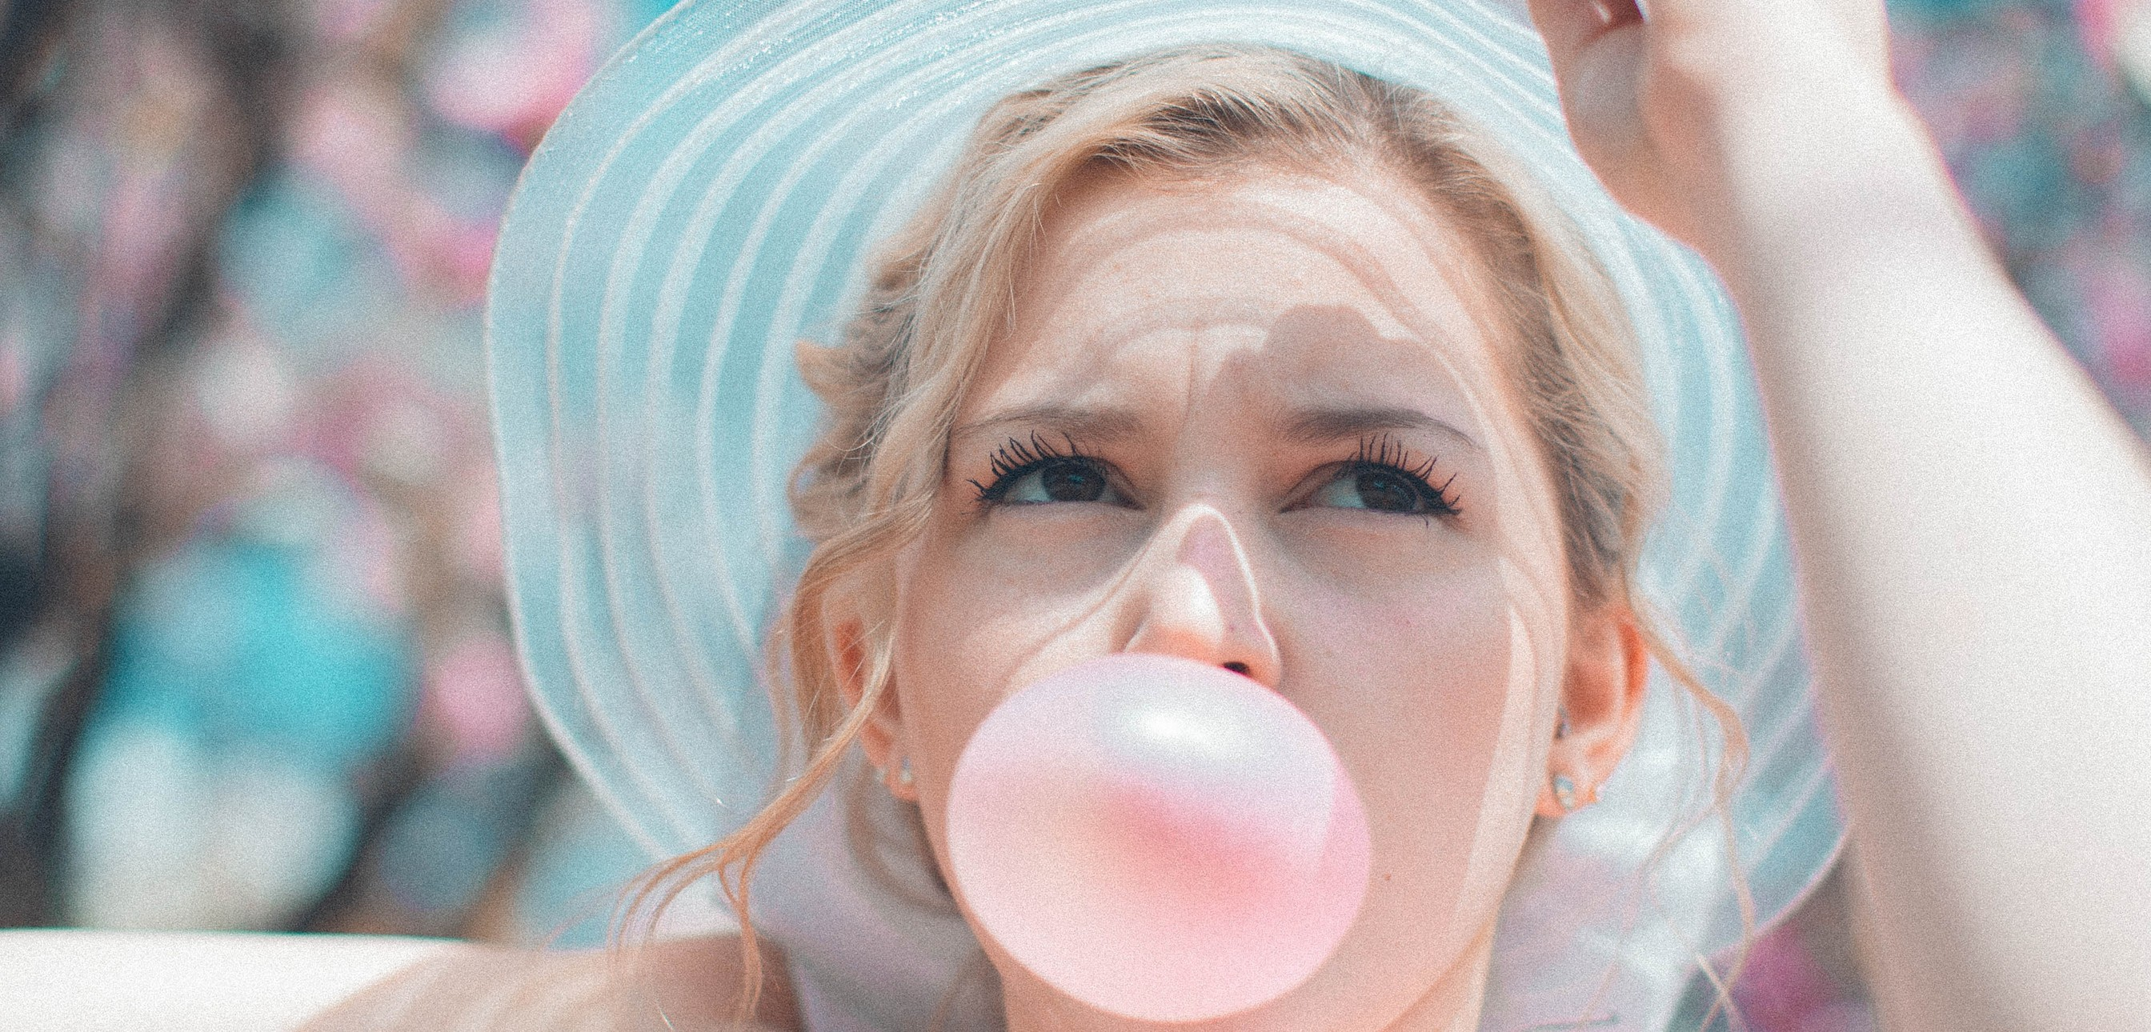

# PART 1

In this lab, you will learn the steps of the scientific method by identifying each step and applying each through a fun activity that compares variables between 2 types of bubble gum. You will be asked to hypothesize, collect and organize data, use scientific measurement, and differentiate between qualitative and quantitative data.

# MATERIALS

2 small pieces of wax paper 1 meter long piece of string 1 meter stick

2 different pieces of bubble gum labeled A and B

3. READ directions carefully before starting the lab. Each group will need one piece of gum labeled A and one labeled B. Make 3 observations about each brand of gum.

### Observations

**Gum A Gum B**

1.____________________________ 1.__________________________

2.____________________________ 2.___________________________

3.____________________________ 3.___________________________

# PROBLEM

Which piece of bubble gum blows the biggest bubble?

# HYPOTHESIS

Predict which piece of gum will blow the biggest bubble and why.

# PROCEDURE

1. The person with brand A will chew their piece of gum for 3 minutes. The person with brand B does not begin chewing until all the tests on brand A are

completed.

1. Blow a bubble.
2. Using a string, your partner will measure the diameter (distance across) the bubble. Put the string on the meter stick to measure the distance in centimeters (cm).
3. Record the measurement in a data table. Repeat the process for trials 2 and 3.
4. Find the average bubble size for brand A (add all the distances up and divide by 3) and put in the data chart.
5. Repeat steps 1-5 with brand B gum.

# DATA TABLE

Design a data collection table to fit the data you will be investigating

# CONCLUSION: FORMING A THEORY

What brand of gum is the best at blowing bubbles and why? Support your answer with observations and your data.

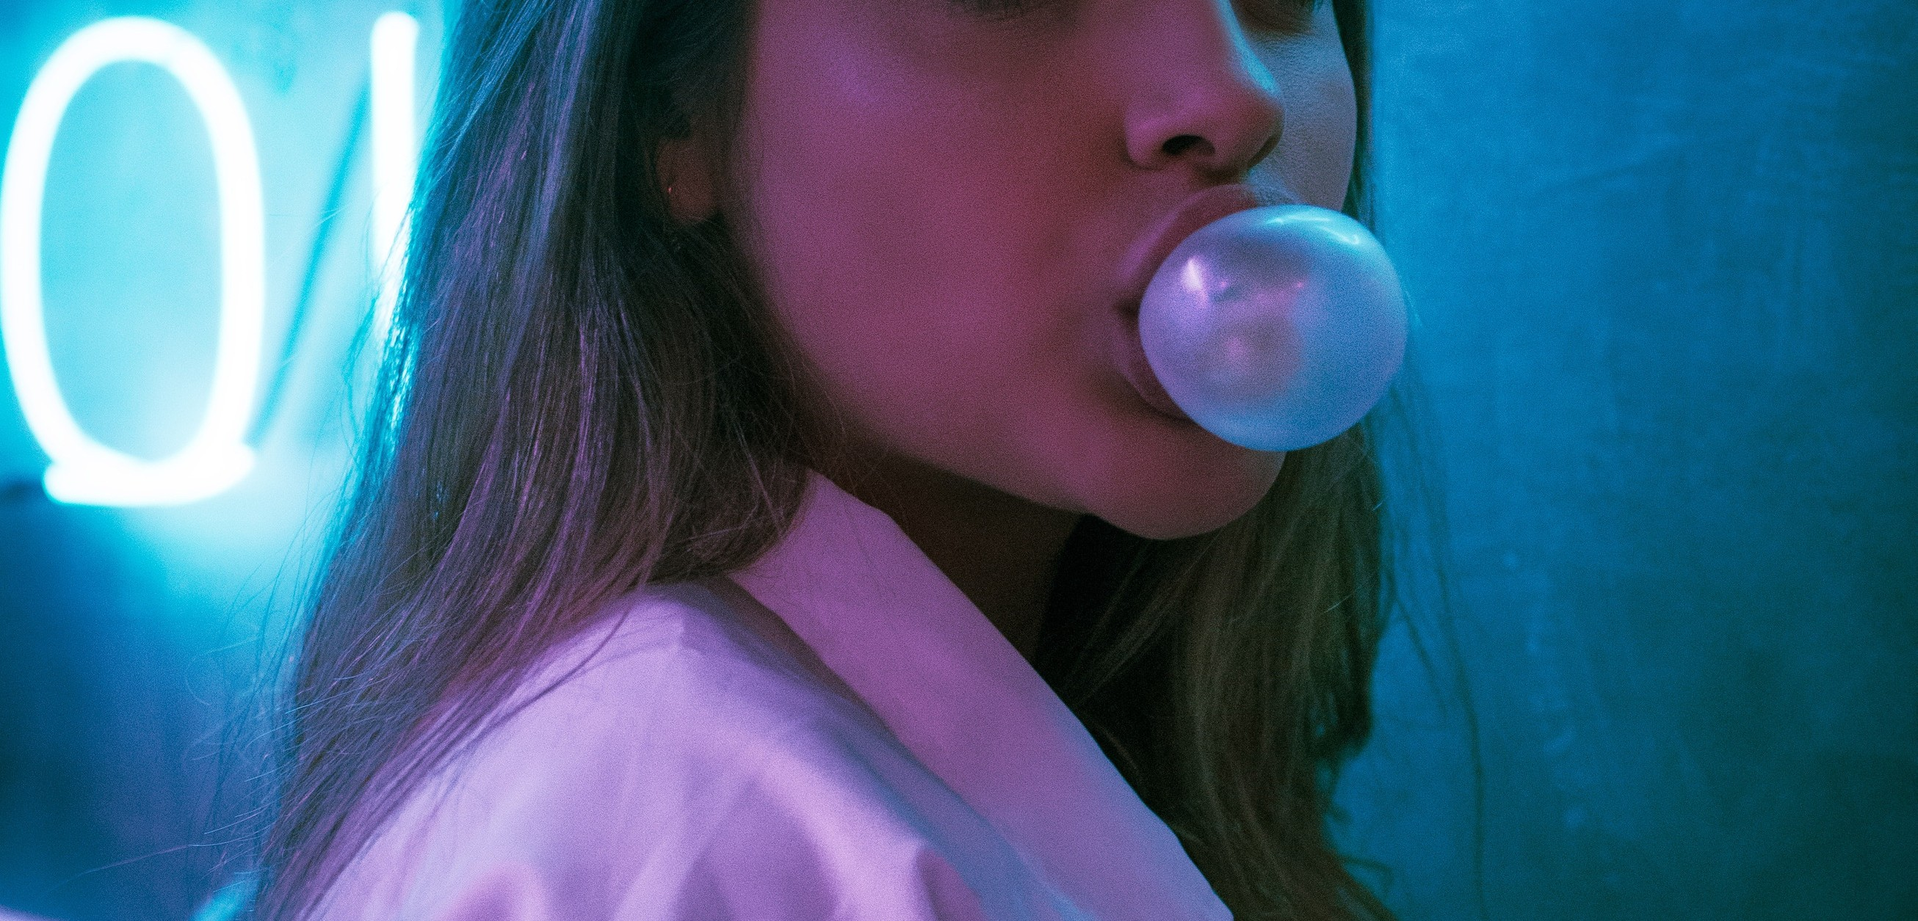

**PART 2**

Combine with another group to complete this part of the lab.

# PROBLEM

How does gum strechability relate to bubble size?

# HYPOTHESIS

Make an educated guess that would answer the above question.

# PROCEDURE

1. The person with brand A will roll their gum into a ball.
2. Hold the gum (brand A) by using the piece of wax paper. Another person in the group would hold the same piece of gum with another piece of wax paper. Hold the gum near your chest, begin to walk slowly backwards.
3. The third person in the group should hold the meter stick and measure the distance in centimeters the gum stretched before breaking.
4. Record the measurement in the data chart. ONLY DO ONE TRIAL
5. Repeat #1-4 for brand B gum

# DATA TABLE

Create a data table to fit the data you will be gathering

**PART 2: CONCLUSION**

**COMPARE DATA FROM BOTH GROUPS IN PART 1 AND PART 2**

## How does gum stretchability relate to bubble size?

With your lab partner, list 5 variables that may affect the outcome of this experiment.

1.

2.

3.

4.

5.

Explain how the data you collected can be described as both qualitative and quantitative

List any questions you still have about the scientific method.

*"Science is a way of thinking much more than it is a body of knowledge."*

*-Carl Sagan"*

# CREDITS AND ATTRIBUTIONS

[Introduction: Adapted from http://www.biologycorner.com/](https://creativecommons.org/licenses/by-sa/4.0/)

["Scientific Method Lab Using Bubble Gum" is licensed under CC BY-NC- SA 3.0 / A derivative from the original work](https://creativecommons.org/licenses/by-sa/4.0/)



### Photo Credits:

Unsplash Photos:

Photo by Ruth Ochoa on Unsplash Photo by Nik MacMillan on Unsplash Photo by Daniel Monteiro on Unsplash