# THE SCIENTIFIC METHOD: HANDS-ON

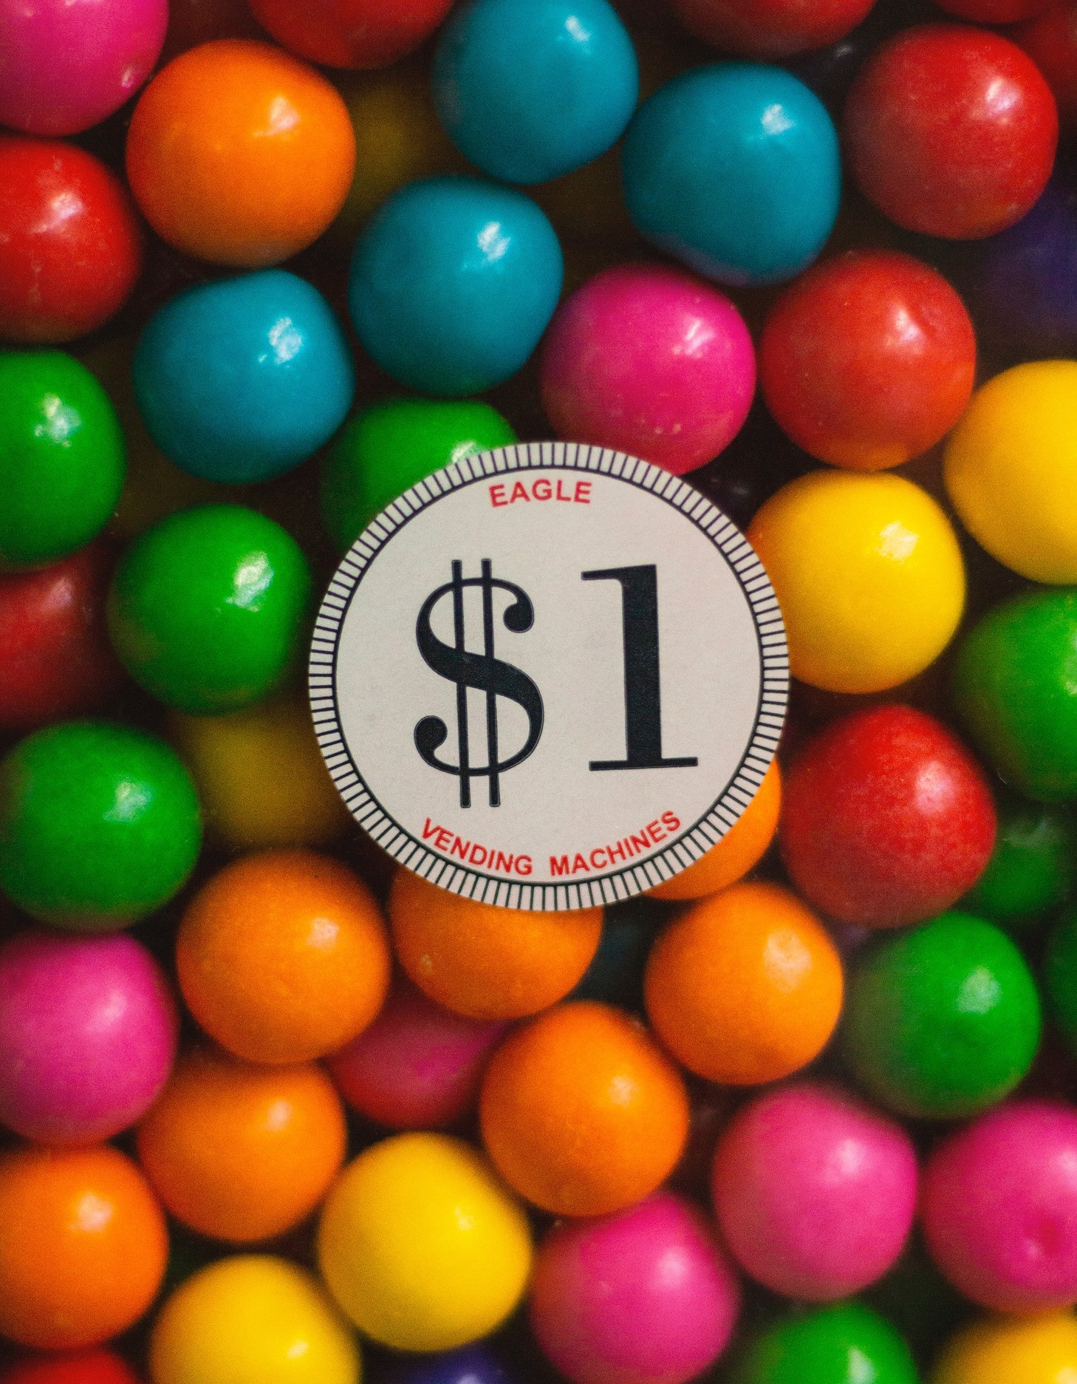**Introduction**

The scientific method is central to the study of biology: it is a process of acquiring and verifying information through experimentation. The general steps of the scientific method are depicted in the figure below. The hypothesis, or suggested explanation for the observation, is the basis for setting up experiments. Good experimental design is essential to the scientific method.

A few keys to good experimental design include effective use of controls, reproducibility, a large sample size, and multiple trials. In an experiment, in order to determine that any changes that occur are due to investigator manipulation only, there must be some basis for comparison. A control group is necessary to establish this basis of comparison. In the control group, everything is kept the same as the experimental group except for the independent variable. The experimental group is actually being experimented upon. For example, in a drug trial there will be a group that receives the drug (the experimental group) and a group that receives a placebo (the control group). The drug itself is considered the independent variable and any change(s) that occur because of the drug are considered the dependent variable. In order to ensure that it is only the drug causing changes, all other variables must be tightly controlled (such as diet, exercise, smoking, etc.). These are referred to as controlled variables.

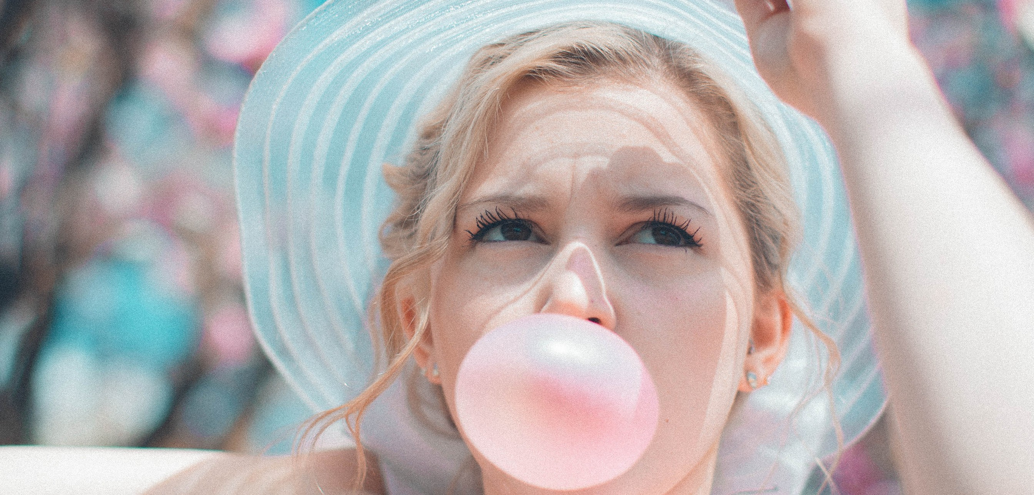

# PART 1

In this lab, you will learn the steps of the scientific method by identifying each step and applying each through a fun activity that compares variables between 2 types of bubble gum. You will be asked to hypothesize, collect and organize data, use scientific measurement, and differentiate between qualitative and quantitative data.

# MATERIALS

Different Types of Bubble Gum Meter Stick

Scale String

Timer (Phone) Wax Paper Weighing Boat(s)

# QUESTIONS AND OBSERVATIONS

**Questions:** Write down at least three questions you may have about the different types/brands of gum.

**Observations:** Write at least three observations about the different types/brands of gum.

# HYPOTHESIS

Formulate a hypothesis. Make a prediction, pose a problem, or write an explanation (if.. then…because) statement.

# IDENTIFY THE VARIABLES

* Independent Variable:
* Dependent Variable:
* Control Variable(s):

# DESIGN AN EXPERIMENT

## Don’t forget! You will need to present your experiment design to your instructor before proceeding!

**GATHER DATA**

You will need to gather either qualitative, quantitative, or both types of data for this experiment. Design a data collection table to fit the data you will be investigating. Record the data you gathered below in an organized manner. (i.e. In a graph, chart, or table)

# RESULTS

What results did your data show? Explai**n.**

# CONCLUSION: FORMING A THEORY

How did your hypothesis turn out? Discuss your hypothesis, your data, and your conclusions.

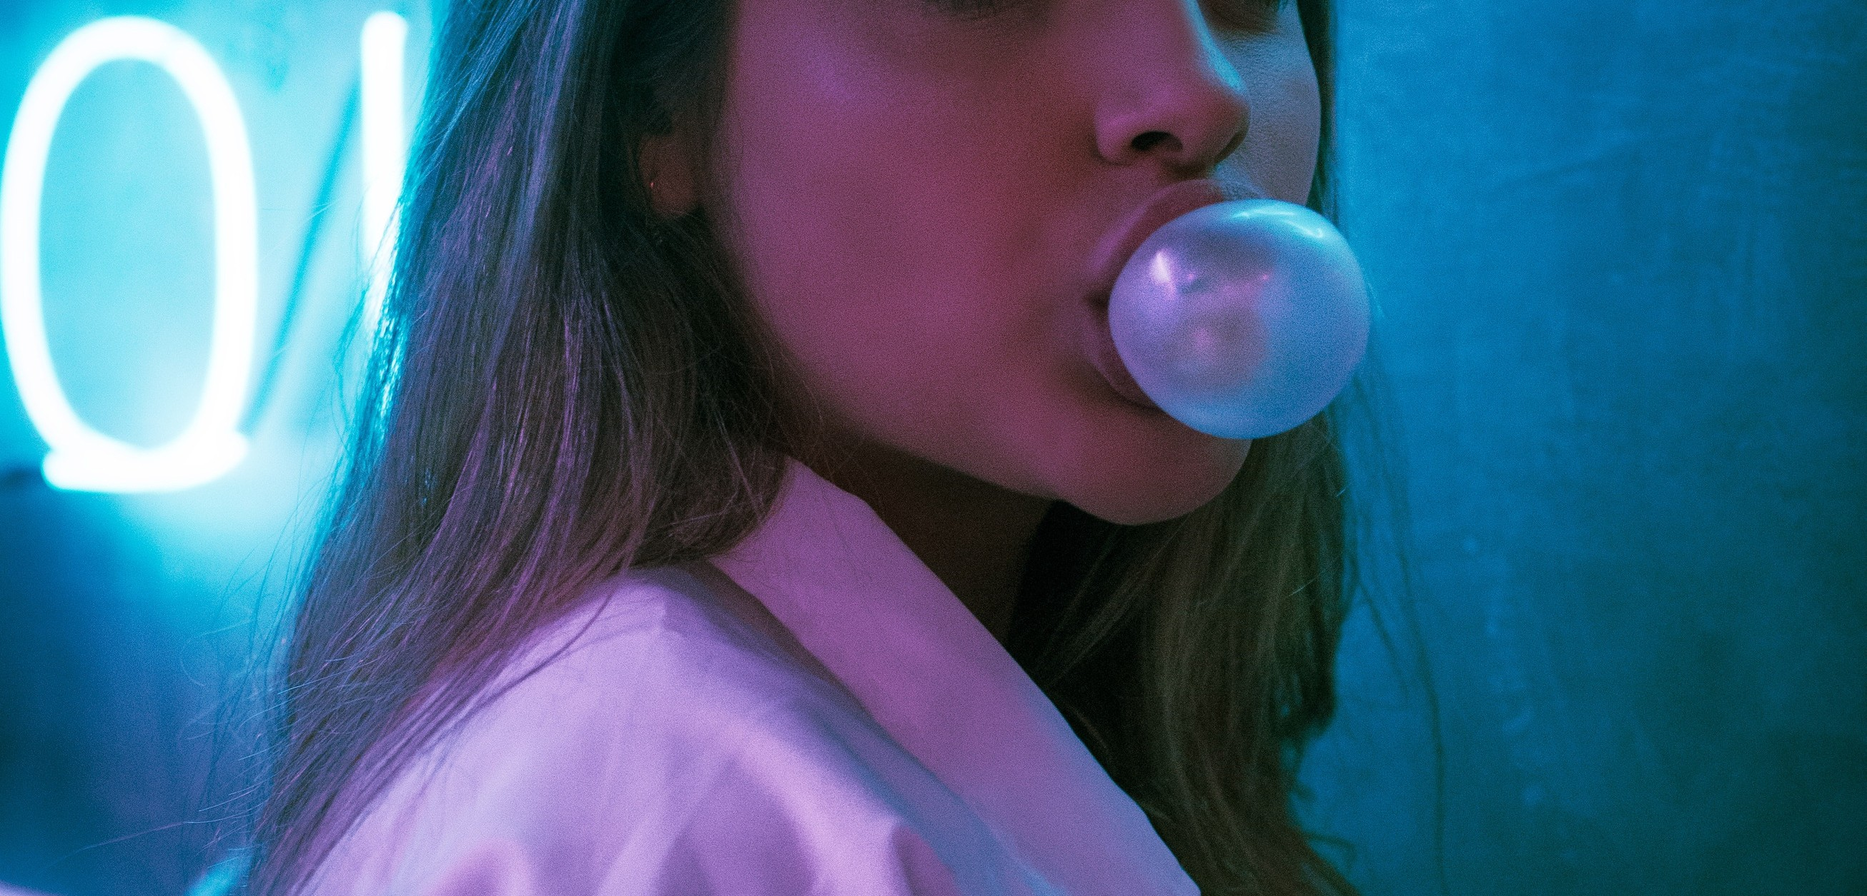

**LAB QUESTIONS**

1. With your lab partner, list a few variables that may affect the outcome of this experiment.
2. Did the ingredients of the different types of gum change the lab results? Why or why not?
3. Are there any changes you would make to improve your lab experiment?
4. What are some other questions or labs you could design around bubble gum?
5. Why do we say that we reject or fail to reject our hypothesis?
6. List any questions you still have about the scientific method.

# CREDITS AND ATTRIBUTIONS

[Introduction: Adapted from http://www.biologycorner.com/](https://creativecommons.org/licenses/by-sa/4.0/)

["Scientific Method Lab Using Bubble Gum" is licensed under CC BY-NC- SA 3.0 / A derivative from the original work](https://creativecommons.org/licenses/by-sa/4.0/)



**Photo Credits:**

Unsplash Photos:

Photo by Ruth Ochoa on Unsplash Photo by Nik MacMillan on Unsplash Photo by Daniel Monteiro on Unsplash