# THE SCIENTIFIC METHOD

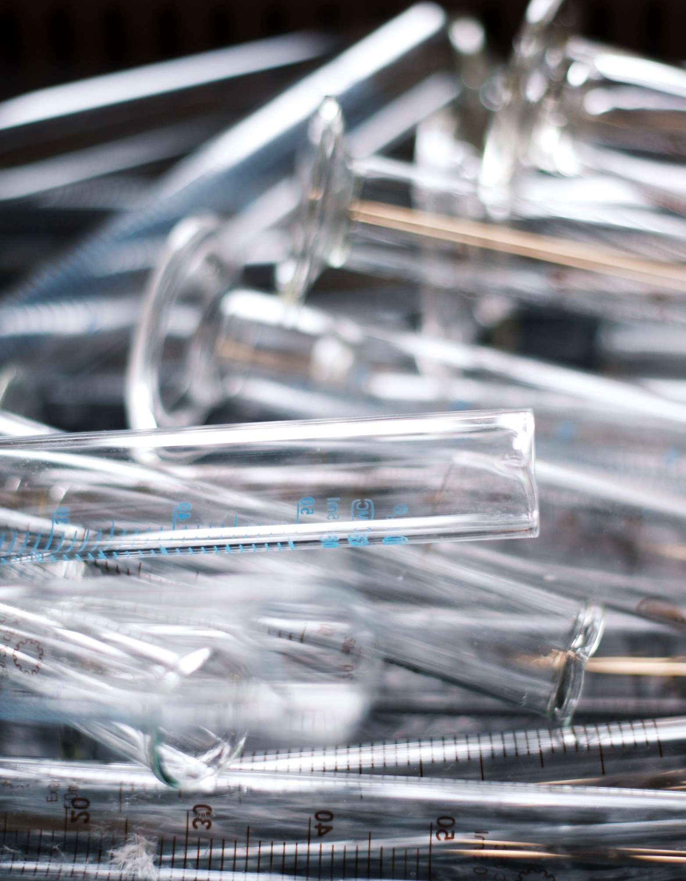**Introduction**

The scientific method is central to the study of biology: it is a process of acquiring and verifying information through experimentation. The general steps of the scientific method are depicted in the figure below. The hypothesis, or suggested explanation for the observation, is the basis for setting up experiments. Good experimental design is essential to the scientific method.

A few keys to good experimental design include effective use of controls, reproducibility, a large sample size, and multiple trials. In an experiment, in order to determine that any changes that occur are due to investigator manipulation only, there must be some basis for comparison. A control group is necessary to establish this basis of comparison. In the control group, everything is kept the same as the experimental group except for the independent variable. The experimental group is actually being experimented upon. For example, in a drug trial there will be a group that receives the drug (the experimental group) and a group that receives a placebo (the control group). The drug itself is considered the independent variable and any change(s) that occur because of the drug are considered the dependent variable. In order to ensure that it is only the drug causing changes, all other variables must be tightly controlled (such as diet, exercise, smoking, etc.). These are referred to as controlled variables.

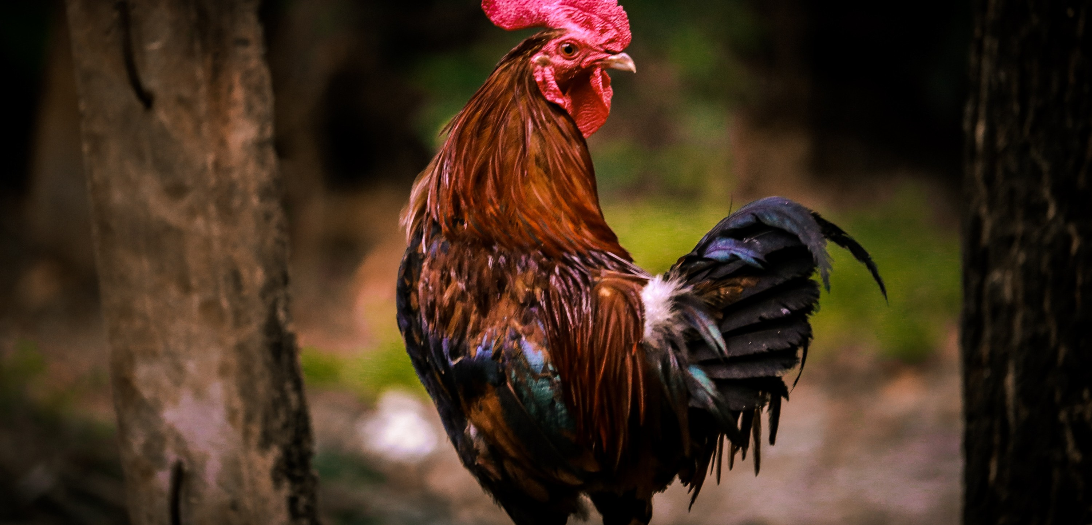

# PART 1 : THE STRANGE CASE OF BERI BERI

In 1887 a strange nerve disease attacked the people in the Dutch East Indies. The disease was beriberi. Symptoms of the disease included weakness and loss of appetite, victims often died of heart failure.

Scientists thought the disease might be caused by bacteria. They injected chickens with bacteria from the blood of patients with beriberi. The injected chickens became sick. However, so did a group of chickens that were not injected with bacteria. One of the scientists, Dr. Eijkman, noticed something. Before the experiment, all the chickens had eaten whole-grain rice, but during the experiment, the chickens were fed polished rice. Dr.

Eijkman researched this interesting case and found that polished rice lacked thiamine, a vitamin necessary for good health.

# PART 1 : QUESTIONS

1. State the Problem
2. What was the hypothesis?
3. How was the hypothesis tested?
4. Do the results indicate that the hypothesis should be rejected?
5. What should be the new hypothesis and how would you test it?

*"I have no special talent. I am only passionately curious."*

*-Albert Einstein*

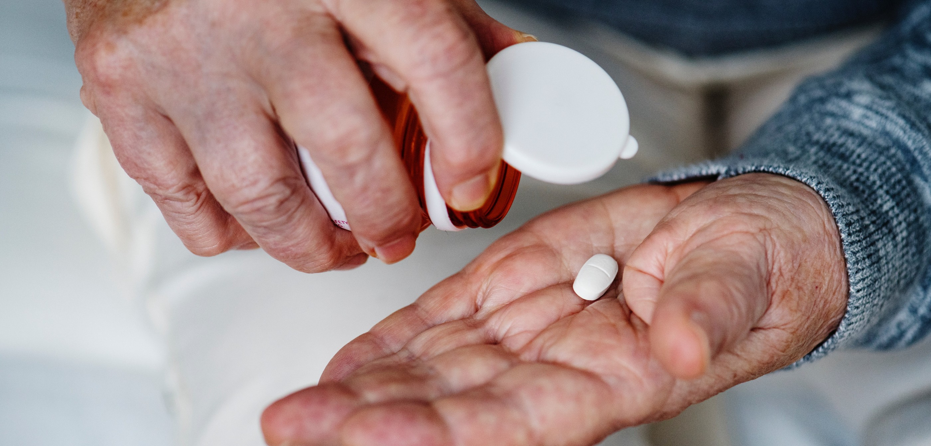

# PART 2: HOW PENICILLIN WAS DISCOVERED

In 1928, Sir Alexander Fleming was studying *Staphylococcus* bacteria growing in culture dishes. He noticed that a mold called Penicillium was also growing in some of the dishes. A clear area existed around the mold because all the bacteria that had grown in this area had died. In the culture dishes without the mold, no clear areas were present. Fleming hypothesized that the mold must be producing a chemical that killed the bacteria. He decided to isolate this substance and test it to see if it would kill bacteria. Fleming transferred the mold to a nutrient broth solution.

This solution contained all the materials the mold needed to grow. After the mold grew, he removed it from the nutrient broth. Fleming then added the nutrient broth in which the mold had grown to a culture of bacteria.

He observed that the bacteria died which was later used to develop antibiotics used to treat a variety of diseases.

**PART 2: QUESTIONS**

## Identify the problem.

1. What was Fleming's hypothesis?
2. How was the hypothesis tested?
3. Do the results indicate that the hypothesis should be rejected?
4. This experiment led to the development of what major medical advancement…?

*"Science is a way of thinking much more than it is a body of knowledge."*

*-Carl Sagan"*

# PART 3: IDENTIFY CONTROLS AND VARIABLES

### Thomas Edison thinks that a lightbulb will increase the productivity of workers. He creates two groups of 50 workers each and assigns each group the same task (in this case, they're supposed to staple a set of papers). Group A is exposed to candlelight while they work. Group B is exposed to the light bulb. After an hour, Edison counts how many stacks of papers each group has made. Group A made 1,587 stacks; Group B made 2,113 stacks.

**IDENTIFY THE:**

**Control Group: Independent Variable: Dependent Variable:** What should Edison's conclusion be?

### How could this experiment be improved?

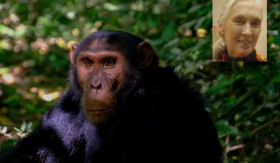

Jane Goodall notices that two of her chimpanzee's favorite toys are covered in a strange green moss. Her field guide tells her that coconut water will get rid of the green moss. She decides to check this out by spraying one toy with coconut water. She sprays the other toy with water. After 3 days of "treatment" there is no change in the appearance of the green moss on either of the chimpanzee's toys.

# IDENTIFY THE:

#### Control Group: Independent Variable: Dependent Variable:

What should Goodall's conclusion be?

How could this experiment be improved?

Nikola Tesla believes that mice exposed to electrocity will become very strong. He decides to perform this experiment by placing 10 mice near a Tesla coil for 5 hours. He compared these 10 mice to another 10 mice that had not been exposed. His test consisted of a heavy block of wood that blocked the mouse food. He found that 8 out of 10 of the exposed mice were able to push the block away, while 7 out of 10 of the other mice were able to do the same.

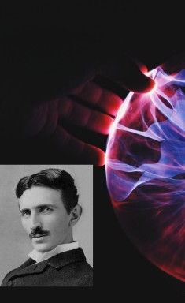**IDENTIFY THE:**

**Control Group: Independent Variable: Dependent Variable:**

### What should Tesla's conclusion be?

How could this experiment be improved?

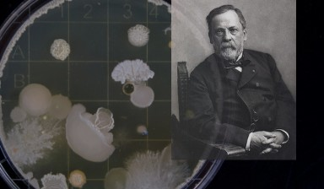

Louis Pasteur hypothesized that a certain yeast was better for fermentation: it appears to cause 50% faster fermentation. Interested in this product, he buys the new yeast and compares it to the old yeast. One test batch of beet juice (A) is sprinkled with the original yeast, and another test batch of beet juice (B) was sprinkled with the new yeast.

Batch A fermented in 45 days. Batch B fermented in 30 days.

# IDENTIFY THE:

#### Control Group: Independent Variable: Dependent Variable:

What should Goodall's conclusion be?

How could this experiment be improved?

# NOW IT'S YOUR TURN:

Imagine that one of your family members is working on a science project. Her task is to answer the question: "Does a popular commercial hair product affect the speed of hair growth?". Your family members are willing to volunteer for the experiment.

Design the experiment below:

*"Science knows no country, because knowledge belongs to humanity, and is the torch which illuminates the world." ~Louis Pasteur.*

# CREDITS AND ATTRIBUTIONS

[Introduction: Adapted from http://www.biologycorner.com/](https://creativecommons.org/licenses/by-sa/4.0/)

[This lab is adapted from The Scientific Method from Dalton State College and licensed under a Creative Commons Attribution-ShareAlike 4.0 International License.](https://creativecommons.org/licenses/by-sa/4.0/)



Photo Credits:

Thomas Edison: This photo is public domain. Louis Pasteur: This photo is public domain. Nikola Tesla: This photo is public domain.

Jane Goodall: Jeekc [CC BY-SA 3.0 (<http://creativecommons.org/licenses/by-> sa/3.0/)]

Unsplash Photos:

https://unsplash.com/photos/13UugSL9q7A https://unsplash.com/photos/vEE00Hx5d0Q https://unsplash.com/photos/N8x-Z4JIqKk https://unsplash.com/photos/6Y88yhsNId8 https://unsplash.com/photos/pgfWIStWIfs https://unsplash.com/photos/hXXncjTJJ1g