**LEAF DISC PHOTOSYNTHESIS**

## INTRODUCTION

*Adapted from Open Stax Biology*

All living organisms on earth consist of one or more cells. Each cell runs on the chemical energy found mainly in carbohydrate molecules (food), and the majority of these molecules are produced by one process: photosynthesis.

Through photosynthesis, certain organisms convert solar energy (sunlight) into chemical energy, which is then used to build carbohydrate molecules. The energy used to hold these molecules together is released when an organism breaks down food. Cells then use this energy to perform work, such as cellular respiration.

The energy that is harnessed from photosynthesis enters the ecosystems of our planet continuously and is transferred from one organism to another. Therefore, directly or indirectly, the process of photosynthesis provides most of the energy required by living things on earth. Photosynthesis also results in the release of oxygen into the atmosphere. In short, to eat and breathe, humans depend almost entirely on the organisms that carry out photosynthesis.

Photosynthesis requires sunlight, carbon dioxide, and water as starting reactants. After the process is complete,

photosynthesis releases oxygen and produces carbohydrate molecules, most commonly glucose. These sugar molecules contain the energy that living things need to survive.

The process of photosynthesis can be represented by an equation, wherein carbon dioxide and water produce sugar and oxygen using energy from sunlight. Although the equation looks simple, the many steps that take place during photosynthesis are actually quite complex, as in the way that the reaction summarizing cellular respiration represented many individual reactions.

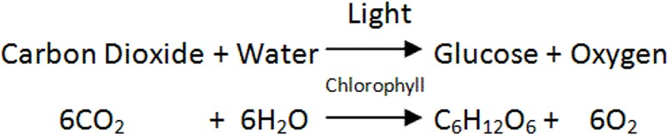

In plants, photosynthesis takes place primarily in leaves, which consist of many layers of cells and have differentiated top and bottom sides.

The process of photosynthesis occurs not on the surface layers of the leaf, but rather in a middle layer called the mesophyll. The gas exchange of carbon dioxide and oxygen occurs through small, regulated openings called stomata.

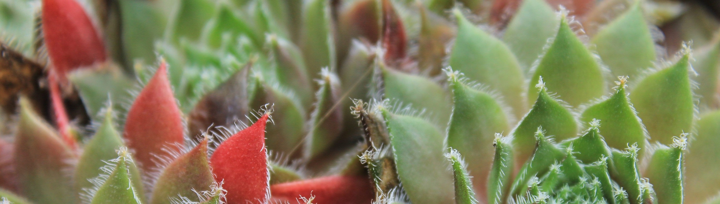

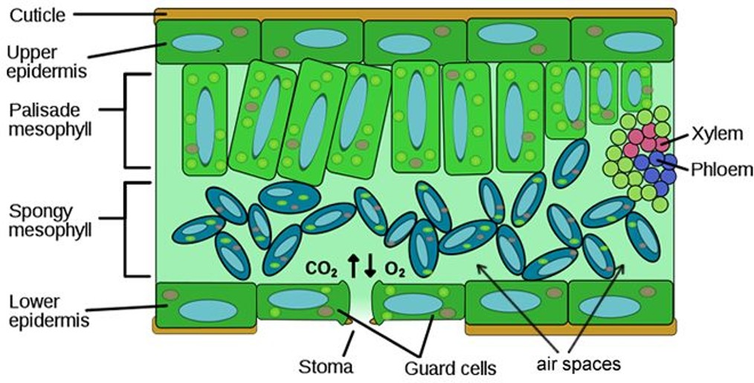

Photosynthesis takes place in two stages: the light-dependent reactions and the Calvin cycle. In the light-dependent reactions, which take place at the thylakoid membrane, chlorophyll absorbs energy from sunlight and then converts it into chemical energy with the use of water. The light-dependent reactions release oxygen from the hydrolysis of water as a byproduct. In the Calvin cycle, which takes place in the stroma, the chemical energy derived from the light-dependent reactions drives both the capture of carbon in carbon dioxide molecules and the subsequent assembly of sugar molecules.

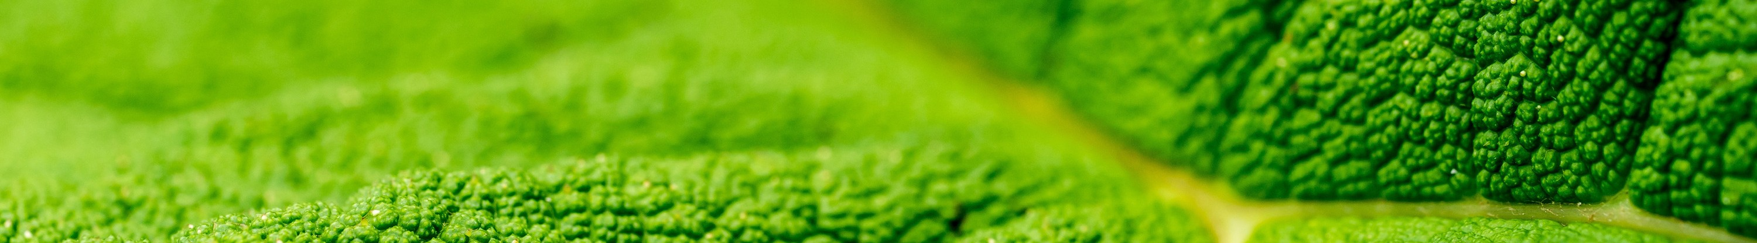The two reactions use carrier molecules to transport the energy from one to the other. The carriers that move energy from the light-dependent reactions to the Calvin cycle reactions can be thought of as “full” because they bring energy. After the energy is released, the “empty” energy carriers return to the light-dependent reactions to obtain more energy.

# Lab Exercise

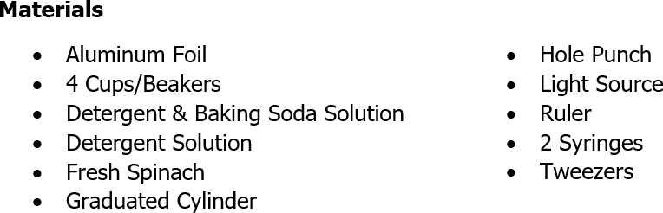

**Procedure:**

1. Formulate a hypothesis and identify both the independent and the dependent variables before starting the lab.
2. Test the syringes by sealing the tip and pulling back on the plunger. When released, the plunger should snap back, indicating a good vacuum. Remove the plunger from a syringe.
3. Use a hole punch to punch out 40 disks from the leaves. The disks should be as uniform in size and mass as possible. Avoid the larger veins of the leaves. As you punch out the leaf disks, put them into the syringe. Continue until you have at least 40 disks.
4. Tap the side of the syringe so that the disks are at the bottom, and then reinsert the plunger— being careful not to crush the leaf disks.
5. Insert the tip of the syringe into the beaker and draw a small amount of the detergent solution into the syringe. Tap the syringe to dislodge disks that are stuck to the sides. There may be a couple of disks that you simply cannot dislodge.
6. Hold the syringe vertically, with the tip pointed upwards, and push in the plunger to expel the trapped air.
7. Close the tip of the syringe with your finger and pull on the plunger to create a vacuum. The vacuum removes gas from the leaf tissues. Hold the plunger in place for 10 seconds and release it. When you release the plunger, liquid infiltrates the tissue. Repeat this a minimum of 3 times or until all disks sink. As liquid infiltrates the leaf tissues, the density of the disks increases, and they begin to sink.

# Procedure: (continued)

1. 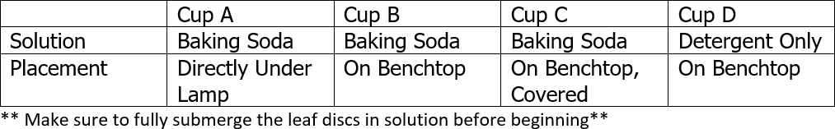Use tweezers to transfer 10 disks to each petri dish and add enough solution to cover the disks. Make sure each cup contains the same amount of liquid; set up the cups according to the table below:
2. Record the number of sunken disks before beginning the experiment in the data table. You will want to subtract any disks that were floating at the beginning of the experiment.
3. Turn on the light and begin recording the time. As oxygen is produced by photosynthesis, it comes out of solution and infiltrates the leaf tissue, replacing some of the water. This decreases the density of the disks, and they begin to float.
4. Record the number of floating disks in 3 minute intervals, continuing the experiment until all disks are floating. Record your data in the table #1.

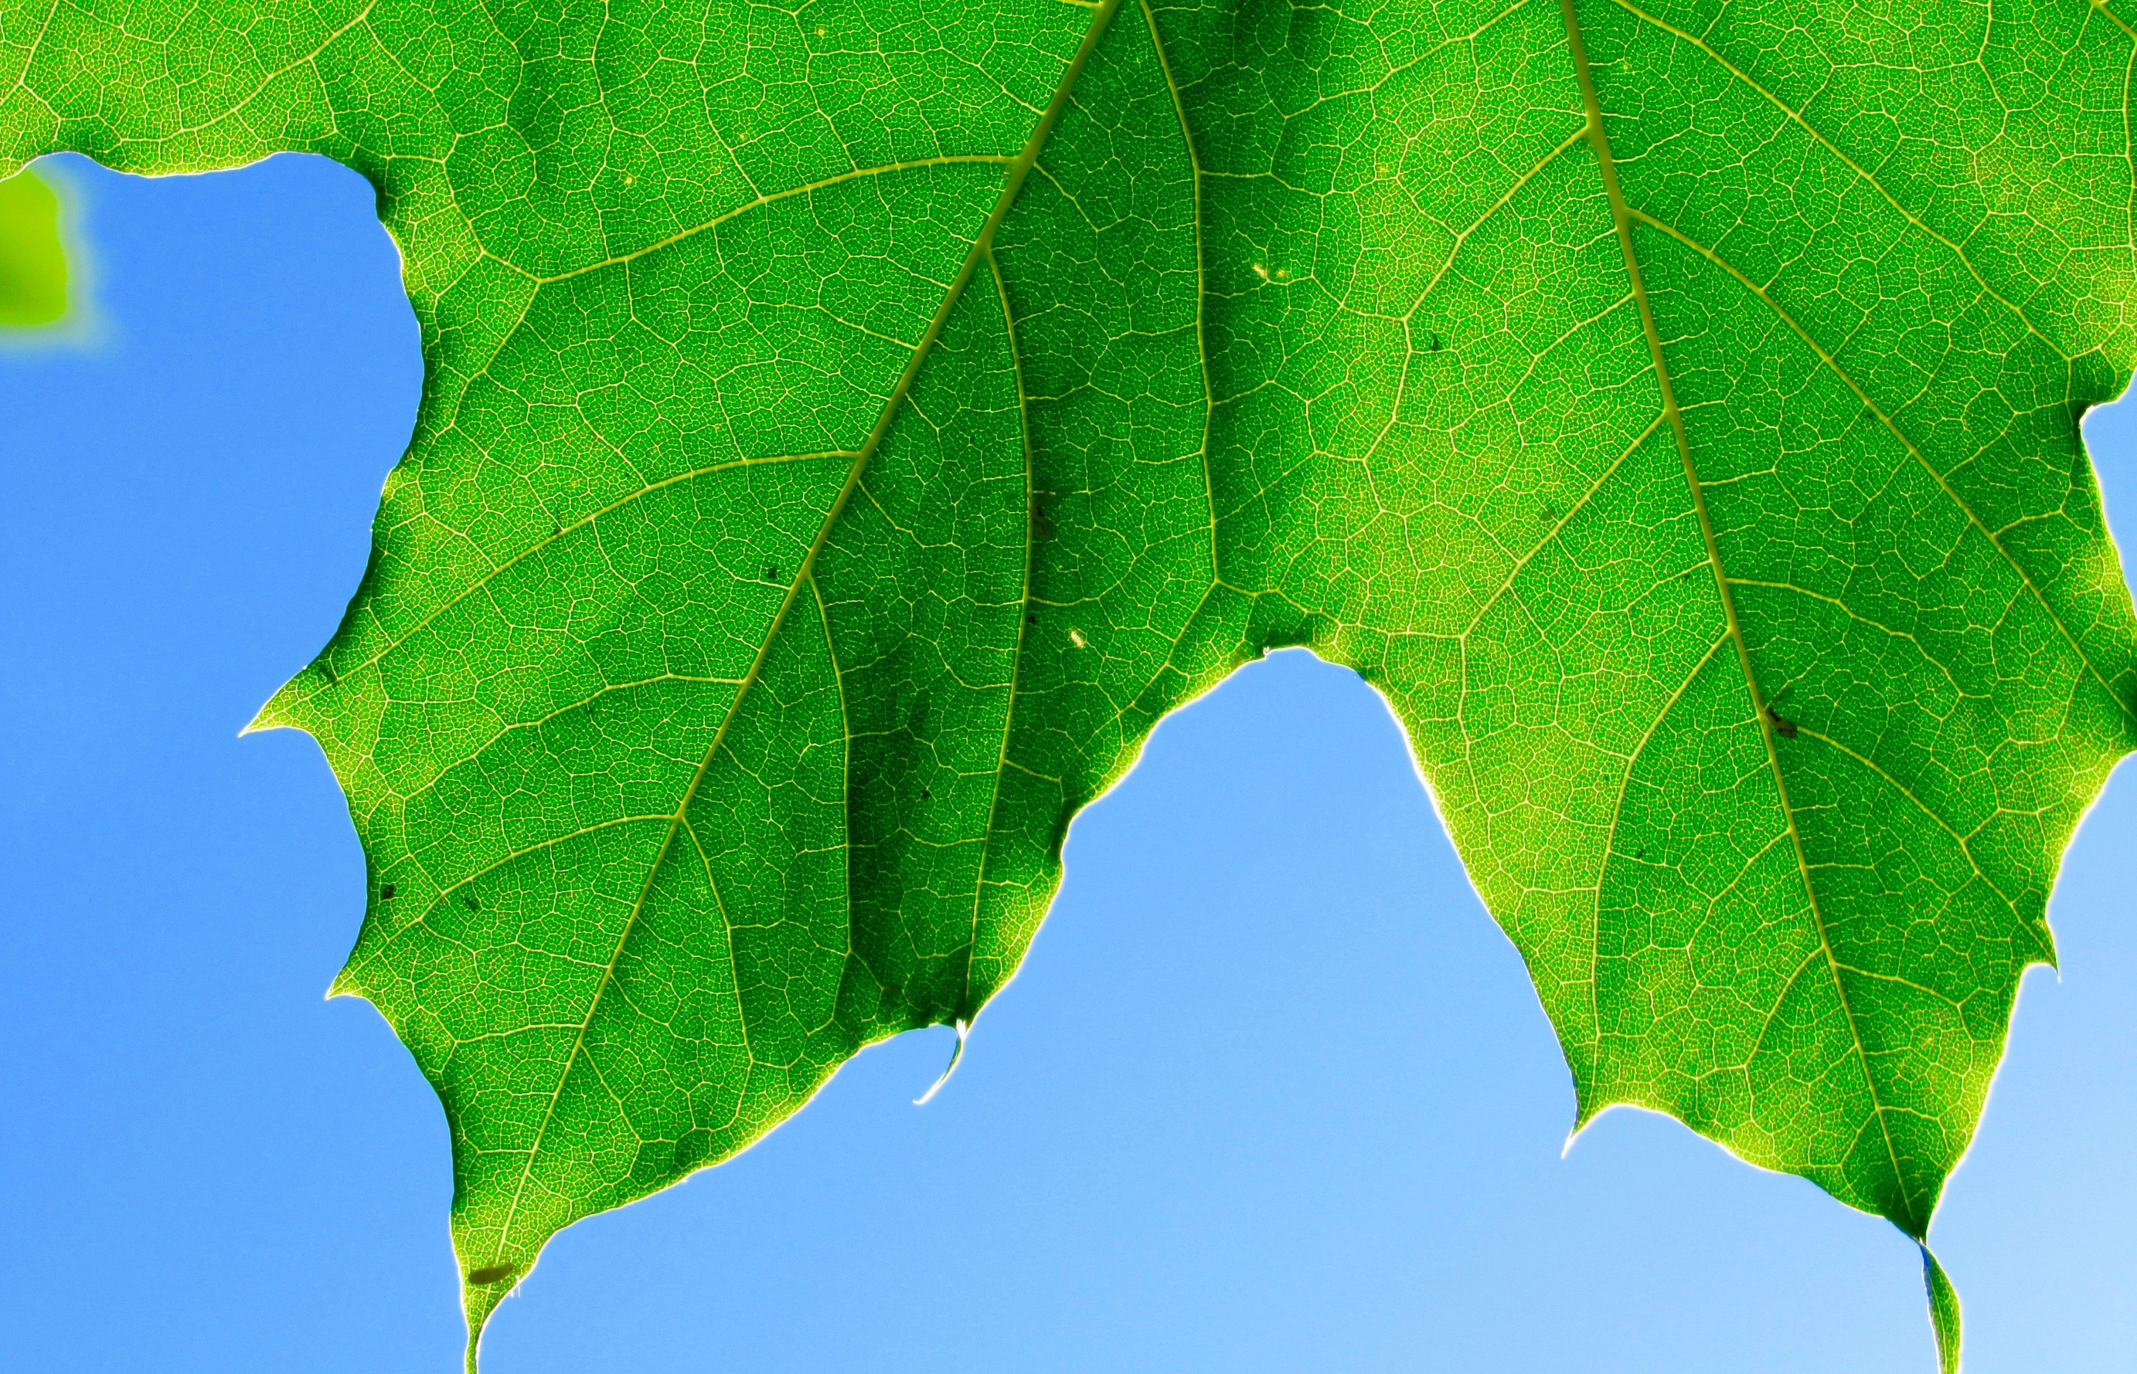

# Hypothesis:

**Variables:**

* + Independent Variable:
  + Dependent Variable:



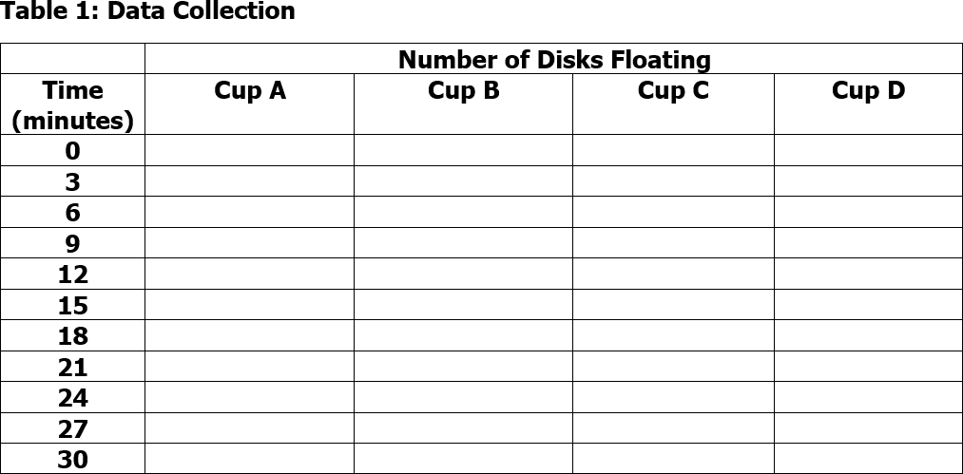

# Analyzing Data

Graph your data below to display the results from the experiment. Label the X Axis with the time and the Y Axis with the number of disks floating. Each cup should have their own colored/textured line on the graph.

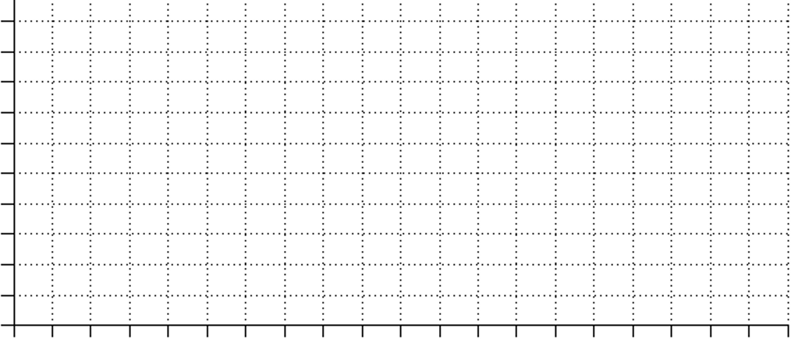

## POST-LAB QUESTIONS:

1. Why was sodium bicarbonate (NaHCO3) added to the solution? Why was detergent added to the solution?
2. Why did we keep Cup/Beaker C covered during the experiment? What did that change?
3. A mutation is capable of reducing the amount of chlorophyll in the leaf. Would this also reduce the rate of photosynthesis?
4. What about a plant that exhibits variegation… Do areas of the leaf with chlorophyll outperform areas that lack chlorophyll? Could you design an experiment to test this?
5. In this experiment, the amount of oxygen produced was observed to measure the rate of photosynthesis. What else could you measure to determine the rate of photosynthesis?
6. List any factors that you think may affect the rate of photosynthesis. Consider environmental factors that you could manipulate during the lab.

"Food is simply sunight in cold storage." ~John Harvey Kellog

## CREDITS AND ATTRIBUTIONS

["Leaf Disc Photosynthesis" by Dr. Ephanie DeBey is licensed under CC BY-SA 4.0 / A derivative from the original work.](https://creativecommons.org/licenses/by-sa/4.0/)



**Unsplash Photos:**

Photo by Ren Ran on Unsplash

Photo by Gwen Weustink on Unsplash Photo by Stefan Steinbauer on Unsplash Photo by Anthony Rossbach on Unsplash Photo by Victor Garcia on Unsplash

**Introduction and Photos** from CNX OpenStax is licensed under the Creative Commons Attribution 4.0 International license.

