## MITOSIS AND CYTOKINESIS LAB

Adapted from the lab by Dr. Leah Howell, Dalton State College

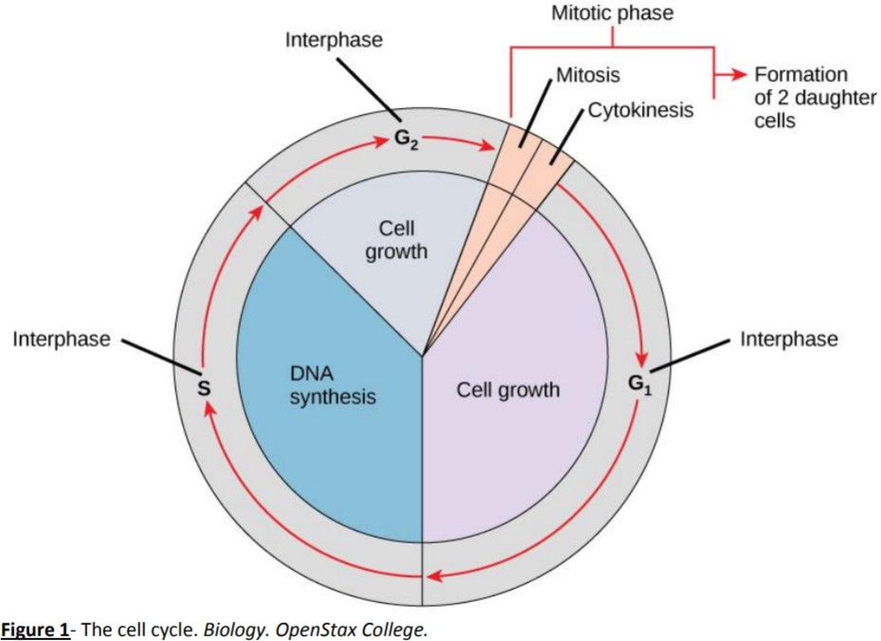

# Introduction

All cells come from preexisting cells, and eukaryotic cells must undergo mitosis in order to form new cells. The replication of a cell is part of the overall cell cycle (**Figure 1**) which is composed of interphase and M phase (mitotic phase). M phase, which consists of mitosis and cytokinesis, is the portion of the cell cycle where the cell divides, reproducing itself. Mitosis is the division of the nucleus and its contents. In mitosis, DNA which has been copied in S phase of interphase is separated into two individual copies. Each copy will end up in its own cell at the end of M phase.

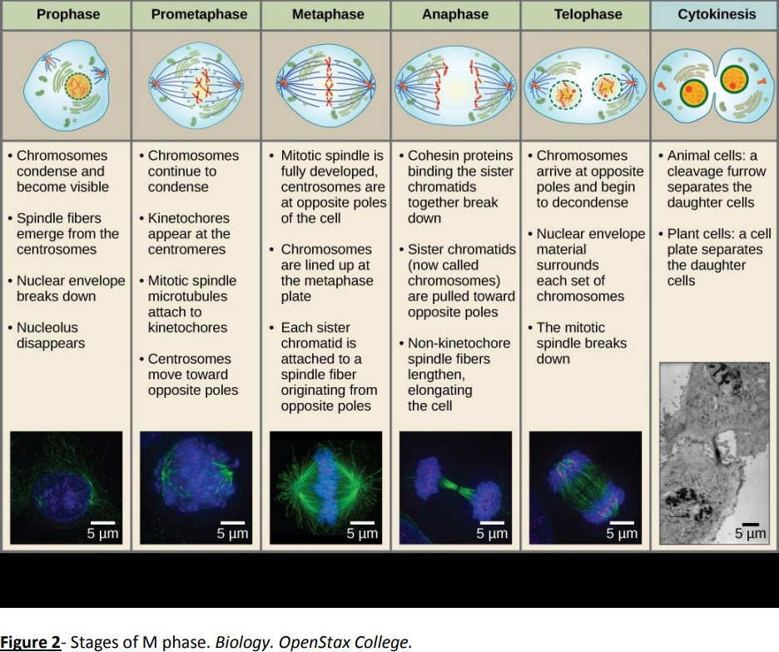

Mitosis has several steps: prophase, prometaphase, metaphase, anaphase, and telophase (**Figure 2**). The spindle fibers, which are formed by the cell as mitosis progresses, are used to attach to chromosomes, align them down the middle of the cell, and pull chromosomes apart into their identical individual chromatids which will end up in separate cells. As mitosis is nearing its end and the cell is in telophase, the cytoplasm also divides so that both new cells will have their own fluid, organelles, etc. This division of the cytoplasm is called cytokinesis. Mitosis and cytokinesis can be viewed under a microscope.

**EXERCISE 1 : SIMULATING MITOSIS USING BEADS**

**Materials** Plastic beads Strings

**Procedure**

1. Organize beads into “chromosomes” as shown in **Figure 4.**
2. Simulate the steps of interphase (specifically S phase) and then M phase using the beads. Hint: The chromosomes in **Figure 4** have not been through S phase yet, so you will eventually need more beads than are shown in **Figure 4.** The strings in the bag are used to simulate spindle fibers.

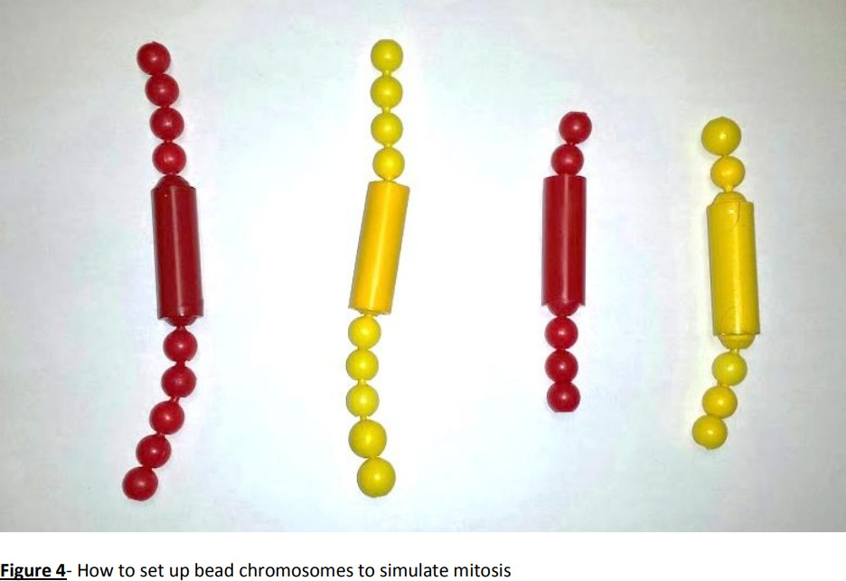

**EXERCISE 2: MITOSIS OF ONION ROOT TIP**

(Adapted from Cell Biology Laboratory Manual Online Dr. William H. Heidcamp, Biology Department, Gustavus Adolphus College, St. Peter, MN 56082 -- cellab@gac.edu)

**Materials**

Prepared slide of onion (allium) root tip Microscope

**Procedure**

* 1. Obtain a slide of allium root tip for observation of the stages of mitosis in a plant cell.
  2. Examine the slide under a microscope.
  3. Draw and label all stages of mitosis below. **Figure 3** can be used for help with this.

**Interphase Prophase Metaphase**

**Anaphase Telophase and Cytokinesis**

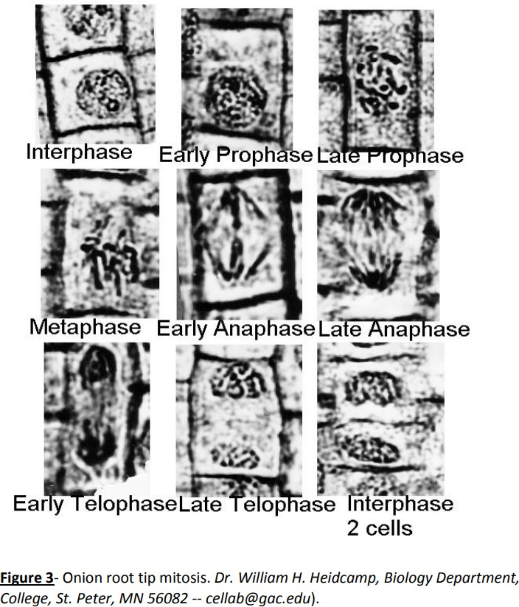

**EXERCISE 3: MITOSIS OF WHITEFISH BLASTULA**

(Adapted from Cell Biology Laboratory Manual Online Dr. William H. Heidcamp, Biology Department, Gustavus Adolphus College, St. Peter, MN 56082 -- cellab@gac.edu)

#### Materials

Prepared slide of whitefish blastula Microscope

**Procedure**

1. Obtain a slide of a whitefish blastula for observation of the stages of mitosis in an animal cell. Since early embryogenesis involves rapid cellular division, the whitefish blastula has long served as a model of mitotic division in animals. It also has the advantage of demonstrating clear spindle formation in the cytoplasm.
2. Examine the slide under a microscope.
3. Draw and label all stages of mitosis below.

**Interphase Prophase Metaphase**

**Anaphase Telophase and Cytokinesis**

**EXERCISE 4: MEIOSIS AND NON-DISJUNCTION EVENTS**

The nuclear division that forms haploid cells, which is called **meiosis**, is related to mitosis. As you have learned, mitosis is part of a cell reproduction cycle that results in identical daughter nuclei that are also genetically identical to the original parent nucleus. In mitosis, both the parent and the daughter nuclei contain the same number of chromosome sets—diploid for most plants and animals.

**Meiosis** employs many of the same mechanisms as mitosis. However, the starting nucleus is always diploid and the nuclei that result at the end of a meiotic cell division are haploid. To achieve the reduction in chromosome number, **meiosis** consists of one round of chromosome duplication and two rounds of nuclear division. Because the events that occur during each of the division stages are analogous to the events of mitosis, the same stage names are assigned.

However, because there are two rounds of division, the stages are designated with a “I” or “II.” Thus, **Meiosis I** is the first round of meiotic division and consists of

prophase I, prometaphase I, and so on. **Meiosis I** reduces the number of chromosome sets from two to one. The genetic information is also mixed during this division to create unique recombinant chromosomes. **Meiosis II**, in which the second round of meiotic division takes place in a way that is similar to mitosis, includes prophase II, prometaphase II, and so on.

<Chapter 7 OpenStax Concepts of Biology>

Failure of chromosomes to separate during mitosis or meiosis will result in an incorrect number of chromosomes in daughter cells.

This occurrence is known as **non-disjunction**, and it is often triggered by a lapse during a mitotic checkpoint. Should non-disjunction occur during meiosis, the resulting egg or sperm cell will have an incorrect number of chromosomes; if this sex cell is then fertilized, the fetus will have a chromosomal abnormality. The term given for having an incorrect number of chromosomes is **aneuploidy**.

A common type of aneuploidy is **trisomy**, which is when there are 3 copies of a particular chromosome instead of 2. Several common chromosomal abnormalities are listed in the table below. The most common trisomy that a human can survive is Down syndrome, which occurs at chromosome 21.

To diagnose a chromosomal abnormality, doctors use a map of the chromosomes known as a **karyotype**. Each chromosome pair is laid out side- by-side so it is relatively easy to determine if there are any irregularities.

Referring to the karyotype below, it is clear that each chromosome pair is present and of relatively equal length. Note that last chromosome pair (23) is labeled X/Y; these chromosomes are the only 2 that do not exactly match.

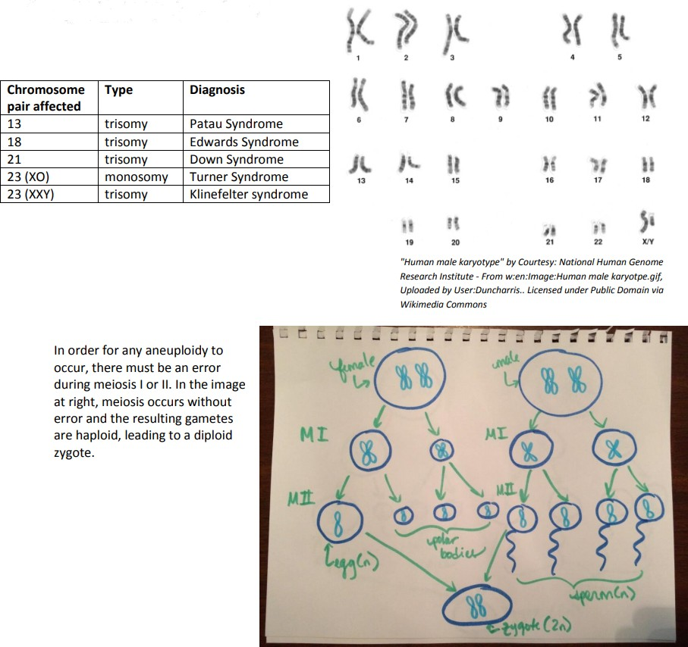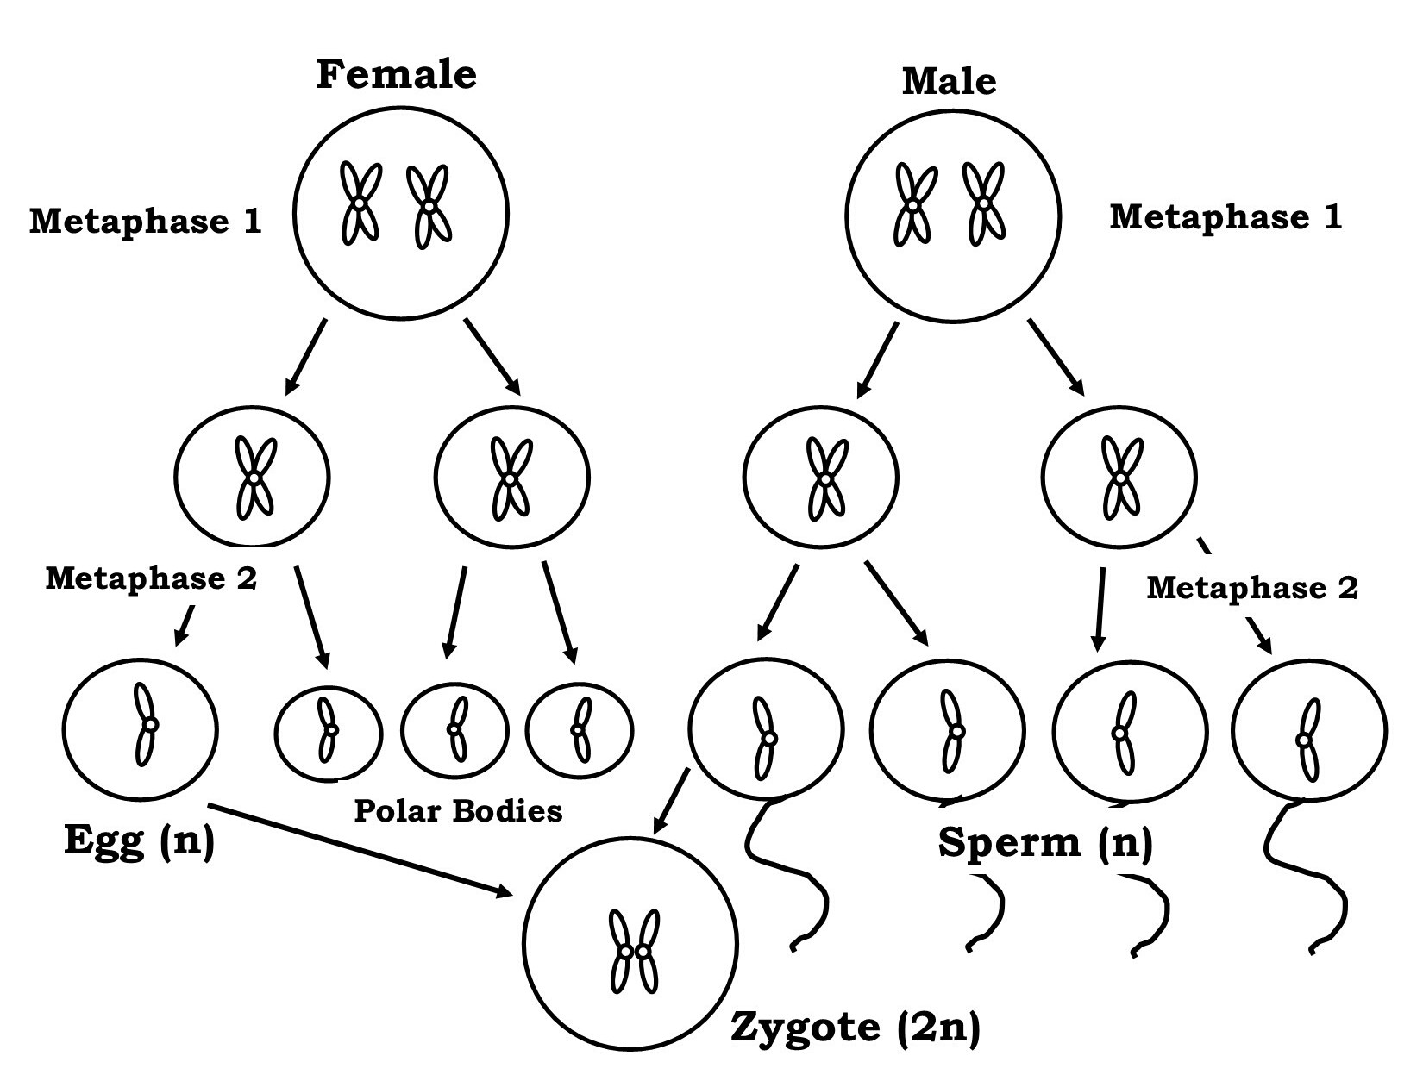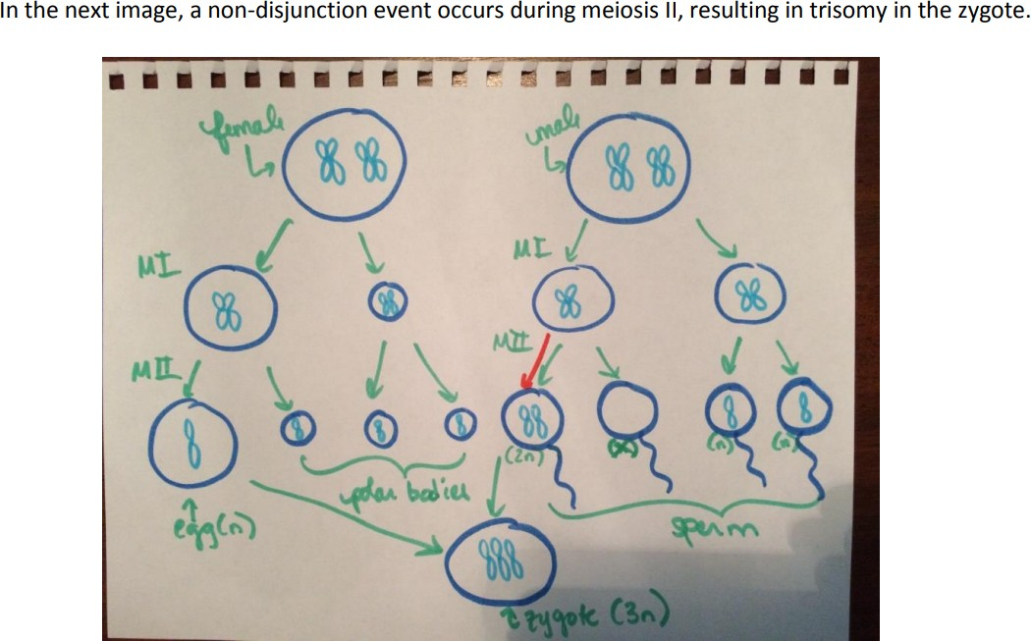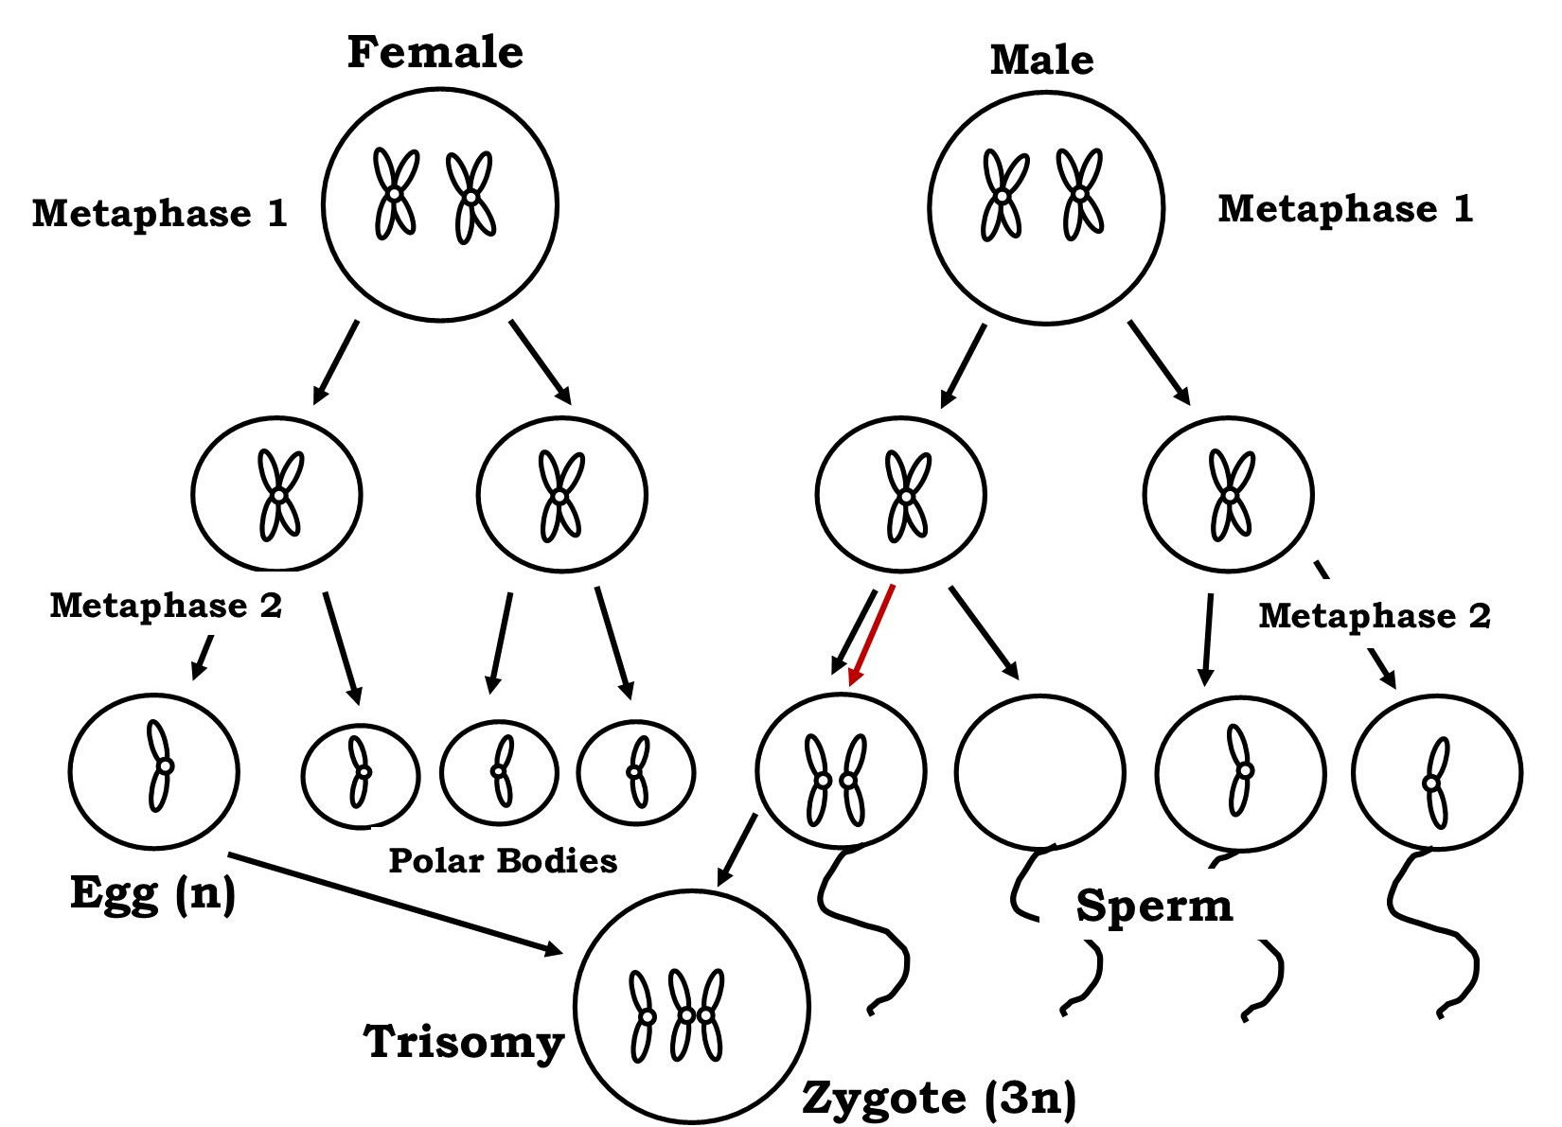

Animal **development** begins with **cleavage,** a series of mitotic cell divisions, of the zygote (Figure 27.3). Cleavage differs from somatic cell division in that the egg is subdivided by successive cleavages into smaller and smaller cells, with no actual cell growth. The cells resulting from subdivision of the material of the egg in this

way are called **blastomeres**. Three cell divisions transform the single-celled zygote into an eight-celled structure. After further cell division and rearrangement of existing cells, a solid morula is formed, followed by a hollow structure called

a **blastula**.

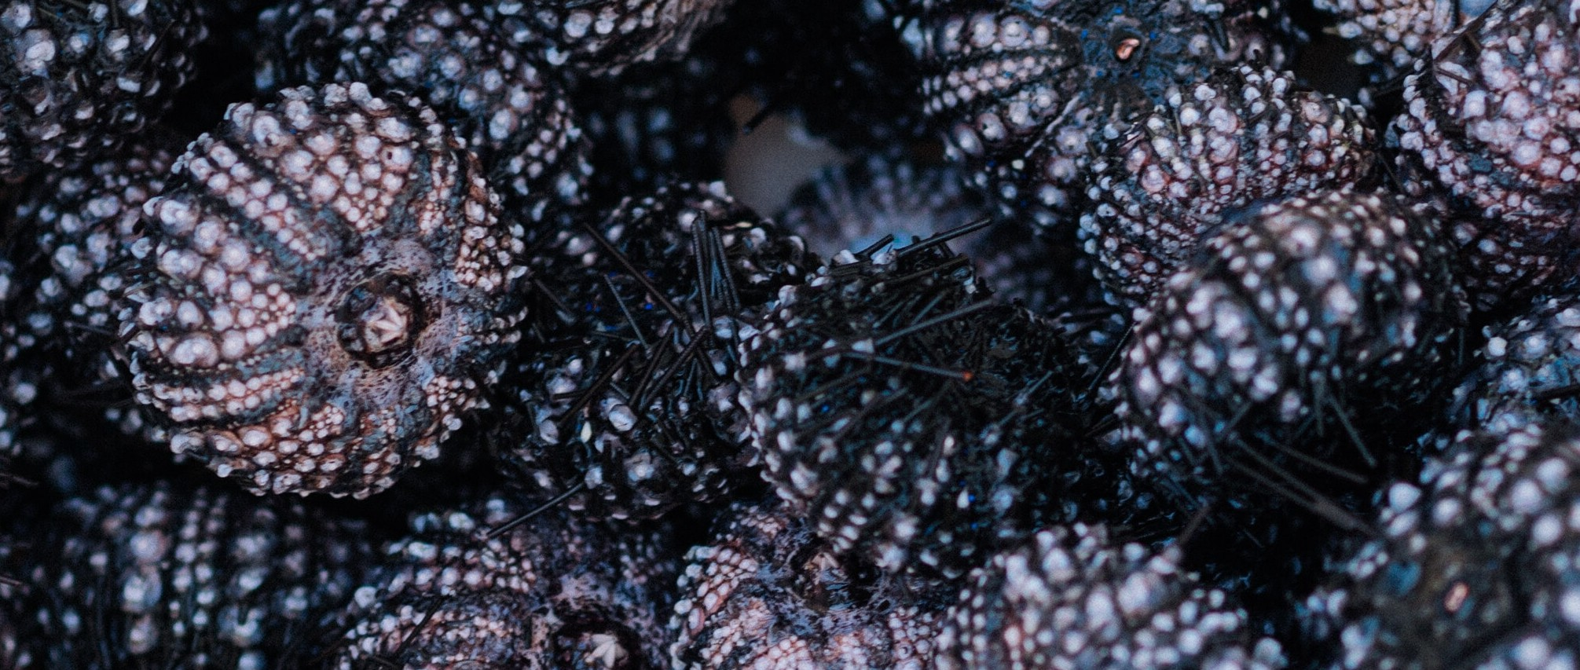

The blastula is hollow only in invertebrates whose eggs have relatively small amounts of yolk. In very yolky eggs of vertebrates, the yolk remains undivided, with most cells forming an embryonic layer on the surface of the yolk (imagine a chicken embryo growing over the egg’s yolk), which serve as food for the developing embryo.

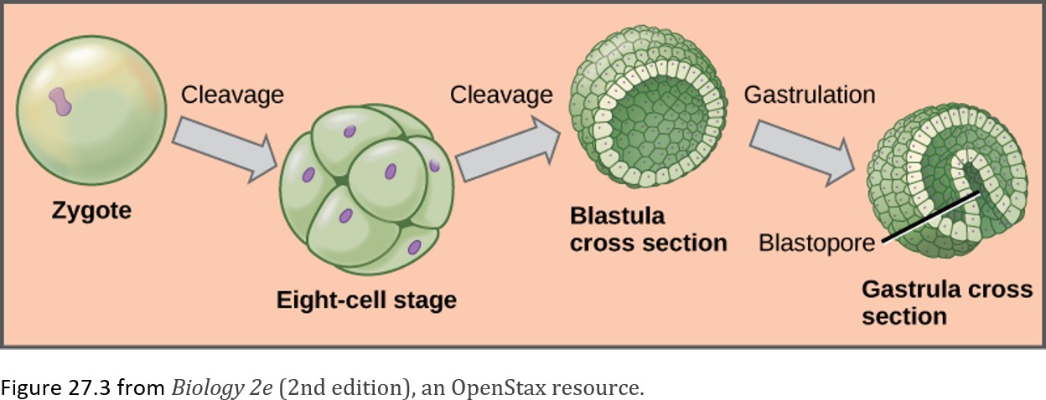

The blastula is hollow only in invertebrates whose eggs have relatively small amounts of yolk. In very yolky eggs of vertebrates, the yolk remains undivided, with most cells forming

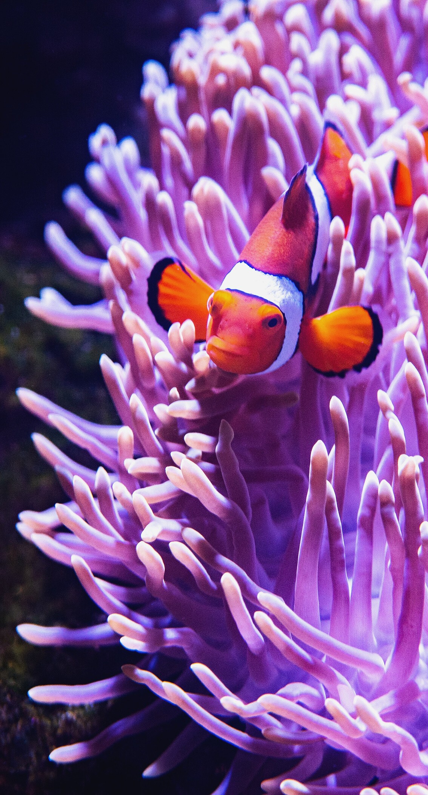an embryonic layer on the surface of the yolk (imagine a chicken embryo growing over the egg’s yolk), which serve as food for the developing embryo.

Further cell division and cellular rearrangement leads to a process called gastrulation.

**Gastrulation** results in two important events: the formation of the primitive gut (archenteron) or digestive cavity, and the formation of the embryonic germ layers, as we have discussed above. These germ layers are programmed to develop into certain tissue types, organs, and organ systems during a process

called **organogenesis.**

<Above from Chapter 27 in Biology 2e (2nd edition), an OpenStax resource>

**EXERCISE 4: ZYGOTE DEVELOPMENT**

#### Materials

Prepared slide of sea urchin development stages Microscope

**Procedure**

1. Obtain a slide of Sea Urchin Development for observation of the stages of mitosis in an animal cell during embryonic development.
2. Examine the slide under a microscope.
3. Draw and label all stages of mitosis in embryonic development below.

**Unfertilized Egg Fertilized Egg Early Cleavage**

2, 4, or 8 cells

# Blastula Gastrula

## POST LAB QUESTIONS:

##### Most nerve cells in the adult human central nervous system, as well as heart muscle cells, do not divide. In contrast, cells lining the inside of the small intestine divide frequently. Discuss this difference in terms of why damage to the nervous system and heart muscle cells (think stroke or heart attack) is so dangerous. What do you think might happen to tissues such as the intestinal lining if a disorder blocked mitotic cell division in all cells of the body?

1. **How do mitosis and cytokinesis differ?**
2. **Ultimately, is it the paternal or maternal gamete that determines sex? Explain.**
3. **In what way are the 23 pairs of human chromosomes “matched” pairs of chromosomes?**
4. **In order to make a karyotype, cell division is arrested at a point when the chromosomes have condensed and the nuclear envelope has disappeared, but before the sister chromatids separate. Which stage of the cell cycle would be a good point to perform a karyotype?**

*"Science knows no country, because knowledge belongs to humanity, and is the torch which illuminates the world." ~Louis Pasteur.*

##### Imagine you are an obstetrician and are performing early genetic testing on a 10 week old fetus. Below is the resulting karyotype. What can you tell about the fetus?

**What is the sex?**

**Are there any abnormalities? If so, where?**

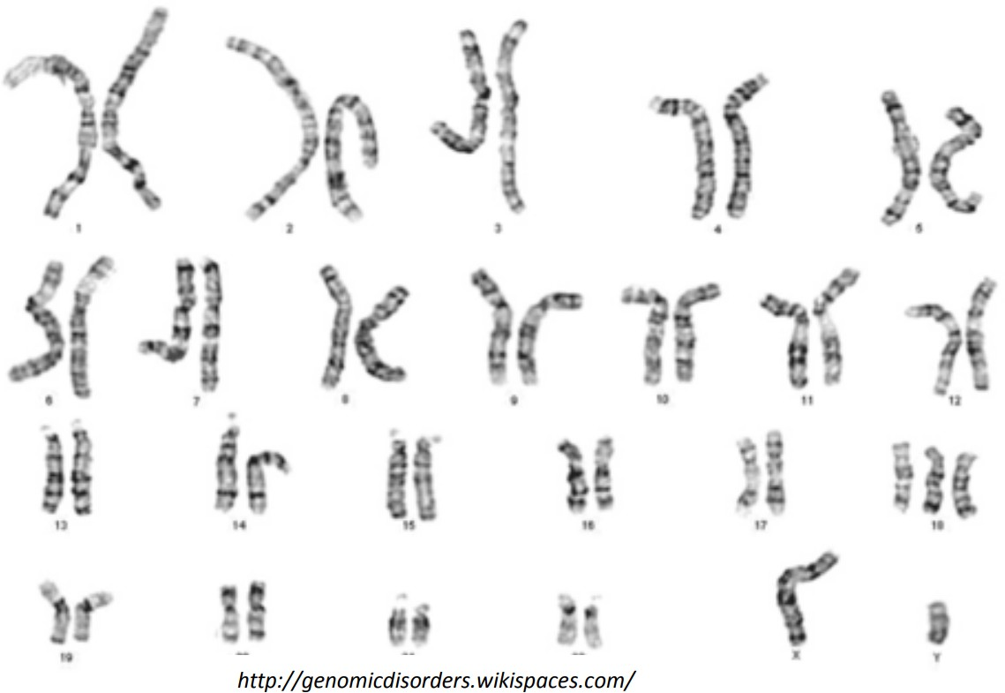

1. **Look up the prognosis for any chromosomal abnormalities you may have detected. What can the parents expect?**
2. **Use the space below to draw out meiotic divisions that could result in trisomy, assuming that the error occurred during meiosis I.**

*"Art is I; science is we..." ~ Claude Bernard*

## CREDITS AND ATTRIBUTIONS

["Mitosis and Cytokinesis Lab" by Dr. Leah Howell, Dalton State College is licensed under CC BY-SA 4.0 / A derivative from the original work](https://creativecommons.org/licenses/by-sa/4.0/)

["Mitosis and Cytokinesis Lab Exercise 4" by Dr. Ephanie DeBey, Tulsa Community College is licensed under CC BY-SA 4.0](https://creativecommons.org/licenses/by-sa/4.0/)



**Unsplash Photos:**

### https://unsplash.com/photos/Ok-KOqEwQjc Photo by Jorge Rosal on Unsplash

Photo by Scott Webb on Unsplash