# MICROSCOPES AND CELLS

**Introduction**

## THE DISSECTING MICROSCOPE

**Microscopy** is the technical field of using a **microscope** to observe samples and objects that are not within the resolution range of the normal human eye. A microscope magnifies (enlarges) the image of a specimen several times, depending on the type of magnifying lens used. As the name of the microscope implies, it can be used to do dissections and to look at objects that are too big to fit flat under a ***cover slip*** on a ***glass slide***.

Typically, the highest magnification is 40X, which is the lowest magnification available on the compound light microscope. Our dissecting microscopes can magnify an object 10X, this is still a significant amount of magnification over what you might see with your naked eye. Light allows for visualization of the specimen from above and from below, depending on the specimen and on the features you want to observe. The path of

light goes through two lenses housed in a protective canister: the ***objective lens*** (close to the object) and the ***ocular lens*** or ***eyepiece*** (close to the eye).

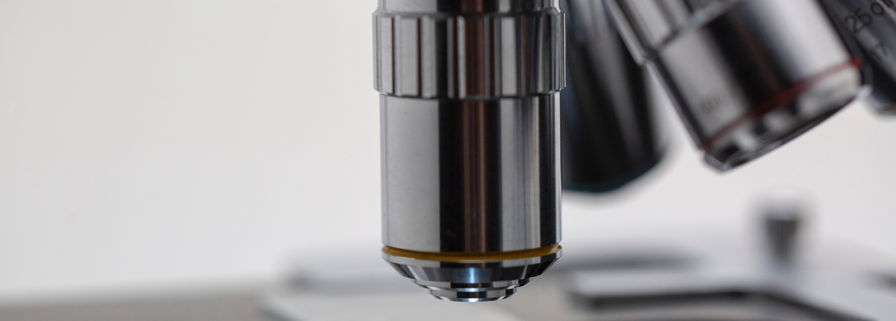

THE COMPOUND LIGHT MICROSCOPE

The compound light microscope has a much larger range of magnification than the dissecting microscope. However, by having an increase in magnification, you give up the depth of focus and the ability to manipulate the specimen. This type of microscope also depends on a light source to illuminate a thin enough specimen to allow light to pass through it; the image is then transmitted into your eye.

This microscope contains a compound set of two lenses, which magnifies the image and allows attaining a total magnification of over 1000X. The ocular lens typically has a magnification of 10X, your microscope has three objectives located on a revolving nosepiece: 4X, 10X, and 40X. The 4X objective is also called the ***scanning lens*** because it allows you to scan or search for the specimen you want to observe. This lens provides the broadest ***field of view*** (amount of area observed) because it has the largest aperture in the opening of the lens. As you increase the magnification, the aperture decreases and thus, the field of view also decreases; increasing magnification requires more light or ***illumination*** in order to better observe the specimen. Increasing the magnification of an image requires a higher ***resolution*** that is the ability to distinguish any two separate points. The maximum resolution with this type of microscope is reached at about 1400X. When calculating total magnification, use the following formula:

### Total magnification = (power of ocular) x (power of objective)

Example: What is the total magnification when using the scanning objective lens (4X)?

**Total magnification = (10X) (4X) = 40X**

CELLS

Cells are the fundamental unit of life. All living things are composed of cells. While there are several characteristics that are common to all cells, such as the presence of a cell membrane, cytoplasm, DNA and ribosomes, not all cells are the same. There are two types of cells, prokaryotic (Greek “before” and “kernel”, which means before true nucleus) and eukaryotic (Greek “good” and “kernel” which means true nucleus) cells. Organisms belonging to the domains Bacteria and Archaea are composed of prokaryotic cells, whereas organisms belonging to the domain Eukarya (protists, fungi, plants and animals) are composed of eukaryotic cells.

Prokaryotic cells are generally smaller than eukaryotic cells (about ten times smaller) and lack a nucleus and other membrane-bound organelles, whereas eukaryotic cells are compartmentalized by membrane-bound organelles with specialized functions, and the DNA is contained inside the nucleus. The cytoplasm is the region of the cell outside the nucleus. It contains fluid, ribosomes, the cytoskeleton, and, in eukaryotes, other membrane-bound organelles. The minute “powerplants" in the cytoplasm of cells are called mitochondria.

These organelles are roughly the size of many bacteria and can only be seen at higher magnifications in specially prepared slides. Plastids are organelles found in plants and algae. Some organic compounds are produced and stored in plastids. The green pigment, chlorophyll, is located in special photosynthetic plastids called chloroplasts. Other kinds of plastids include chromoplasts, which contain pigments other than chlorophyll, and amyloplasts which store starch.

The central vacuole often occupies a large space within the cytoplasm of plant cells, but may be small or absent in other types of cells. Often, other organelles found in plant cells are located adjacent to the plasma membrane because the central vacuole takes up so much space within the cell.

Under healthy conditions for plant cells, the central vacuole is large and produces turgor pressure against the cell wall, which is located outside the cell membrane. The cell wall keeps plant cells from bursting. Some other cells also have cell walls, but they are generally made of different materials. Plant cell walls are made of cellulose, while bacteria have cell walls made of peptidoglycan and fungi have cell walls made of chitin.

Archaea and algae also have cell walls made of various compounds.

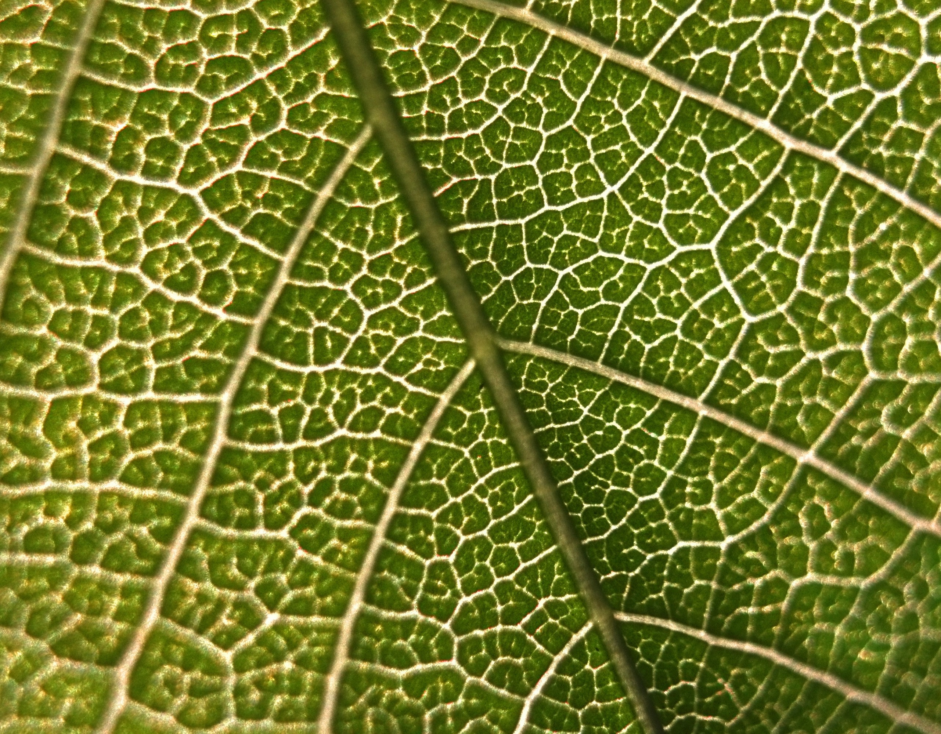

## PROTISTA

The kingdom “Protista” is an artificial grouping of organisms and include members that are unicellular, colonial and multicellular; examples: Paramecia (a), Amoeba (b), Euglena (c) and kelp. Amoebas move using extended projections called pseudopodia. These structures can also be used to engulf food in a process called phagocytosis. Euglena is a genus characterized by having a flagellum (pl. flagella), it is a long, thin, whip-like projection that is used for locomotion. This genus can be both autotrophic and heterotrophic. These cells contain chloroplasts for photosynthesis

and they may also engulf food by phagocytosis when light s not available. Paramecia contain hair-like structures for movement called cilia and they get their nutrients through phagocytosis.

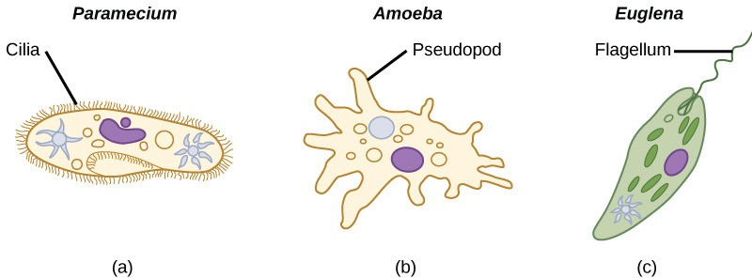

# PRE-LAB QUESTIONS

1. Calculate the total magnification using the 10X and the 40X objectives:
2. (10X ocular)(10X objective) = _________
3. (10X ocular)(40X objective) = _________
4. Circle the objective that produces the smallest field of view:

**4X / 10X / 40X**

1. List three similarities and three differences between prokaryotic and eukaryotic cells.

Similarities:

Differences:

1. Which domains contain organisms composed of prokaryotic cells?

**LAB EXERCISE**

# MATERIALS

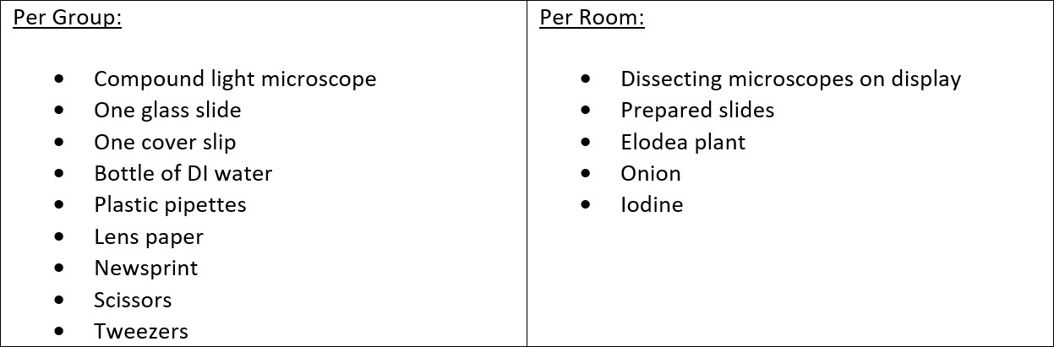

**PROCEDURE: IDENTIFYING THE PARTS OF THE MICROSCOPE**

1. Obtain a compound light microscope from the shelf or drawer by holding it with both hands: one from the arm and the other one under the base.
2. Carefully, place the microscope on the table with the arm away from you. Do not drag the microscope on the table, lift it up and place it where you need it (lenses may come lose and fall off).
3. Identify the parts of the compound light microscope and determine their function, as explained by your instructor.
4. Complete the diagram on the following page.

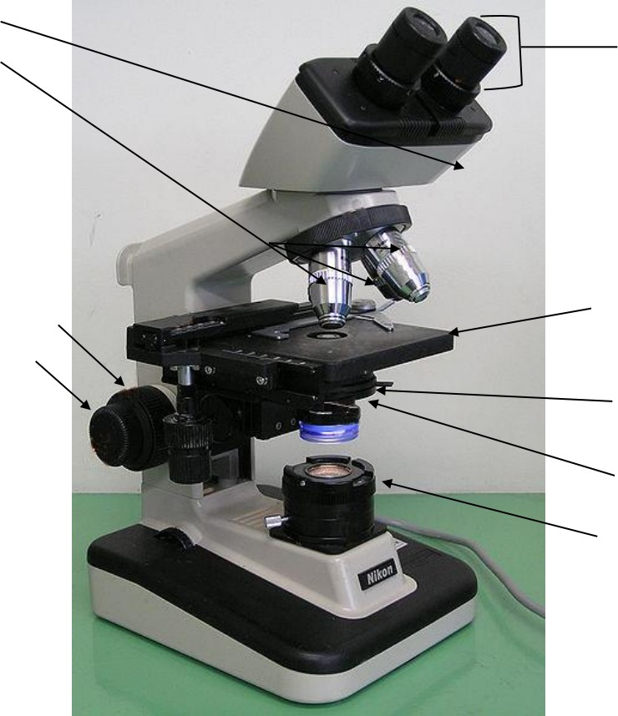

**Label the parts of the microscope from the following bank below:**

**Condenser Objectives**

**Fine focus knob Iris Diaphragm Nose piece**

**Ocular**

**Coarse focus knob Illuminator Mechanical stage**

**Caring for the Microscope**

1. Ocular and objective lenses may be wiped clean only with lens paper, never use a paper towel as this may scratch the lens. Do NOT touch the lenses, body oils may also damage the lens.
2. Preparing a Wet Mount:
3. Most specimens must be killed, fixed, sectioned, and stained for microscopy.
4. Place a drop of the sample in the center of the microscope slide. If the specimen is not in water, place a small, thin section of the specimen on the slide and add a drop of water on top of it.
5. Place a coverslip over the drop of sample by positioning its edge onto the slide to one side of the drop and then lowering the coverslip slowly over the specimen. Do this slowly to avoid excess bubbles; however, if you get a couple of bubbles, be aware not to confuse them with your cells, a bubble looks like a perfect circle with a dark circumference.
6. Follow the steps for scanning your specimen and switch to a higher power as needed.
7. Determining orientation and the depth of focus:
   1. Plug in the microscope and turn the light switch on.
   2. Add letter “e” slide: Place the slide with the letter “e” on the stage and secure it using the stage clip.
   3. By rotating the revolving nosepiece, allow the smallest objective to click into position for viewing.
   4. Using the condenser height adjustment knob, make sure the condenser is all the way up under the stage.
   5. While looking at the stage, carefully turn the coarse adjustment knob to bring the stage up until it stops.
   6. While viewing down through the oculars, slowly turn the coarse adjustment knob away from you to bring the stage down until you see the letter “e” clearly.
   7. 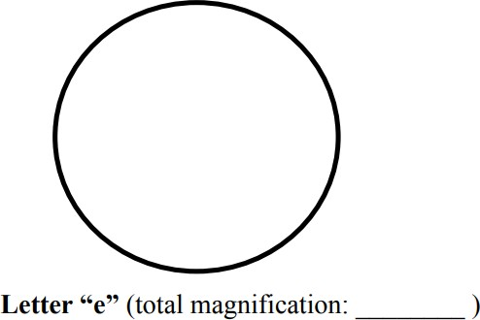Using the specimen holder knobs, move the letter “e” to the center of the field of view.
   8. Fine focus your image by until the image is clear to your eyes. Sketch the orientation of the letter “e” as you observe it under the microscope.

While looking AT YOUR OBJECTIVE LENSES, rotate the revolving nosepiece slowly while making sure the objective lens is not touching the surface of the cover slip, then, click it into position. NOTE: If it seems like the objective will touch the slide, STOP and return to observing the object under the lower magnification. Use only the fine focus knob to find the clearest image of your specimen.

NEVER use the coarse adjustment knob when working with higher magnification lenses as you may scratch or crash the lens with the slide. Higher magnification will require higher illumination, you may also open or close the diaphragm of the condenser using the aperture iris diaphragm lever to change the contrast of your specimen, notice the different features you can observe under differing lighting conditions.



# CELL VIEWING AND SKETCHING

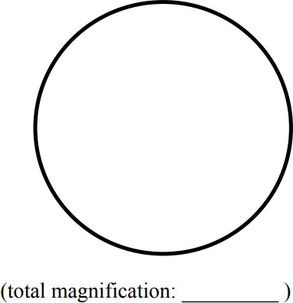Bacteria:

Protist:

Protist:

**Plant Cells**

Most plants (except parasitic plants) use light as an energy source in a process called photosynthesis. Plants cells contain three unique organelles not found in animal cells: a **cell wall** provides a rigid structure (often cube or rectangular shape), **chloroplasts** performed photosynthesis (transformation of sunlight to glucose), and **central vacuole**, which stores water, starch, pigments or toxins.

*Elodea* cells

Make a wet mount of an Elodea leaf with the upper side of the leaf facing up and view under 100X and 400X total magnification and record your results below.

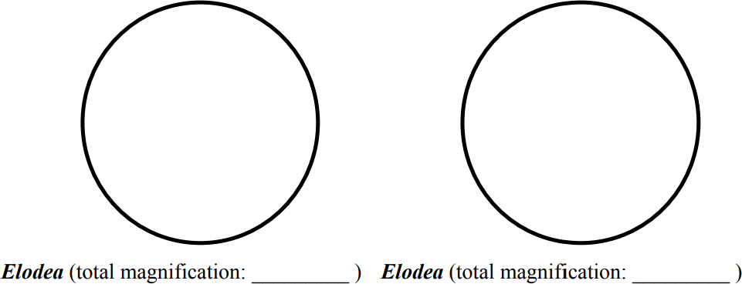

1. What color are the cells?
2. Do you see any chloroplasts? .
3. If you do, do you see any movement of the chloroplasts? .
4. Why do you think this might occur?
5. Can you determine where the central vacuole is? (Think about the location of the other organelles if a central vacuole is present)
6. Where do you think the pigments are located in the cells?

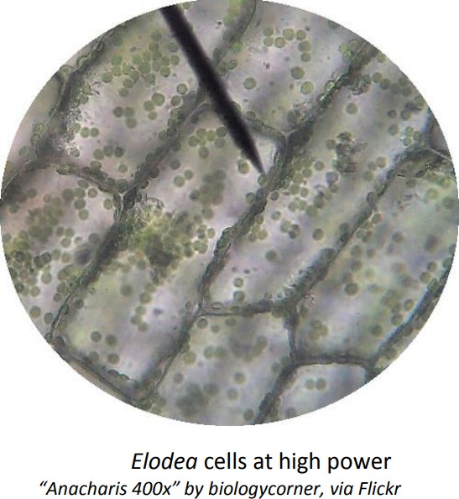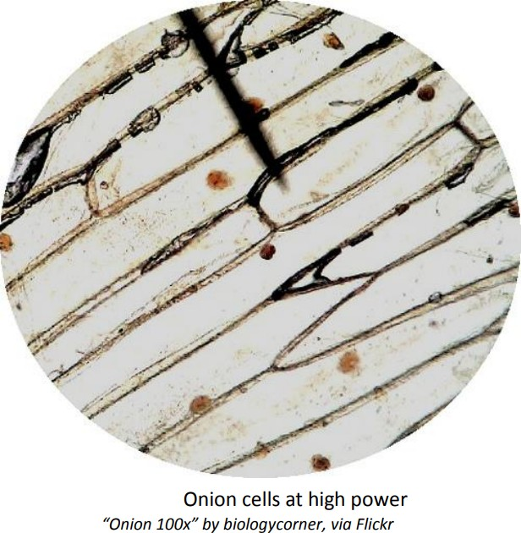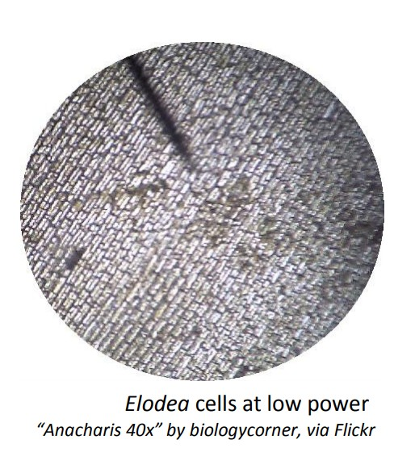

Onion cells

Make a wet mount of an onion and view under 100X and 400X total magnification (see “B. Procedure: Scan your specimen; Move to a higher power” above) and record your results below.

1. What color are the cells?
2. Do you see any chloroplasts? .
3. If you do, do you see any movement of the chloroplasts? .
4. Why do you think this might occur?
5. Can you determine where the central vacuole is? (Think about the location of the other organelles if a central vacuole is present)
6. Where do you think the pigments are located in the cells?

**Animal Cells**

Animals are eukaryotic, multicellular organisms which obtain their energy from feeding on other organisms or organic materials. Some animals are mobile (move) whereas others are sessile (don’t move). They do not photosynthesize and therefore do not possess chloroplasts. They also lack cell wall and central vacuole that plant cells have. You may be provided 3 types of animal cells.

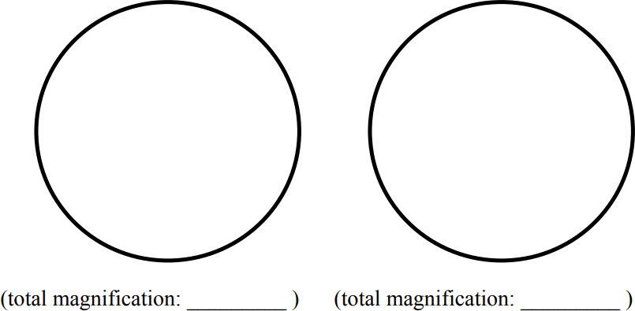

Provide 3 ways how you can differentiate between a plant cell and an animal cell as viewed under the microscope:

1)

2)

3)

**Storage of the Microscope**

1. Turn off the light switch.
2. Remove the slide and reposition the slide mount arm so that it does not extend out past the stage.
3. Turn the revolving nosepiece to the lowest objective or to no objective.
4. Bring the stage down using the coarse adjustment knob.
5. Carefully unplug the cord, wrap it around itself and place it next to the base of the microscope. Do not wrap the cord around the base of the microscope or insert the wrapped cord under the stage.
6. Cover the microscope with the bag and place the microscope in its correct, numbered spot in the cabinet with the arm of the microscope facing out.

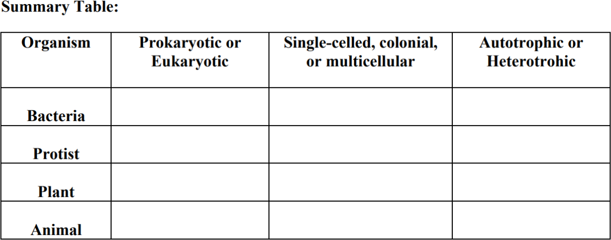

# POST-LAB QUESTIONS:

1. Define the following terms:
2. Resolution:
3. Field of view:
4. What is the total magnification when using the 40X objective? Show your work.
5. Provide the 4 first steps to properly store the microscope away: 1)

2)

3)

4)

4. Use the following table to contrast prokaryotic versus eukaryotic cells:

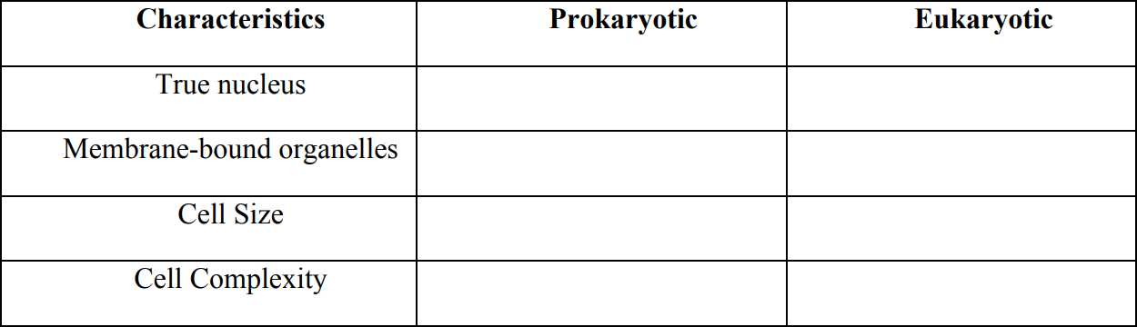

1. Calculate the number of cells in 10 ml of a pond sample. The number of cells per drop is 25 cells (use your known number of drops of water per ml). Show your work.
2. What are the three ways of locomotion of protist cells? 1)

2)

3)

1. Provide the domain for the following cells: Bacteria:_______________________________________________________

Protist:__________________________________________

Animal & plant:_________________________________________________

1. Name the three organelles found only in plant cells and not in animal cells.

1)

2)

3)

1. Compare the sizes of bacterial, protist, plant, and animal cells by drawing a simple sketch in the fields of view provided.

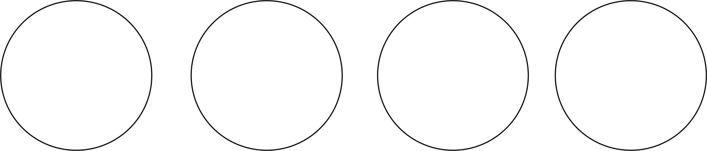

### Bacteria Protist Plant Animal

1. What are the functions of the following organelles?

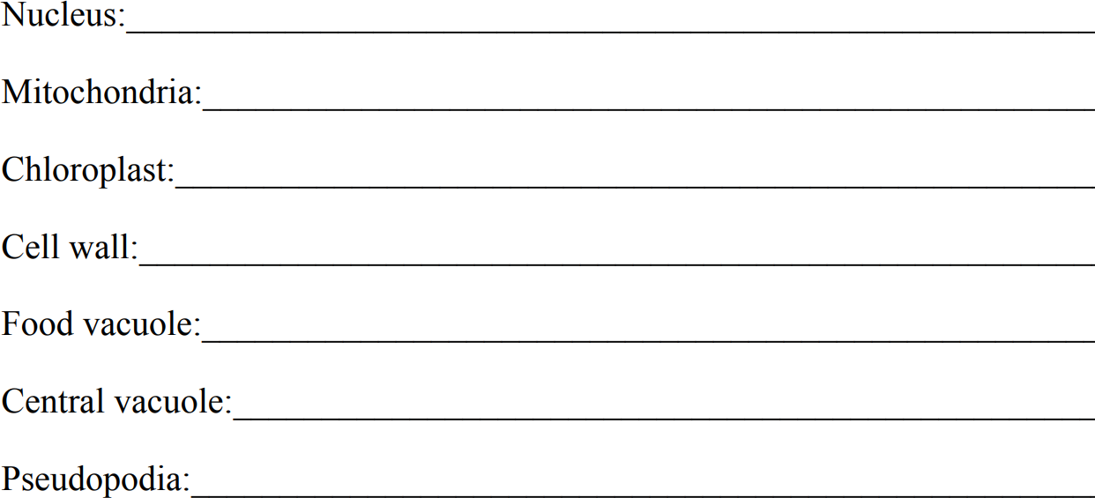

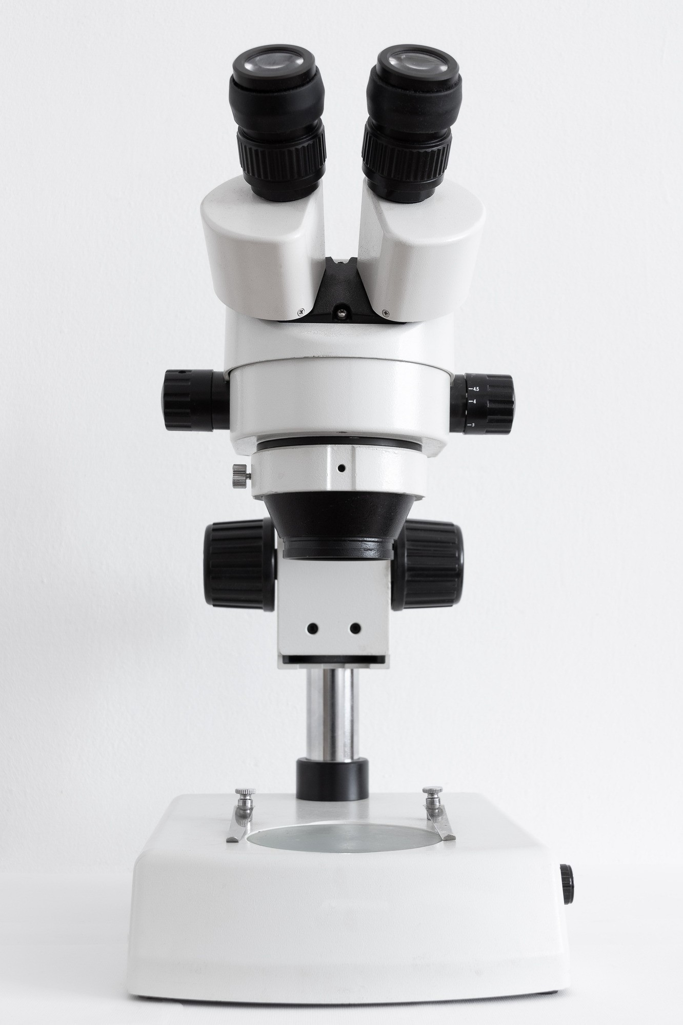

*“By ‘life,’ we mean a thing that can nourish itself and grow and decay.”~Aristotle*

# CREDITS AND ATTRIBUTIONS

[Introduction: Adapted from Washington State Open Course Library: http://opencourselibrary.org/](https://creativecommons.org/licenses/by-sa/4.0/)

[This lab is adapted from Microscopes and Cells from College of the Canyons and licensed under a Creative Commons Attribution 4.0 International License. This is a derivative work.](https://creativecommons.org/licenses/by-sa/4.0/)



Unsplash Photos:

Photo by Paweł Czerwiński on Unsplash https://unsplash.com/photos/Ok-KOqEwQjc Photo by Vadim Gromov on Unsplash

Photo: Paramecium, Amoeba, Eugleana from CNX OpenStax is licensed under the Creative Commons Attribution 4.0 International license.



Additional photos from: "Principles of Biology I Lab Manual " by Dalton State College is licensed under CC BY 4.0

