# MACROMOLECULES AND NUTRITION

**Introduction**

In an age where we have unlimited access to a wealth of information at our fingertips (literally), the challenge we are faced with is making sense of that information and evaluating the accuracy of it. Nutritional information is a good example of this.

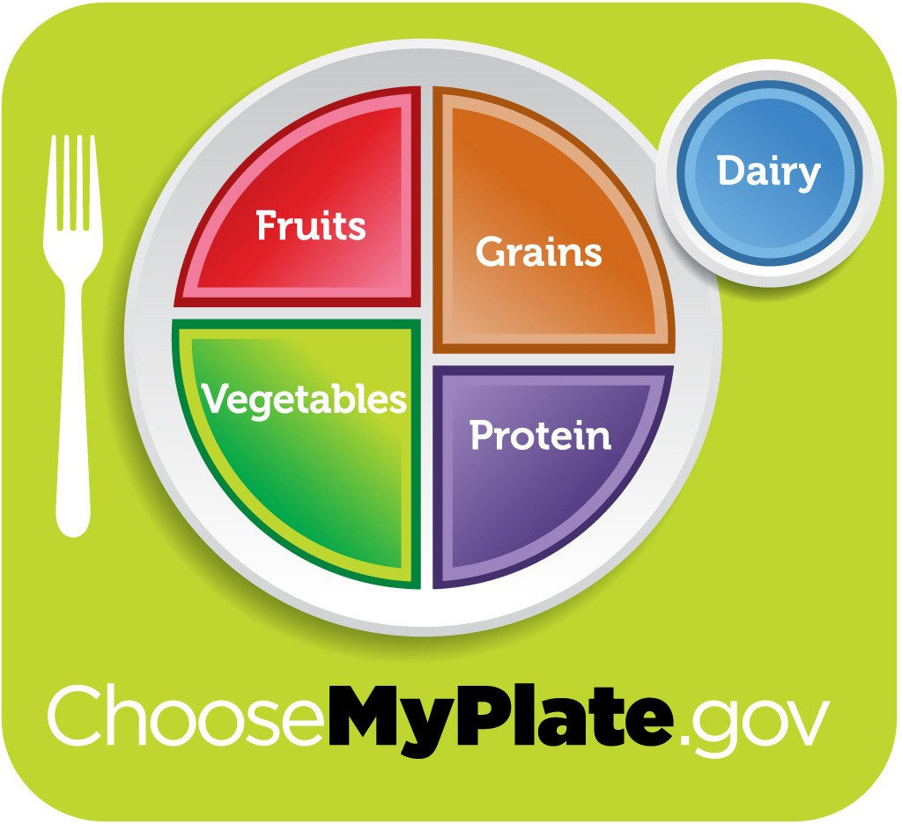

Image reproduced courtesy of U.S. Dept. of Agriculture

Every day we are bombarded by news organizations, health magazines, self-help books and food company advertisements, all trying to tell us what to eat and what to avoid, what is the latest fad for losing weight, what is part of “a healthy breakfast”, etc. In order to evaluate these claims objectively, it is essential to have an understanding of the basic chemistry of biological macromolecules and human nutritional requirements.

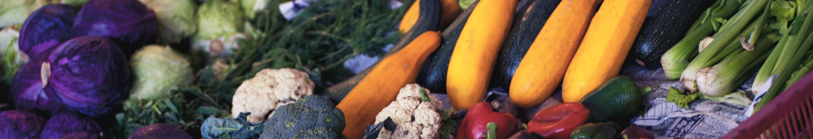

**MACROMOLECULES**

Macromolecules are very large molecules, formed of smaller subunits. In this lab, we will focus on the three macromolecules that are important energy sources for biological organisms: carbohydrates, proteins and fats.



CARBOHYDRATES

A carbohydrate is an organic compound that consists only of carbon, hydrogen, and oxygen. Your body uses carbohydrates (carbs) to make glucose, which is the fuel that gives you energy and helps keep everything going. Your body can use glucose immediately or store it in your liver and muscles for when it is needed.

In general, the smaller carbohydrate compounds are commonly referred to as sugars, which are found naturally in foods such as fruits, vegetables, milk, and milk products. Simple carbohydrates also include sugars added during food processing and refining.

Starch and dietary fiber are the two types of complex carbohydrates. Starch must be broken down through digestion before your body can use it as a glucose source. Quite a few foods contain starch and dietary fiber such as breads, cereals, and vegetables.

## PROTEINS

Proteins are part of every cell, tissue, and organ in our bodies. These body proteins are constantly being broken down and replaced. The protein in the foods we eat is digested into amino acids that are later used to replace these proteins in our bodies.

Protein is mainly found in the following foods: meats, poultry, and fish, legumes (dry beans and peas), tofu, eggs, nuts and seeds, milk and milk products, and grains. Most adults in the United States get more than enough protein to meet their needs. It is rare for someone who is healthy and eating a varied diet to not get enough protein. There are 20 different amino acids that join together to make all types of protein.

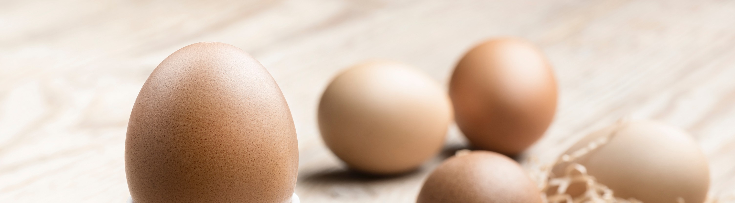Our bodies cannot make some of these amino acids so these are known as *essential* amino acids – it is essential that our diet provide these. A complete protein source is one that provides all of the essential amino acids, for example, meat, poultry, fish, milk, eggs, and cheese are considered complete protein sources. An incomplete protein source is one that is low in one or more of the essential amino acids. Complementary proteins are two or more incomplete protein sources that together provide adequate amounts of all the essential amino acids (e.g. rice and beans).

## FATS

Although the term ***lipid*** is sometimes used as a synonym for ***fats***, fats are actually a subgroup of lipids composed of triglycerides. Moreover, triglycerides that are solid at room temperature are often called ***fats*** while those that remain liquid at room temperature are called **“*oils.*”** Triglycerides are also composed of carbon, hydrogen and oxygen atoms, but in different ratios than in carbohydrates. Triglycerides have long chains of carbon and hydrogen bonds, which creates the hydrophobic tail. This property prevents triglycerides from mixing readily with water and causes them to separate relatively easily in solution, a property that we will utilize in our experiment today.

## UNSATURATED FATS, SATURATED FATS AND TRANS FATS

Most of the fat that you eat should come from unsaturated sources: polyunsaturated fats and monounsaturated fats. In general, nuts, vegetable oils, and fish are sources of unsaturated fats.

Polyunsaturated fats can also be broken down into two types: ***Omega-6 polyunsaturated fats***: these fats provide an essential fatty acid that our bodies need, but can't make (e.g. soybean oil, corn oil and safflower oil).

***Omega-3 polyunsaturated fats***: these fats also provide an essential fatty acid that our bodies need (e.g. soybean oil, canola oil, walnuts, flaxseed and fish). In addition, omega-3 fatty acids, particularly from fish sources, may have potential health benefits.

Saturated fats are oftentimes the "solid" fats, but other saturated fats can be more difficult to see in the foods we consume. In general, saturated fat can be found in the following foods: high-fat cheeses, high-fat cuts of meat, whole-fat milk and cream, butter, ice cream and palm and coconut oils. Although animal fats are the primary source of saturated fat, palm and coconut oils, and cocoa butter are also important sources of saturate fat, and these are often added to commercially-prepared foods, such as cookies, cakes, doughnuts, and pies. Solid vegetable shortening often contains palm oils and some whipped dessert toppings contain coconut oil.

Trans fats have received a lot of media attention recently. Consuming trans fat can increase the amount of “bad" cholesterol in the body and may also have other adverse health effects like decreasing the amount of "good" cholesterol. The most common types of trans fats are found in foods that contain partially hydrogenated oil. Food manufacturers use artificial trans fat in food products because it is inexpensive and it increases the food’s shelf life, stability, and texture. Major contributors to artificial trans fat intake include fried items, savory snacks (like microwave popcorn), frozen pizzas, cake, cookies, pie, margarines and spreads, ready-to-use frosting, and coffee creamers .

# FOOD CALORIES

When speaking of the energy content of a macromolecule we often refer to calories or Calories. There is a big difference between discussing "calories" and "Calories." A calorie is defined as the amount of heat needed to raise the temperature of 1g of water by 1°C.

This is how a physicist would describe a calorie. Nutritionists measure the amount of energy in food in Calories (with a capital letter "C'), which is equivalent to 1 kcal or 1000 calories (lower case "c"). The amount of Calories per gram of each macromolecule is listed below.

### 1 gram of carbohydrate = 4 Calories 1 gram of protein = 4 Calories

**1 gram of fat = 9 Calories**

You can see from the values above that one gram of fat contains more than double the amount of energy as a gram of carbohydrate or protein. By analyzing nutrition labels, it is possible to calculate the amount of Calories that each macromolecule contributes by multiplying the number of grams by the Caloric value. You can also calculate the % Calories by dividing the Calories from each macromolecule by the total Calories.

### Example: A candy bar contains 5g of carbohydrate, 4g of Protein and 2g of Fat. The Calories contributed by each macromolecule:

**Carbohydrate: 5g x 4 Cal = 20 Calories Protein: 4g x 4 Cal = 16 Calories**

**Fat: 2g x 9 Cal = 18 Calories Total: 20 + 16 + 18 = 54 Calories**

**% Calories from Carbohydrate: (20/54) x 100 = 37%**

**% Calories from Protein: (16/54) x 100 = 30%**

**% Calories from Fat: (18/54) x 100 = 33%**

The Nutrition Facts label is designed to give consumers important nutritional information about a product and allow comparisons with other food. The serving size indicates the amount of food that the nutrition information applies to.

However, the label is not meant for direct comparison with the Food Pyramid's recommended servings. For example, a serving of milk may be 1 cup on the Food Pyramid, but 1/2 cup on the nutrition facts label. Also, a serving size according to a package may bear little resemblance to the amount of the food that most people eat at a time.

When doing Calorie calculations using the Nutrition Facts label, it is important to also look at the serving size. For example, a bag of chips may be 2 servings, so to calculate the total and % calories for the entire bag (if that is what is being asked in the question), you will need to multiply the values by 2.

# CHEMICAL ANALYSIS OF FOOD

The presence of various biological macromolecules can be determined using the following tests:

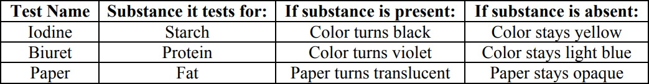

# INFORMATION ADAPTED FROM:

Centers For Disease Control and Prevention: Nutrition For Everyone <http://www.cdc.gov/nutrition/everyone/index.html>

**PRE-LAB QUESTIONS**

1. a) List the three types of macromolecules that provide energy for biological organisms.

b) How much energy is provided by each type of macromolecule?

1. A package of peanut butter crackers contains 7g of fat, 16g of carbohydrates and 4g of protein.
2. Calculate the Calories from each macromolecule. (Show your work.)
3. Calculate the % Calories for each macromolecule. (Show your work.)
4. An unknown food item is tested using Iodine, Biuret and paper. The results are listed below. Fill in the table with the required information.

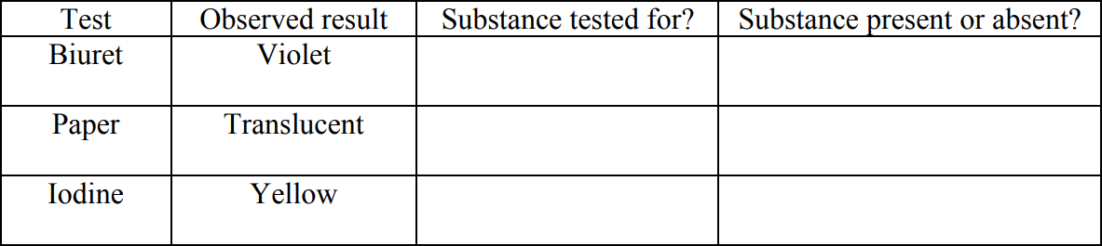

1. During the week prior to this lab, you will choose two different meals and record what you ate for each meal and how much. If you choose a restaurant meal or packaged food, you should record the nutritional information that is posted. If you choose a home-cooked meal, you should record the approximate amount of each food and drink item you consumed.

During the lab, you will be asked to calculate the total and % Calories of the meals you have recorded. *Note: If possible, bring in the empty, cleaned food containers (or photos of them) and/or restaurant nutritional information pamphlets with you to lab.* You may also use the following website to help keep track of your meals: https://cronometer.com/

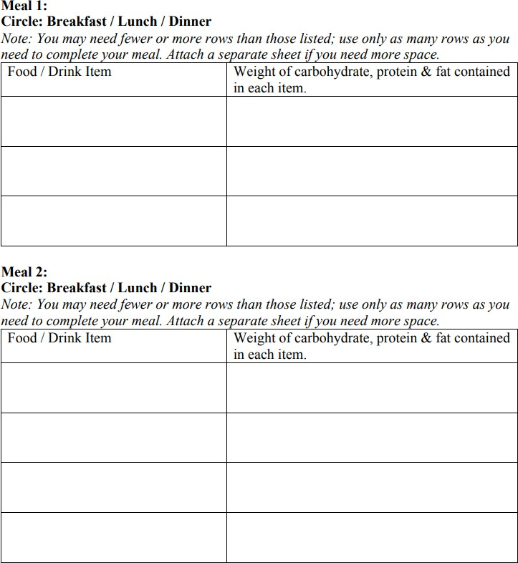

**LAB EXERCISE**

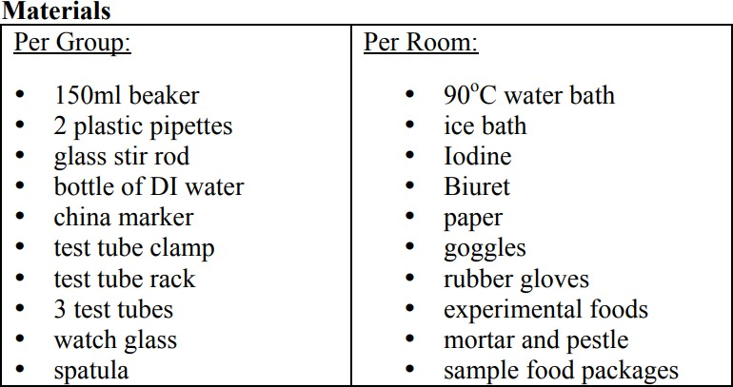

# PROCEDURE: CHEMICAL ANALYSIS OF SAMPLE FOOD

* 1. Fill approx. 1/3 of one of your test tubes with a sample food item that is available. If the food is in solid form (i.e. cookies), you will need to grind it to a very fine powder using a mortar and pestle, add water to it and mix it well.
  2. Label the test tube with your group name and place it in the 90°C water bath for 15 min.
  3. Prior to conducting your experiment, formulate a hypothesis about which macromolecules you would expect to find in your chosen food substance. Record your hypothesis in the table below.
  4. Remove the test tube and observe the layers. There may be a distinct top, yellowish layer and a bottom layer, or there may be just a single layer. The bottom layer may contain solid precipitate (i.e. cookie crumbs). One of the layers may be a liquid and the other one a solid. Write or draw your observation of the layers in the data section of Table 1.
  5. **Paper test:** Remove 2 drops from the top of the solution, place it onto a piece of paper and rub it in. Observe and record whether the paper remains opaque or turns translucent.
  6. **Iodine test:** Place 2 drops of the solution into a clean test tube. Add 2 drops of iodine to it and mix well. Observe and record whether the solution remains yellow or turns black.
  7. 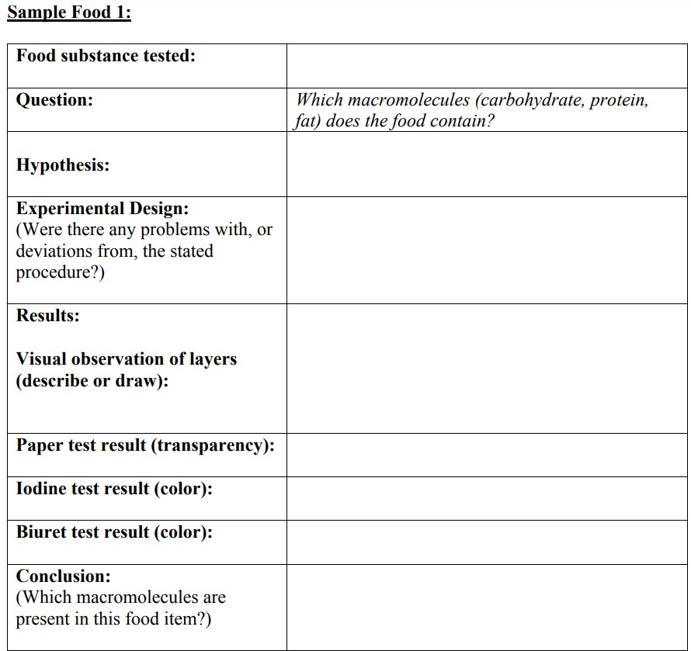**Biuret test:** Place 2 drops of the solution on to a watch glass. Add 2 drops of Biuret to it and mix well. Wait 5 min. and record whether the solution remains light blue or turns violet. Note: the color change may be subtle; for best results observe the solution against a white background.
  8. After completing the data table for sample food 1, answer the following:

1. Were there any results that surprised you? If yes, what might be the reason behind your observed result?
2. Were there any results that confused you? What additional tests could you conduct to clarify your results?
   1. After analyzing sample food 1, wash all your glassware and repeat steps 1-8 for sample food 2. Wask all of your glassware when you are finsihed.

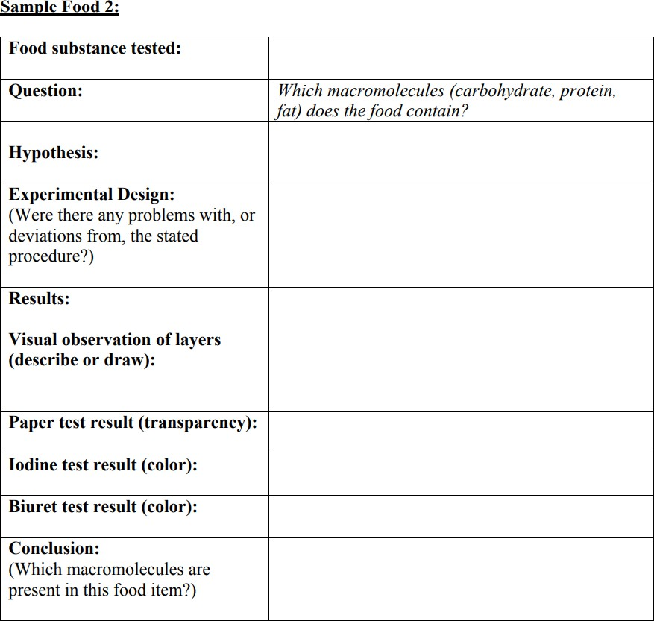

* 1. After completing the data table for sample food 2, answer the following questions:

1. Were there any results that surprised you? If yes, what might be the reason behind your observed result?
2. Were there any results that confused you? What additional tests could you conduct to clarify your results?

**ANALYSIS OF A DIET:**

Using your food log from the pre-lab questions section, complete the following table for each of your meals.

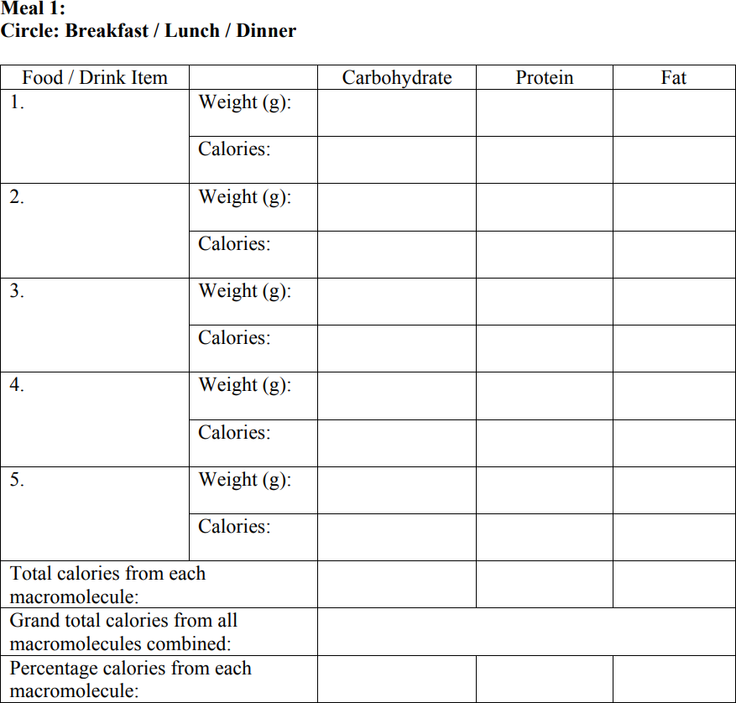

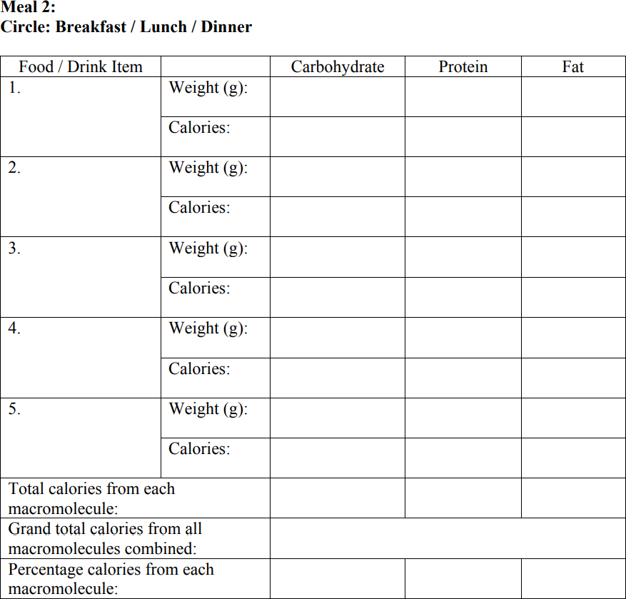

#### CDC recommended nutritional guidelines:

Calories from carbohydrates: 45 - 65%

Calories from protein: 10 - 35% Calories from fats: 20-35%

1. Compare the % Calories for your sample meals with the CDC recommended values (listed above). In what ways are they similar and/or different?
2. Do the meals in your food log accurately represent the proportion of carbohydrate, protein and fat you consume in the rest of your meals? If not, how are they different?

# ANALYSIS OF SODIUM AND SUGAR IN SAMPLE FOODS

1. Observe the sample food containers on display and match the pre- measured amounts of sodium and sugar to each of the sample foods.
2. The nutrition labels have been purposefully covered. You will have to rely on your own judgment to complete the activity as accurately as possible.
3. Enter your answers in the data tables below and then check your answers with the key provided.

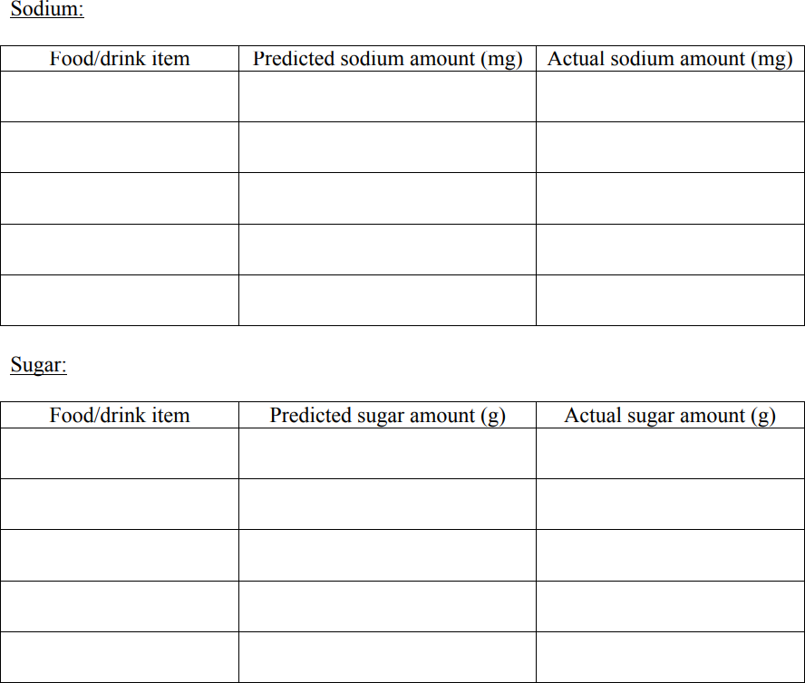

How accurate were you in your predictions? Did any of your answers surprise you?

# POST-LAB QUESTIONS:

#### Use the nutrition label below to answer the following questions:

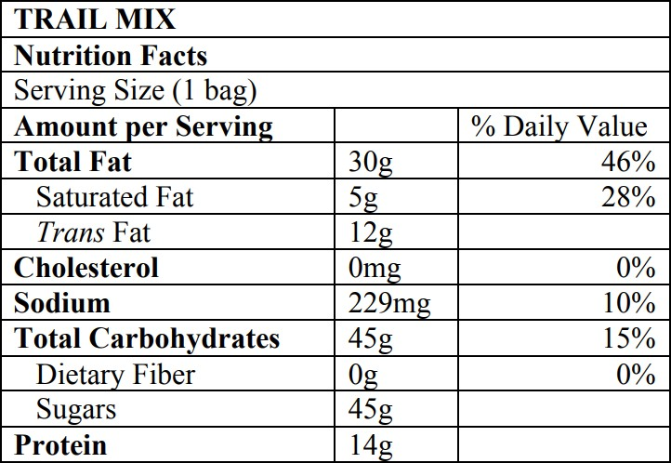

1. Complete the following table for the entire bag of trail mix.

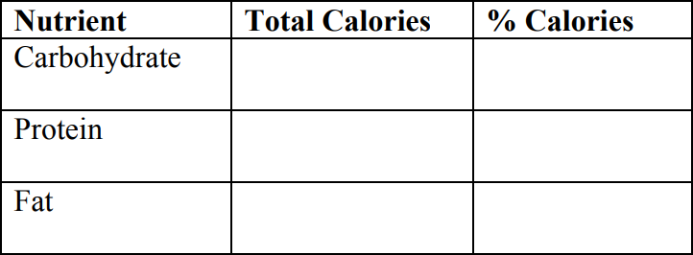

1. Compare the % Calories for carbohydrate, protein and fat in the trail mix with the CDC recommended values. Which of them lie outside the recommended range?
2. Based on these results, is this bag of trail mix a healthy snack choice? Why or why not?
3. Why do you think there are no % Daily values listed for Trans Fat, Sugars and Protein?
4. Use the following website to calculate your BMR (Basal Metabolic Rate) and then click on the link on the BMR page to calculate your daily caloric needs.

<http://www.bmi-calculator.net/bmr-calculator/>

*"Science knows no country, because knowledge belongs to humanity, and is the torch which illuminates the world." ~Louis Pasteur.*

# CREDITS AND ATTRIBUTIONS

[Introduction: Adapted from https://www.cdc.gov/nutrition/](https://creativecommons.org/licenses/by-sa/4.0/)

[This lab is adapted from Macromolecules and Nutrition from College of the Canyons and licensed under a Creative Commons Attribution 4.0 International License. This is a derivative work.](https://creativecommons.org/licenses/by-sa/4.0/)



Unsplash Photos:

Photo by Alexandr Podvalny on Unsplash Photo by Clark Young on Unsplash

Photo by Enrico Mantegazza on Unsplash