# FERMENTATION

**Introduction**

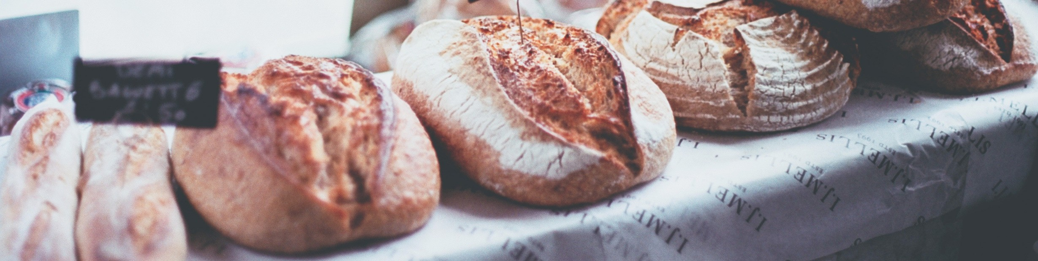

Yeasts are neither plants nor animals, but belong to the fungi kingdom. They are unicellular, and like plants they have a cell wall, although the cell wall in this case is made of the material chitin (similar to the hard material in crab shells) rather than the cellulose of plant cells. Like other fungi, yeasts generally reproduce asexually by budding (similar to mitosis), but they can and do reproduce sexually on occasion. Normally yeasts thrive in warm, moist places. They can, however, survive for long periods of time in a dormant state when kept cool and dry.

What makes yeasts especially interesting and useful is the fact that they respire anaerobically. Both plant and animal cells generate energy for cellular functions, including cell division, by breaking down glucose in the presence of oxygen. In the process, they generate the by- products carbon dioxide and water. Yeasts, on the other hand, do not require oxygen and can simply break down glucose, yielding the by-products carbon dioxide and ethyl alcohol.

It is the by-products of yeast respiration that are of commercial value to humans. A small amount of dry, dormant yeast (easily obtained in packets at a grocery store) added to the other ingredients of bread dough (flour, water, sugar, and salt) will quickly become rehydrated and active. They will begin to consume the sugar, reproduce, and before long generate enough carbon dioxide gas to let the dough rise. When baked, the result is soft bread laced with small holes in the interior, which are the actual pockets of carbon dioxide gas.

# EXPERIMENT

Design an experiment using yeast (Saccharomyces cerevisiae).

1. Think about…How do different types sugar (honey, sugar) products affect yeast fermentation? Does temperature affect fermentation? Does the amount of sugar or yeast affect fermentation? Think of other questions you can ask.
2. Formulate a hypothesis
   1. State your hypothesis:
   2. What is your Independent variable?
   3. What is your dependent variable?
   4. What is your control?

**MATERIALS AND PROCEDURE**

Write materials and procedures you will follow to address your research question.

* Use fermentation tubes, water baths, various sugar concentrations, and yeast. Your instructor will demonstrate how to fill the fermentation tube and measure CO2 produced.
* Your instructor will need to approve your experimental design before you begin. Email or meet with your instructor. Discuss what you will be doing or email your instructor before you begin!

**PROCEDURE**

"A loaf of bread, a jug of wine, and thou. " ~Omar Kahyyam

# RESULTS

## **Table and Graph**: Make a data table to record quantitative and qualitative data. You will need to use Excel to make a graph of your data.

Briefly summarize overall results (approximately 1-2 paragraphs 200 words).

"The art of bread making can become a consuming hobby, and no matter how often and how many kinds of bread one has made, there always seems to be something new to learn." ~Julia Child

**CONCLUSION/DISCUSSION**

**Grade Rubric:** Your instructor will provide how to write a lab report guide.

In 1-2 paragraphs (200 words), analyze and interpret results. Do you reject or fail to reject the hypothesis? If your data and observations support or confirm your hypothesis, then you accept the hypothesis (fail to reject). If the data contradicts the hypothesis, reject the hypothesis.

Address any problems encountered, how you can improve the experiment, medical application or relevancy.

**CREDITS AND ATTRIBUTIONS**

[Introduction:](https://creativecommons.org/licenses/by-sa/4.0/)

[The introduction of this lab has been modified from the Teach Engineering Digital Library and is intended for internal, non-commercial use by TCC students and faculty only according to the terms of use found here.](https://creativecommons.org/licenses/by-sa/4.0/)

[This lab is created by By Dr. Ephanie DeBey and Mary Wells Phillips, Tulsa Community College is licensed under CC BY-SA 4.0 / An original work](https://creativecommons.org/licenses/by-sa/4.0/)



Photo Credits:

Unsplash Photos:

Photo by Florencia Viadana on Unsplash