# FERMENTATION

**Introduction**

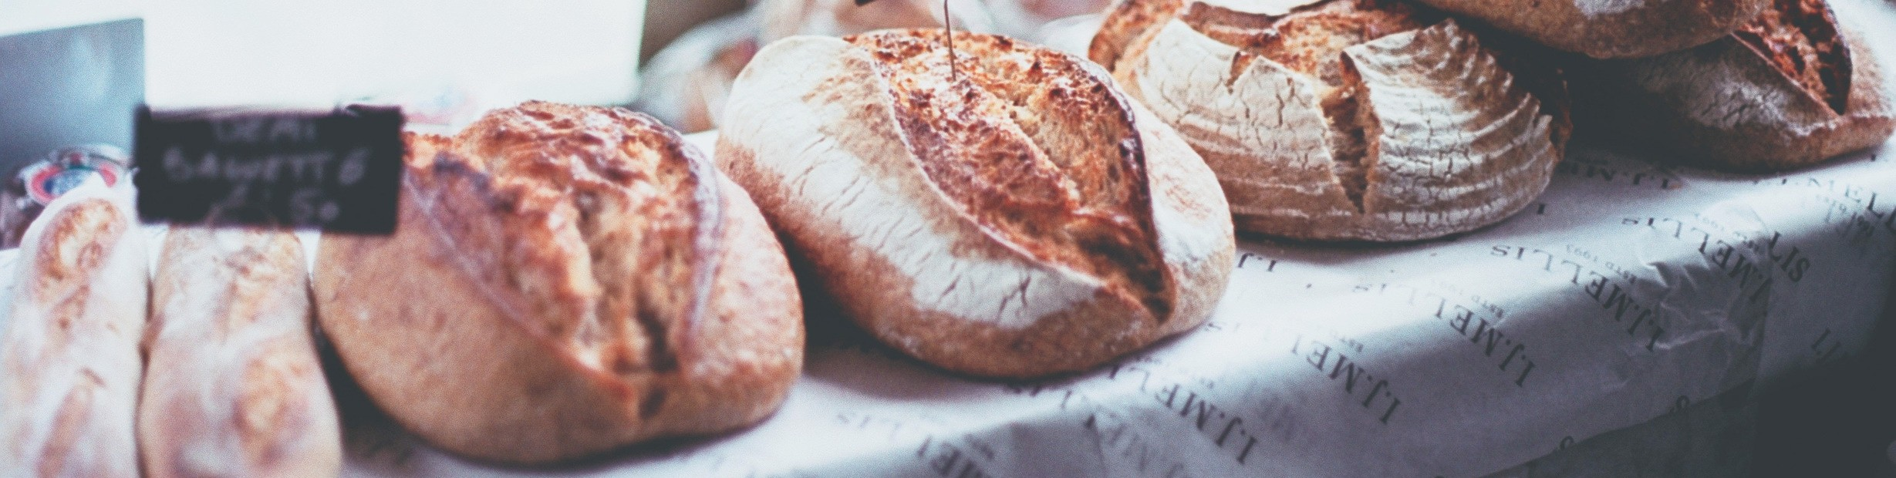

Yeasts are neither plants nor animals, but belong to the fungi kingdom. They are unicellular, and like plants they have a cell wall, although the cell wall in this case is made of the material chitin (similar to the hard material in crab shells) rather than the cellulose of plant cells. Like other fungi, yeasts generally reproduce asexually by budding (similar to mitosis), but they can and do reproduce sexually on occasion. Normally yeasts thrive in warm, moist places. They can, however, survive for long periods of time in a dormant state when kept cool and dry.

What makes yeasts especially interesting and useful is the fact that they respire anaerobically. Both plant and animal cells generate energy for cellular functions, including cell division, by breaking down glucose in the presence of oxygen. In the process, they generate the by- products carbon dioxide and water. Yeasts, on the other hand, do not require oxygen and can simply break down glucose, yielding the by-products carbon dioxide and ethyl alcohol.

It is the by-products of yeast respiration that are of commercial value to humans. A small amount of dry, dormant yeast (easily obtained in packets at a grocery store) added to the other ingredients of bread dough (flour, water, sugar, and salt) will quickly become rehydrated and active. They will begin to consume the sugar, reproduce, and before long generate enough carbon dioxide gas to let the dough rise. When baked, the result is soft bread laced with small holes in the interior, which are the actual pockets of carbon dioxide gas.

# OPTION 1

## Design an experiment using yeast (Saccharomyces cerevisiae).

1. Think about…How do different types sugar (honey, sugar) products affect yeast fermentation? Does temperature affect fermentation? Does the amount of sugar or yeast affect fermentation? Think of other questions you can ask.
2. Formulate a hypothesis
   1. State your hypothesis:
   2. What is your Independent variable?
   3. What is your dependent variable?
   4. What is your control?

# MATERIALS AND PROCEDURE

Write materials and procedures you will follow to address your research question.

* Use fermentation tubes, water baths, various sugar concentrations, and yeast. Your instructor will demonstrate how to fill the fermentation tube and measure CO2 produced.
* Your instructor will need to approve your experimental design before you begin. Email or meet with your instructor. Discuss what you will be doing or email your instructor before you begin!

**PROCEDURE**

**RESULTS**

**Table and Graph**: Make a data table to record quantitative and qualitative data. You will need to use Excel to make a graph of your data.

Briefly summarize overall results (approximately 1-2 paragraphs 200 words).

**CONCLUSION/DISCUSSION**

**Grade Rubric:** Your instructor will provide how to write a lab report guide.

In 1-2 paragraphs (200 words), analyze and interpret results. Do you reject or fail to reject the hypothesis? If your data and observations support or confirm your hypothesis, then you accept the hypothesis (fail to reject). If the data contradicts the hypothesis, reject the hypothesis.

Address any problems encountered, how you can improve the experiment, medical application or relevancy.

# OPTION 2

## Make a fermented food product to learn about glycolysis

Choose one fermented food product to make to learn about glycolysis. Be sure to connect food product to glycolysis. Find a recipe for a fermented food product. For example, Greek yogurt, Chinese Kombucha, Korean kimchi, Japanese natto, Hawaiian poi, Indonesian tempeh, European sauerkraut, Asian soy sauce, or other traditional fermented food product of your choice. Sorry, please no alcoholic beverages!



## Make a PPT presentation and include the following:

1. **Title Page**
2. **Background Information:** Research the history of your food product. Include cultural and social practices of food product around the world (e.g., Is it is a specialty product eaten only during holidays, daily, etc.). 2-3 PPT slides (background)

Use 2-3 references for your research. Cite information, photos you used in the PPT.

Create a Works Cited page (MLA or APA format) with the references you used.

1. **Recipe:** Write down the recipe you used (cite website URL in MLA or APA format) and follow each step of the procedure.

Where did you purchase ingredients?

1. **Connection to glycolysis:** What is the microorganism(s) used to make your food product? What is the product of the fermentation process? Summarize glycolysis.
2. **Photos:** Take photos (5 or more) of you (selfie- head shot) performing the procedure and photos of the results you obtained.
3. **Discuss:** Does food product have any health value? Did you enjoy making the product? Have you ever eaten the food product before? Did your friends and family eat the product with you? If yes, how did they like it? How did your product compare to restaurant or purchased product?
4. **Be creative with your report!**

Grade Rubric:

**Background Information 2-3 slides includes citations = 10 pts Recipe and citation (MLA or APA) = 2 pts**

**Connection to glycolysis = 3 pts**

**Five or more photos of you (selfie head) making product and results = 5 pts**

**Discussion Items = 5 pts Works Cited page = 5 pts**

**OPTION 3**

Visit a winery or brewery. You must be 21 years of age.

Complete and submit travel form before your field trip.

Ask permission to take photos. Take photos- selfies (5 -8) of you at the winery or brewery, tour, process, etc.

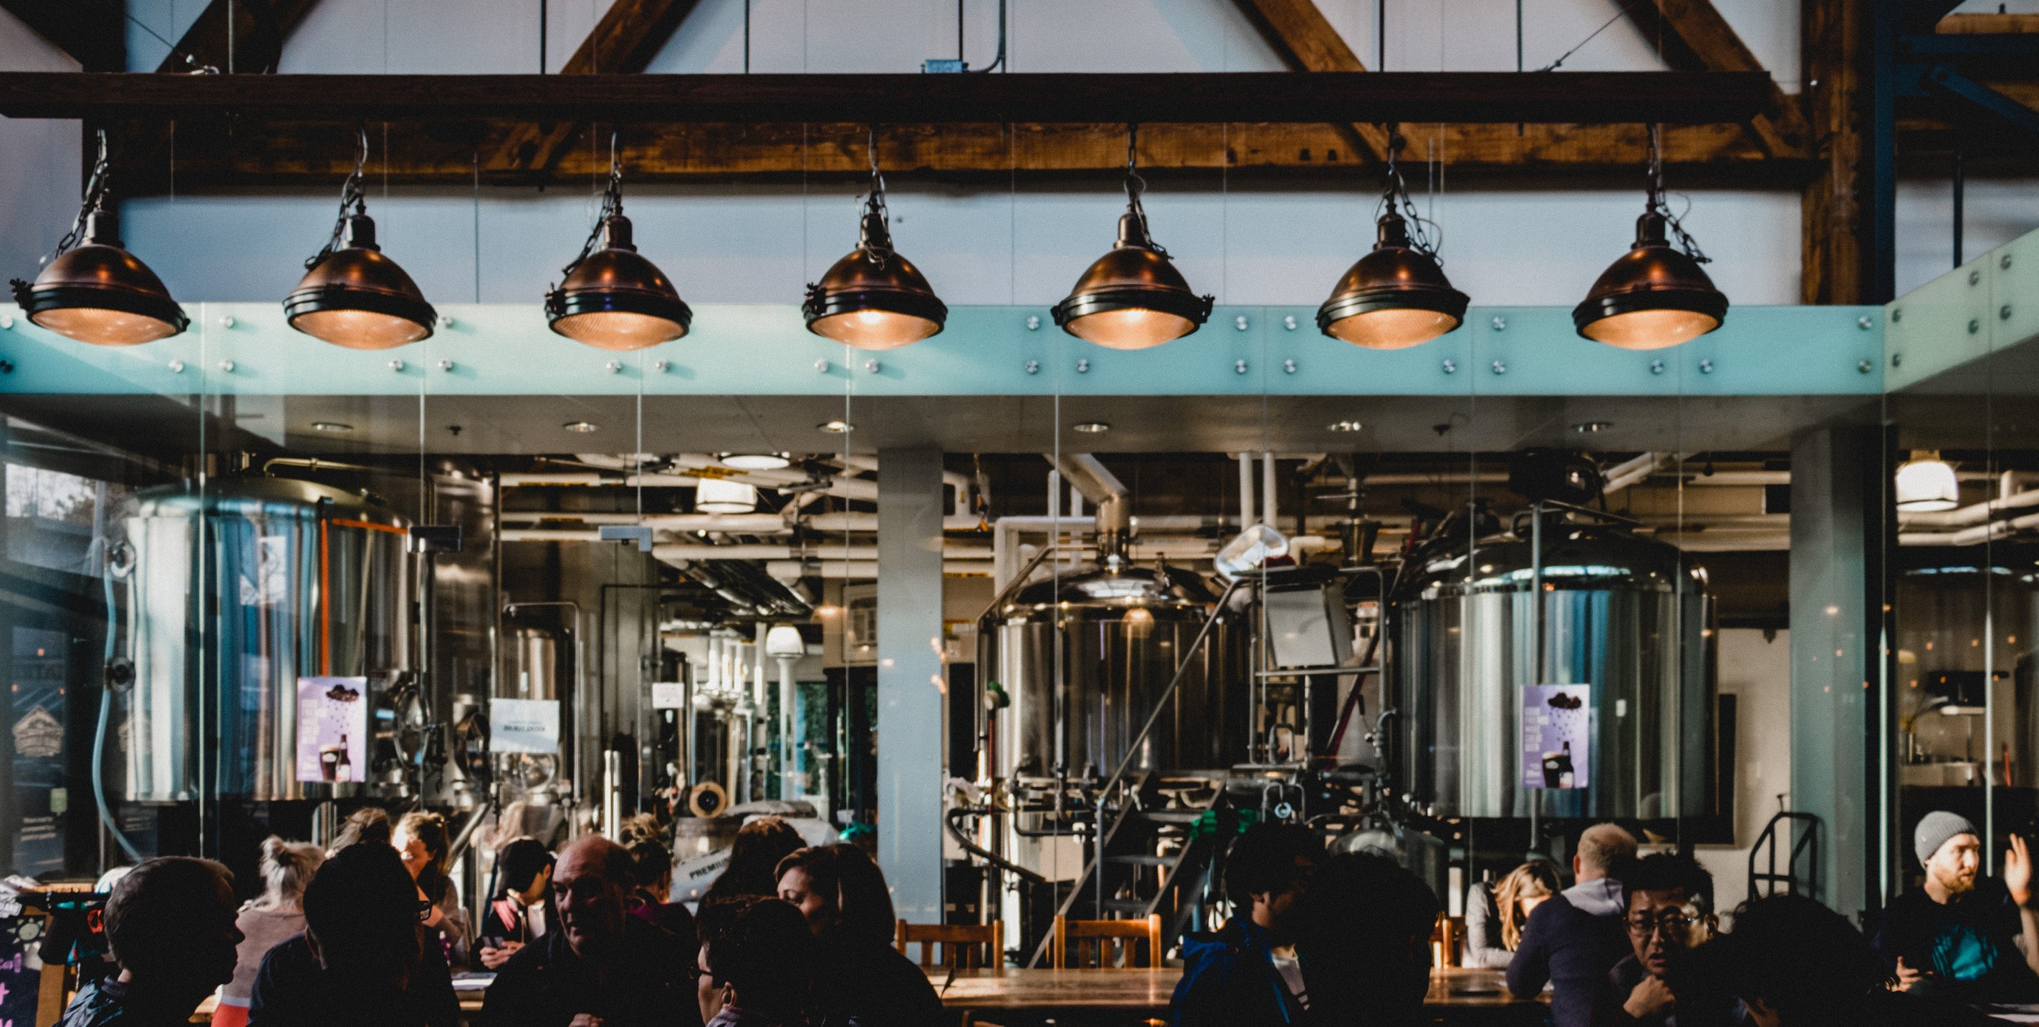

## Make a PPT presentation and include the following:

* **Title page: Your name; Name and address of winery or brewery; Date and time of visit.**
* **Contact information of the person who led the tour: Name, phone number, email address.**
* **Research/Background Information: Overview of local winery or brewery. Research history of wine or beer making- 5 or more slides with citations.**
* **General Information: What characteristics make some wines and beers more expensive than others? What plant species are used? Are they local? Organic? What are the characteristics in the various types of wines and beers?**
* **Connection to glycolysis: What is the microorganism(s) used What is the product of the fermentation process? Alcoholic content?**
* **Reflection: Did you enjoy your visit? Include personal reflection, notes and information from the tour.**

**o Works Cited: Create a reference page (APA or MLA format) with 3- 4 references you used.**

Grade rubric

**Title Page/Contact Information = 2 pts Background/History/General Information with citations = 10 pts Connection to glycolysis = 3 pts**

**Photos of you (selfie head) 5-8 = 5 pts Reflection = 5 pts**

**Works Cited = 5 pts**

**CREDITS AND ATTRIBUTIONS**

[Introduction:](https://creativecommons.org/licenses/by-sa/4.0/)

[The introduction of this lab has been modified from the Teach Engineering Digital Library and is intended for internal, non-commercial use by TCC students and faculty only according to the terms of use found here.](https://creativecommons.org/licenses/by-sa/4.0/)

[This lab is created by By Dr. Ephanie DeBey, Tulsa Community College is licensed under CC BY-SA 4.0 / An original work](https://creativecommons.org/licenses/by-sa/4.0/)



Photo Credits:

Unsplash Photos:

Photo by Florencia Viadana on Unsplash Photo by Stage 7 Photography on Unsplash Photo by Carlos Blanco on Unsplash