# EXPLORING EVOLUTIONARY MECHANISMS



**Introduction**

Your team has discovered a new population of Sticky Notes that lives along the coast. This organism is haploid, meaning it only has one copy of each chromosome. It has one visible phenotype (color), which is determined by the Color Gene. Like budding yeast, Sticky Notes reproduce clonally via a budding process, resulting in two individuals who have the same genome and phenotype. They are exceptionally long-lived, meaning that each Note can reproduce for many generations. Everything these Notes need to survive is on the coast – they can see an island off in the distance, but cannot reach it.

1. Establish your own population of sticky notes – there will be 2 individuals of each color. Initial phenotypic ratios (remember to write in your phenotype colors):

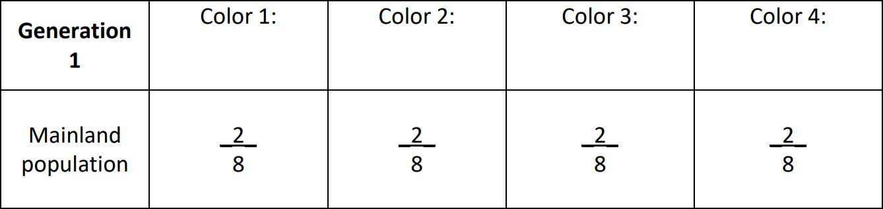

Sticky Notes are haploid, so how many alleles does a single Sticky Note have for the Color Gene?

How many alleles for the Color Gene exist in Population 1?

1. What is the **founder effect**?

A rare low tide has exposed a temporary sandbar. Some curious Sticky Notes take this opportunity to explore the nearby island, but they’re stuck there once the sandbar is covered.

Move a few Sticky Notes of any color to the island (no more than 3). After moving the Notes, draw a mark on each note to help you distinguish Generation 1 notes from their progeny in the next step.

After this tragic separation, each Note will clonally reproduce one time.

For each Sticky Note on the island and the mainland, add another Sticky Note of the **same** color to the same population.

## Phenotypic Ratios:

After reproduction, how do the mainland phenotypic frequencies of Generation 2 compare to those on the **mainland** in Generation 1?

After reproduction, how do the mainland phenotypic frequencies of Generation 2 compare to those on the **island** in Generation 1?

1. What is **gene flow**?

Every so often the currents are favorable and allow some Sticky Notes to swim from the island to the mainland or vice versa.

One member of your group will choose up to 5 intrepid Sticky Notes to move from one population to the other – some can move to the mainland, while others can move to the island.

After the migration, each sticky note reproduces clonally one time.

Draw a mark on each Note. Then, for each Note on the island and the mainland, add another Note of the same color to the same population.

## Phenotypic Ratios:

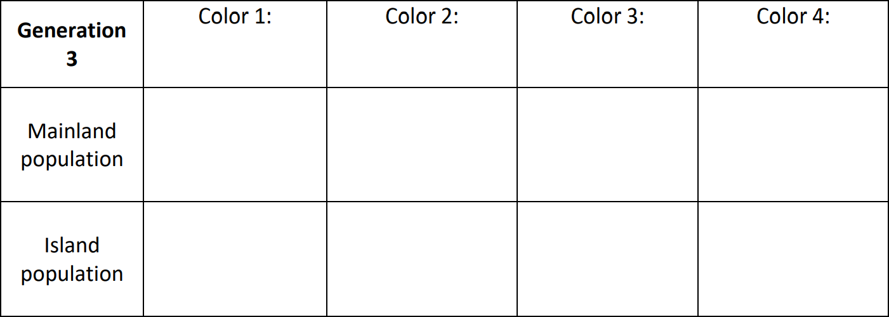

Does evolution occur if a Sticky Note migrates from the island to the mainland, but then dies without reproducing? Why or why not?

1. What is **genetic drift**?

You and your team have gone to get more supplies to continue your work at the field site, so several generations go by before you can make an observation of these populations. Chose another group member to act out the effects of genetic drift.

They will **close their eyes** and remove 2 Notes from the mainland population and 2 from the island population.

These unfortunate Sticky Notes have perished before they are able to reproduce. All the remaining Sticky Notes will reproduce clonally one time.

Draw a mark on each Note. Then, for each Note on the island and the mainland, add another Note of the same color to the same population.

Again, the group member will:

close their eyes and remove 8 Notes from the mainland population and 8 from the island population.

All the remaining Sticky Notes will reproduce clonally one time.

Draw a mark on each Note. Then, for each Note on the island and the mainland, add another Note of the same color to the same population.

## Phenotypic Ratios:

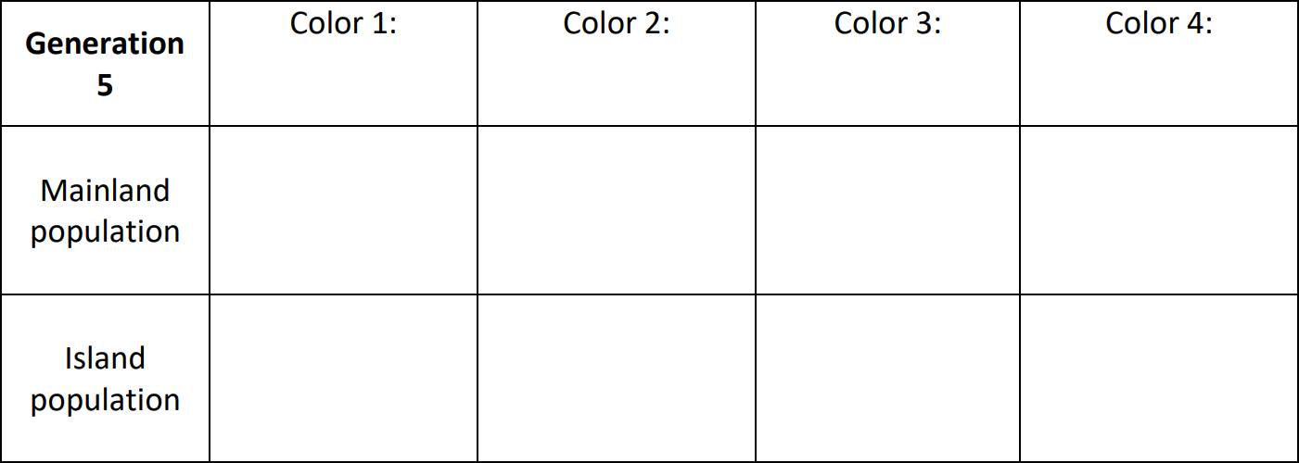

Which color, if any, has become more prevalent in the mainland population?

Which color has become more rare?

Which color, if any, has become more prevalent in the island population?

Which has become more rare?

Which population looks most different from your original population at Generation 1?

1. What is **natural selection**?



Choose another group member to act as a dreaded flying predator of the Sticky Notes. This group member will choose their **two favorite colors** of Notes to eat.

Fly between the island and the mainland, removing 10 Sticky Notes of these two colors in total (decide how many to eat from each population).

All the remaining (and relieved) Sticky Notes will reproduce clonally one time.

Draw a mark on each Note. Then, for each Note on the island and the mainland, add another Note of the same color to the same population.

## Phenotypic Ratios:

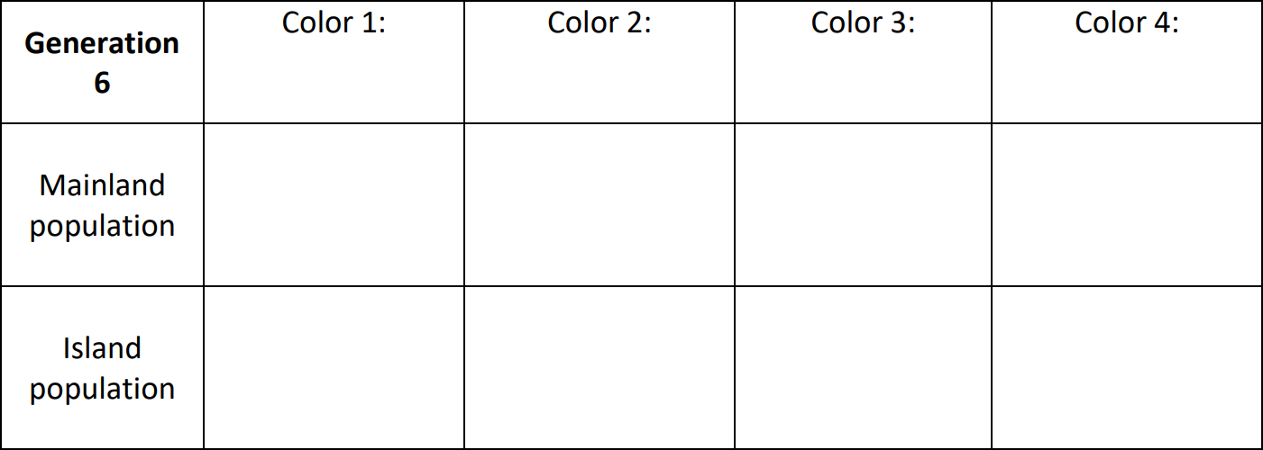

What characteristics of Sticky Notes or their environment might help one color of Sticky Note survive better than another?

Does evolution happen if a Sticky Note is better at surviving, but would not reproduce?

1. What is a population bottleneck?

Chose another group member to become a force of nature. This group member will decide what event of mass destruction they represent (hurricane? earthquake? zombies?). Sticky Notes will die in alarming numbers, but which ones will depend on the event. Will it be proximity to the ocean?

Phenotypic color or disease susceptibility? Completely at random?

Remove all but 10 Sticky Notes (decide how to split the survivors between populations).

These (extremely shaken) Sticky Notes are grateful to have survived and begin to rebuild their lives. They undergo one last repopulation event.

Draw a mark on each Note. Then, for each Note on the island and the mainland, add another Note of the same color to the same population.

## Phenotypic Ratios:

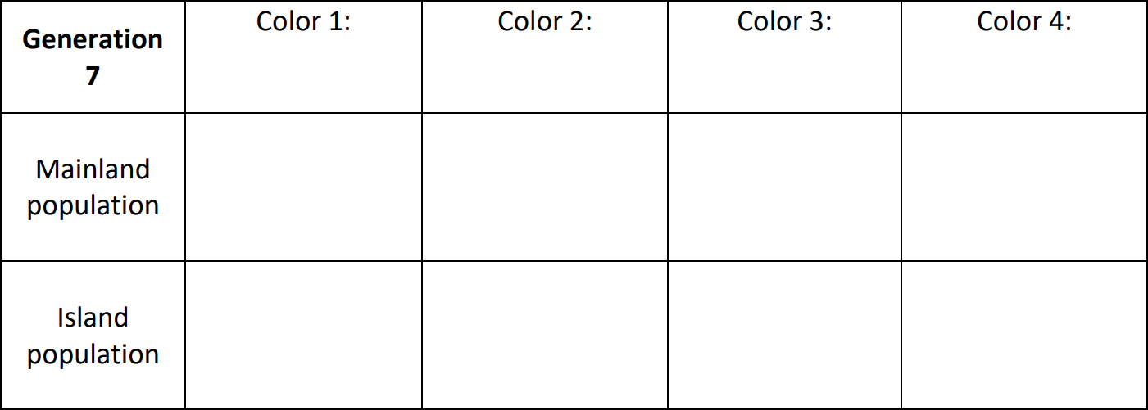

**POST-LAB QUESTIONS:**

[Now that you’ve completed your field season, describe what happened to each color of Sticky Note over the seven generations you’ve observed.](https://creativecommons.org/licenses/by-sa/4.0/)

[Have any colors disappeared in Generation 7, in either population?](https://creativecommons.org/licenses/by-sa/4.0/)

[Will there be any Sticky Notes of this color in future generations? Why or Why not?](https://creativecommons.org/licenses/by-sa/4.0/)

# CREDITS AND ATTRIBUTIONS

["Making evolution stick: using sticky notes to teach the mechanisms of evolutionary change" by Dr. Kathleen Grogan,Penn State is licensed under CC BY 4.0 / A derivative from the original work](https://creativecommons.org/licenses/by-sa/4.0/)



## Unsplash Photos:

Photo by Jeremy Bishop on Unsplash https://unsplash.com/photos/-1_RZL8BGBM