# DNA EXTRACTION

## Introduction

DNA is the instruction manual for living things. By far, the greatest amount of DNA is located in the nucleus of eukaryotic cells and described as a double-helix. The double stranded genetic blue print, runs antiparallel, with bases bonding in a complementary fashion, ensuring that with every round of replication or transcription, a parent (or template) strand remains[1].

This semi-conservative replicative strategy ensures the integrity of the code, for the proteins that result from the nucleotide sequence are vital to the cell. Every cell that comprises a living organism contains the complete genetic blueprint of that organism, what enables the specialization of a particular cell in a particular area of the body is control over which genes are expressed and when.

As every cell contains DNA, isolating the genetic sequence of an organism from a subset of cells, such as blood, sweat, and skin, to name a few. Once a sample has been obtained, the DNA must be released from the nucleus, which involves the physical disruption of the cell. After the cells have broken open, a salt solution (NaCl) and a detergent solution containing the compound SDS (sodium dodecyl sulfate) are added, to breakdown the cell membrane.

[2] Finally, ethanol is added causing the DNA to precipitate (settle out) of the solution, leaving behind all the cellular components that aren't soluble in alcohol. The resulting DNA can be spooled (wound) on a stirring rod and pulled from the solution at this point.

## Extracting DNA From Your Cells

Each cell in your body has a nucleus with multiple chromosomes. Each chromosome contains a DNA molecule.

Each cell is surrounded by a cell membrane that regulates what gets into and out of the cell. The nucleus is also surrounded by a membrane.

To extract DNA from human cells, you will need to break open the cell membranes and nuclear membranes and separate the DNA from the other types of biological molecules in human cells. You will be using the same basic steps that biologists use when they extract DNA (e.g. to clone DNA). You will follow these 3 easy steps to extract the DNA:

## DETERGENT

**ENZYMES (MEAT TENDERIZER) ALCOHOL**

### Why Am I Adding Detergent?

To get the DNA out of your cheek cells you need to break open both the cell membranes and the nuclear membranes. Cell membranes and nuclear membranes consist primarily of lipids. Dishwashing detergent, like all soaps, breaks up clumps of lipids. This is why you use detergents to remove fats (which are lipids) from dirty dishes. Adding the detergent to your cheek cell solution will break open the cell membranes and nuclear membranes and release your DNA into the solution.

### Why am I adding enzymes?

Each chromosome in the nucleus of a cell contains a very long molecule of DNA. If you stretched out the DNA found in one of your cells, it would be 2-3 meters long. To fit all of this DNA inside a tiny cell nucleus, the DNA is wrapped tightly around proteins. The enzyme in meat tenderizer is a protease, which is an enzyme that cuts proteins into small pieces. As this enzyme cuts up the proteins, the DNA will separate from the proteins and unwind.

Each DNA molecule consists of two strands of nucleotides twisted together in a long spiral called a double helix. DNA is made up of four different types of nucleotide: A, C, G and T.

Each DNA molecule contains multiple genes. Each gene is a segment of DNA with a sequence of nucleotides that provides the instructions for making a protein.

A cell needs many different types of proteins to function. For example, a cell needs:

protein enzymes to carry out the chemical reactions needed for life transport proteins to move ions and molecules into and out of the cell and to move substances around inside the cell

structural proteins.

### Why am I adding alcohol?

The cold alcohol reduces the solubility of DNA. When cold alcohol is poured on top of the solution, the DNA precipitates out into the alcohol layer, while the lipids and proteins stay in the solution.

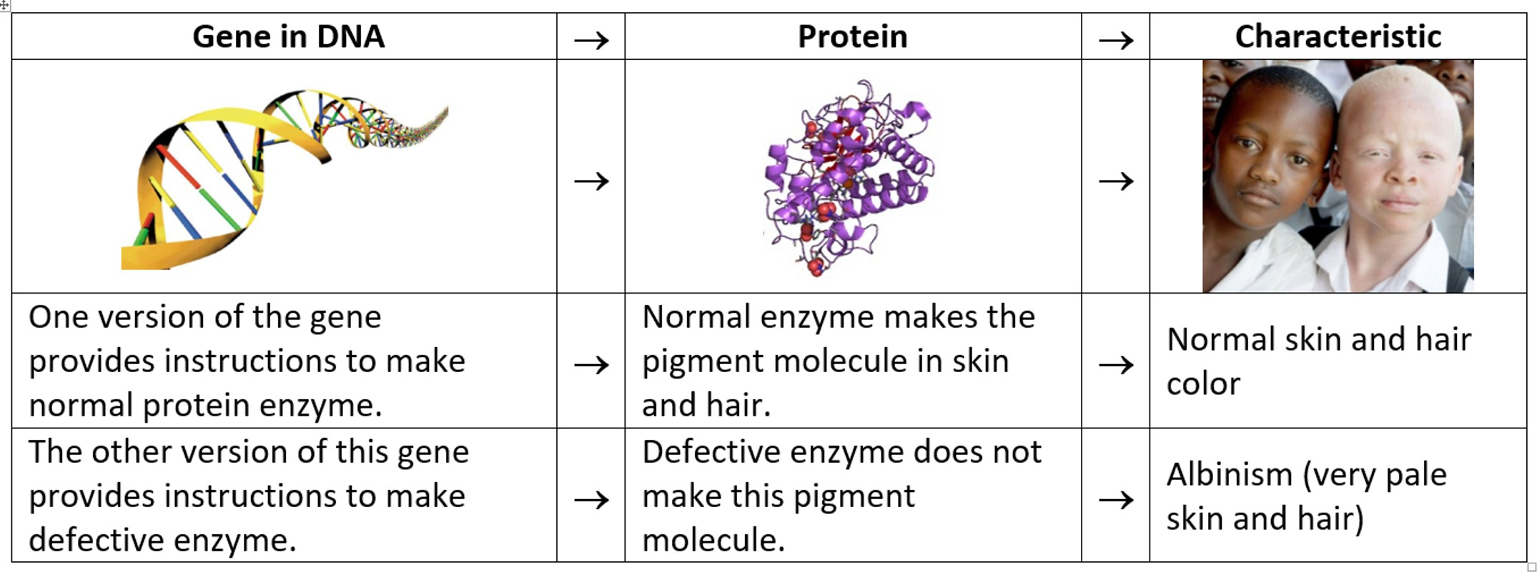Genes influence an organism's characteristics by determining which types of proteins the organism makes. The flowchart shows an example. Two different versions of a human gene give the instructions for producing either a normal or defective version of a protein enzyme which results in either normal skin and hair color or albinism.

### DNA Structure and Function

This drawing shows a short section of a DNA double helix with a diagram of four nucleotides in each strand of the double helix. Each nucleotide has:

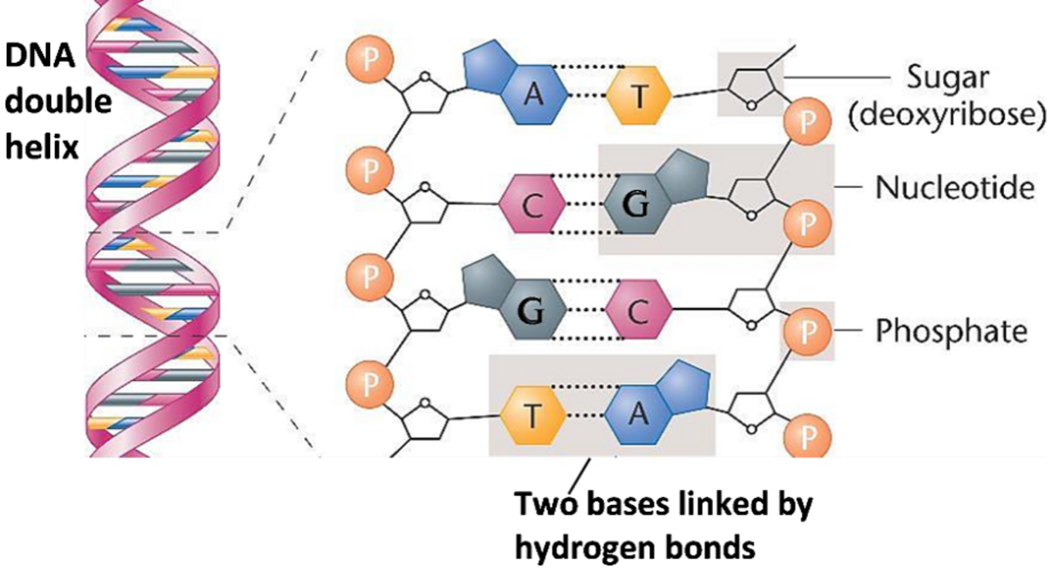a phosphate group (P) and a sugar molecule in the backbone of the DNA strand one of the four bases (**A** = adenine, **C** = cytosine, **G** = guanine, or **T** = thymine)

Each base in one strand of the DNA double helix pairs with a base in the other strand of the double helix. The base-pairing rules describe which bases pair together in a DNA double helix.

Since all the nucleotides in DNA are the same except for the base they contain, each nucleotide is given the same symbol as the base it contains (**A**, **C**, **G**, or **T**).

A polymer consists of many repeats of a smaller molecule (a monomer). For example, a protein is a polymer of amino acids.

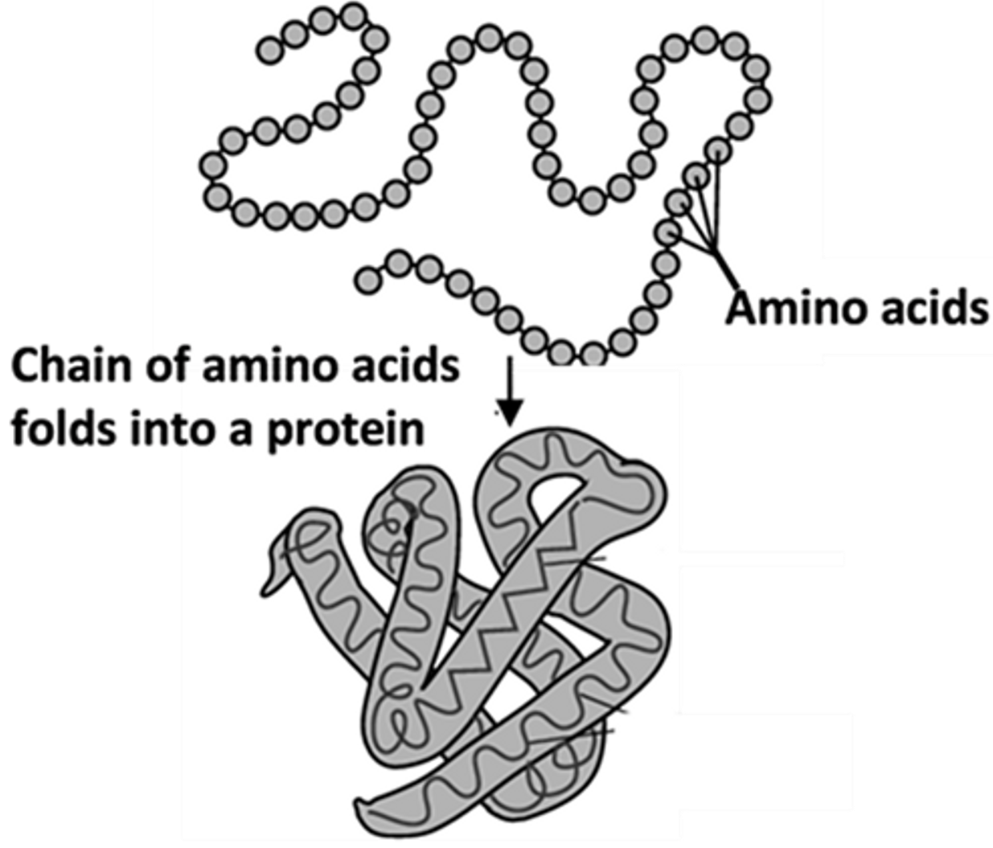The sequence of nucleotides in a gene in the DNA determines which amino acids are joined together to form a protein. A slightly different sequence of nucleotides in a gene can result in a different sequence of amino acids in the protein which can change the structure and function of the protein.

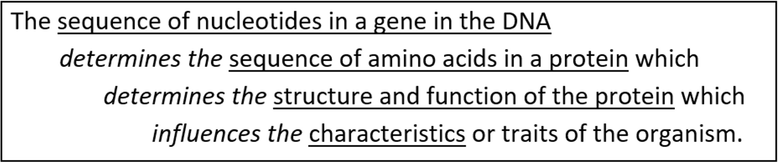

#### DNA Replication

Our bodies need to make new cells to grow or to replace damaged cells. New cells are formed by cell division which occurs when a cell divides into two daughter cells.

Before a cell can divide, the cell must make a copy of all its DNA; this is called DNA replication.During DNA replication, the two strands of the DNA helix are separated and each old strand provides the information needed to make a new matching strand.

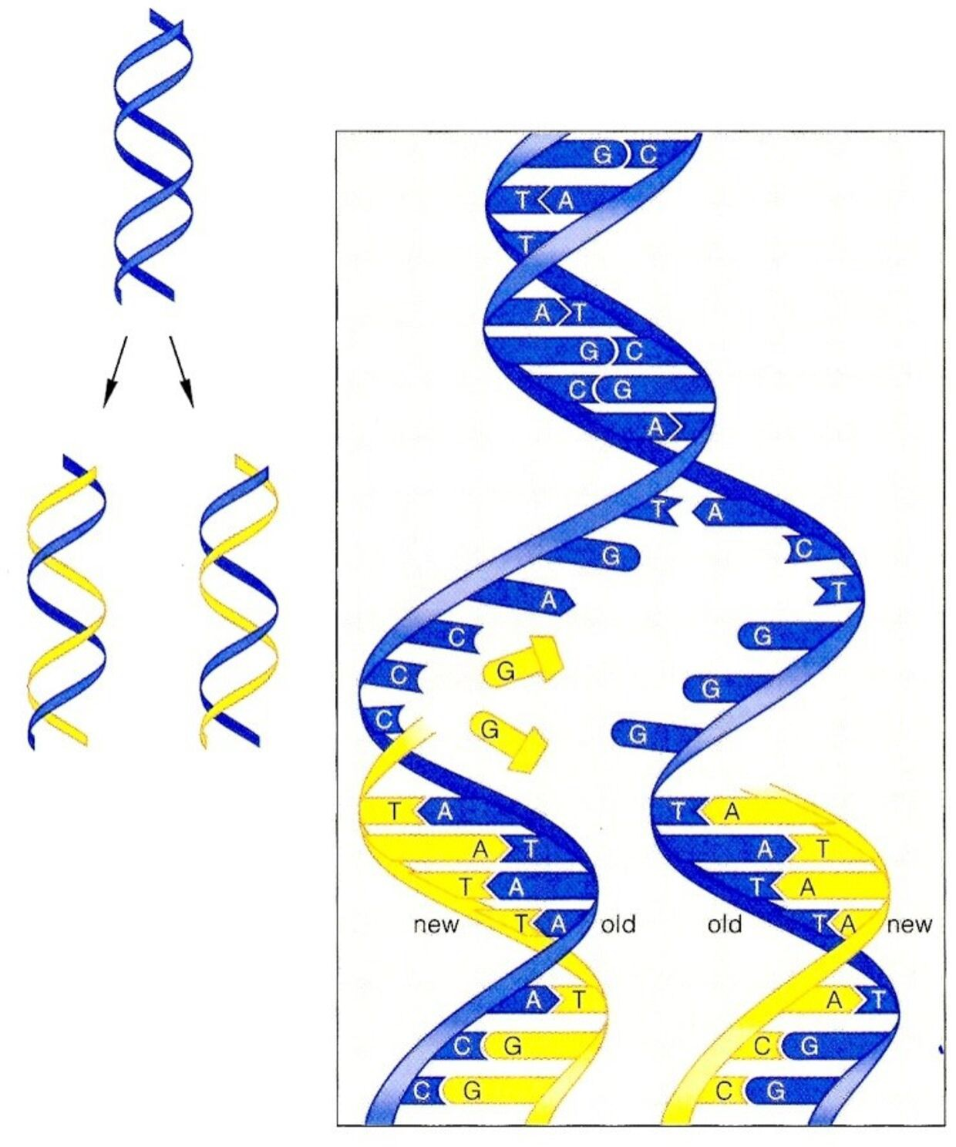

Each nucleotide in the new strand is matched to a nucleotide in the old strand using the base-pairing rules.

The enzyme DNA polymerase helps to make the new matching DNA strand by adding the matching nucleotides one at a time and joining each new nucleotide to the previous nucleotide in the growing DNA strand.

DNA replication results in two new DNA molecules that are identical to the original DNA molecule. Thus, each of the new DNA molecules carries the same genetic information as the original DNA molecule.

# PRE-LAB QUESTIONS

##### All living organisms, including bacteria, plants, humans and other animals, are made up of one or more cells. Explain why all living organisms need to have DNA. Include the words genes and proteins in your explanation.

1. For most people, when a blood vessel is injured the clotting proteins in their blood produce a blood clot which prevents excessive bleeding. However, some people have a defective version of one type of clotting protein, so clots do not form normally. As a result, they tend to bleed excessively after even minor injuries; they have hemophilia. Explain how a person's DNA can determine whether or not he has hemophilia.
2. Each base in one strand of the DNA double helix pairs with a base in the other strand of the double helix. The base-pairing rules describe which bases pair together in a DNA double helix. Complete the following sentences to give the base-pairing rules.

A in one strand always pairs with _____ in the other strand.

C in one strand always pairs with _____ in the other strand.

*"I have no special talent. I am only passionately curious."*

*-Albert Einstein*

##### 4. DNA is a polymer of ___________________________ .

1. Explain how a difference in the sequence of nucleotides in a gene could result in one of these boys having albinism and the other boy not having albinism.



1. Explain why DNA replication is needed before a cell divides into two daughter cells.

*"Biology is the most powerful technology ever created. DNA is software, protein*

*are hardware, cells are factories." -Arvin Gupta*

# PROCEDURE

#### DNA Extraction

1. Obtain several models to compare, such as fruit, vegetable, meat, and cheek cells.
2. Put the first sample into a plastic Ziploc bag, seal thoroughly and gently smash sample for about two minutes.
3. In a plastic cup, prepare the extraction solution: mix together 2 teaspoons of detergent, 1 tsp of salt and ½ c water.
4. Add approximately 2 teaspoons of the extraction solution to the specimen bag.
5. Reseal the bag and gently smash for another minute (avoid making too many soap bubbles).
6. Obtain a second cup and line with a filter/wet paper towel. a.Pour the liquid into the filter/wet paper towel.

b. The filter/wet paper towel can be compressed to squeeze any remaining liquid into the cup.

1. Add an equal amount of alcohol to the cup.
   1. Pour down the side of the cup to facilitate layering of solutions.
   2. Do not mix or stir.
2. Watch for the development of a white cloudy substance (this is the DNA) in the top layer above the extract layer.
   1. Tilt the cup and pick up the DNA using a wooden stirring stick or tweezers.
   2. Set aside.
3. Repeat procedure using several alternative food sources and record the data on the result table.

**PROCEDURE**

Extract Human DNA

1. Mix the bottled water with the salt in a cup. Stir until salt is dissolved.
2. Gargle the salt water solution for approximately 1 minute.
   1. Don't swallow it!
   2. Spit the water back into salt solution cup.
3. Add one drop of dish soap to the salt water. a.Stir gently.

b.Try not to create any bubbles.

1. Add equal amount of alcohol (plus optional food coloring) into the salt water cup.

a.Pour down the side of the cup to facilitate layering of solutions. b.Do not mix or stir.

1. Wait for 2.5 minutes. You should see white clumps and strings forming.
   1. Tilt the cup and pick up the DNA using a wooden stirring stick or tweezers.

b.Set aside.

**RESULTS**

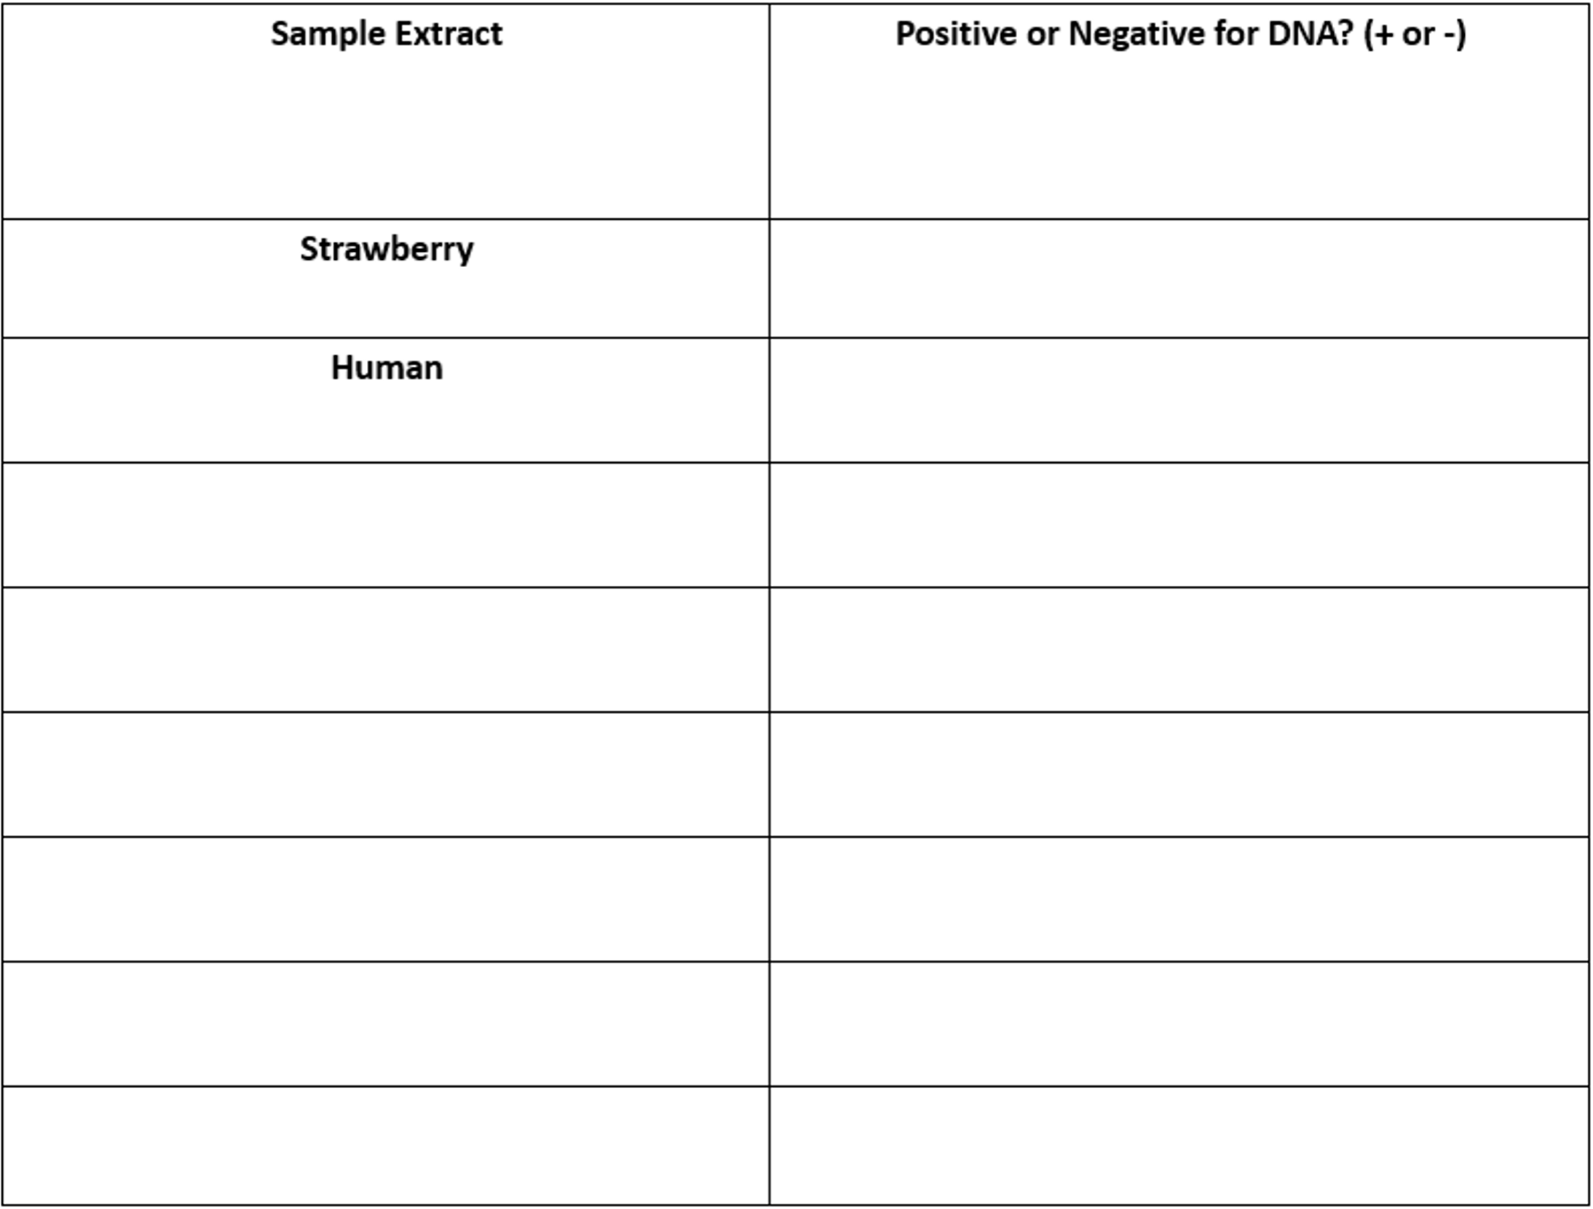Record your results to the table below, you may not have to use all the spaces provided.

1. Describe the role of the detergent in DNA extraction.
2. Describe the role of the salt solution in DNA extraction.
3. Describe the role of alcohol in DNA extraction.

**POST-LAB QUESTIONS**

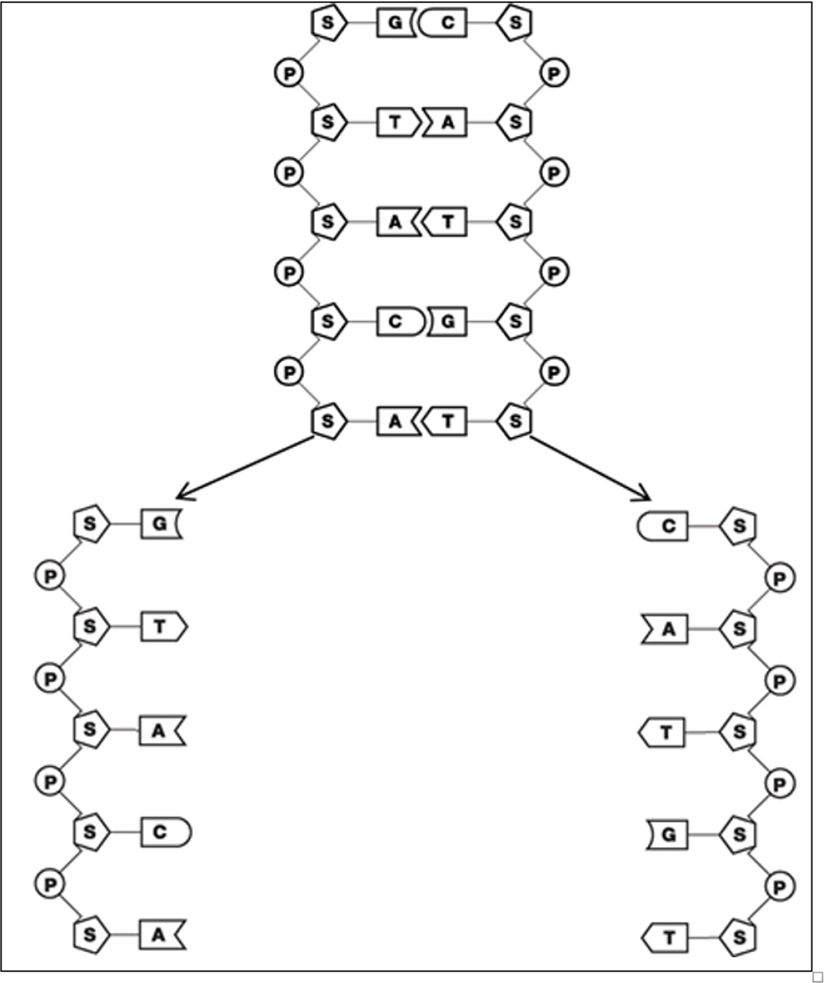

##### This drawing shows a short segment of DNA which separates into two strands in preparation for replication.

Your job is to play the role of DNA polymerase and create new matching strands of DNA to produce two pieces of double-stranded DNA. Add matching nucleotides one at a time, using the base-pairing rules and the nucleotides and tape provided.

7a. Are there any differences between the two new double-stranded pieces of DNA?

7b. Are these new double-stranded pieces of DNA the same as or different from the original piece of DNA?

1. Why is it important that both copies of the DNA molecule have the exact same sequence of nucleotides as the original DNA molecule?
2. Based on the function of DNA polymerase, explain why each part of the name DNA polymerase (DNA, polymer, -ase) makes sense.
3. Explain how DNA polymerase, the double helix structure of DNA, and the base-pairing rules work together to produce two identical copies of the original DNA molecule.

**CREDITS AND ATTRIBUTIONS**

[Introduction:](https://creativecommons.org/licenses/by-sa/4.0/)

1. [Purcell, Adam. "DNA". Basic Biology.](https://creativecommons.org/licenses/by-sa/4.0/)
2. [Sambrook, Michael R. Green, Joseph. Molecular Cloning. (4th ed. ed.). Cold Spring Harbor, N.Y.: Cold Spring Harbor Laboratory Pr.](https://creativecommons.org/licenses/by-sa/4.0/)

[This lab is adapted from "DNA Extraction" by By Dr. Sascha McKeon, Blue Mountain Community College is licensed under CC BY-NC-SA 3.0 / A derivative from the original work](https://creativecommons.org/licenses/by-sa/4.0/)



Photo Credits:

Eukaryote_DNA.svg: *Difference_DNA_RNA-EN.svg: *Difference_DNA_RNA- DE.svg: Sponk (talk)translation: Sponk (talk)Chromosome.svg: *derivative work: Tryphon (talk)Chromosome-upright.png: Original version: Magnus Manske, this version with upright chromosome: User:Dietzel65Animal_cell_structure_en.svg: LadyofHats (Mariana Ruiz)derivative work: Radio89derivative work: Radio89 [CC BY-SA 3.0 (https://creativecommons.org/licenses/by-sa/3.0)]