**DIFFUSION AND OSMOSIS**

### INTRODUCTION

*Adapted from Open Stax Biology*

#### Plasma membranes must allow certain substances to enter and leave a cell, while preventing harmful material from entering and essential material from leaving. In other words, plasma membranes are selectively permeable—they allow some substances through but not others. If they were to lose this selectivity, the cell would no longer be able to sustain itself, and it would be destroyed. Some cells require larger amounts of specific substances than do other cells; they must have a way of obtaining these materials from the extracellular fluids.

The most direct forms of membrane transport are passive. Passive transport is a naturally occurring phenomenon and does not require the cell to expend energy to accomplish the movement. In passive transport, substances move from an area of higher concentration to an area of lower concentration in a process called diffusion. A physical space in which there is a different concentration of a single substance is said to have a concentration

gradient.

Diffusion is a passive process of transport. A single substance tends to move from an area of high concentration to an area of low concentration until the concentration is equal across the space. Materials move within the cell’s cytosol by diffusion, and certain materials move through the plasma membrane by diffusion. Diffusion expends no energy. Rather the different concentrations of materials in different areas are a form of potential energy, and diffusion is the dissipation of that potential energy as materials move down their concentration gradients, from high to low. Each separate substance in a medium, such as the extracellular fluid, has its own concentration gradient, independent of the concentration gradients of other materials. Additionally, each substance will diffuse according to that gradient.

**Several factors affect the rate of diffusion:**

**Extent of the concentration gradient:** The greater the difference in concentration, the more rapid the diffusion.

**Mass of the molecules diffusing:** More massive molecules move more slowly.

#### **Temperature:** Higher temperatures increase the energy and therefore the movement of the molecules, increasing the rate of diffusion.

**Solvent density**: As the density of the solvent increases, the rate of diffusion decreases.

Osmosis is the diffusion of water through a semipermeable membrane according to the concentration gradient of water across the membrane. Whereas diffusion transports material across membranes and within cells, osmosis transports only water across a membrane and the membrane limits the diffusion of solutes in the water. Osmosis is a special case of diffusion. Water, like other substances, moves from an area of higher concentration to one of lower concentration.

P A R T O N E : O S M O S I S

## O P T I O N A : D I A L Y S I S T U B I N G

### MATERIALS

#### Pre-soaked dialysis tubing String to Tie/Clips

Glucose, Sucrose, NaCl Solutions Glucose Test Strips

5 Plastic Cups/Beakers Distilled water Graduated Cylinder Timer

Scale

Silver Nitrate Paper Towels

**HYPOTHESIS FOR EXPERIMENT:**

*Formulate a hypothesis. Make a prediction, pose a problem, or write an explanation (if.. then*…*because) statement.*

# Identify the Variables:

* Independent Variable:
* Dependent Variable:

# Procedure:

1. Obtain dialysis tubing (keep in fresh distilled water until used)
2. Open one of the dialysis tubing by rubbing it between your fingers. BE GENTLE! DIALYSIS TUBING IS EASY TO TEAR!
3. Use either the clips or tie off one end of the tubing as shown in class and in the diagram above. If you’re tying it, make sure it is a water tight seal.
4. Repeat with the other tubes of dialysis tubing (one end should still be opened).
5. Fill the tubing by pouring 10 mL of test solution into the open end of the tubing.

* Tube #1: 10 mL of distilled H2O
* Tube #2: 10 mL of 20% Glucose
* Tube #3: 10 mL of 20% NaCl Solution
* Tube #4: 10 mL of 20% Sucrose

1. Remove most of the air from the bag by drawing the dialysis bag between two fingers. To close the bags, clip/tie a knot at the other end, as before (step 2), thereby sealing the solution within the bag. BE SURE that you have left 1.5 to 2 times as much empty space as that taken up by the volume of the solution in the bag. (This leaves enough unfilled space within the bag to accommodate the possible accumulation of water.)

# Procedure: (continued)

#### How to Tie Dialysis Tubing

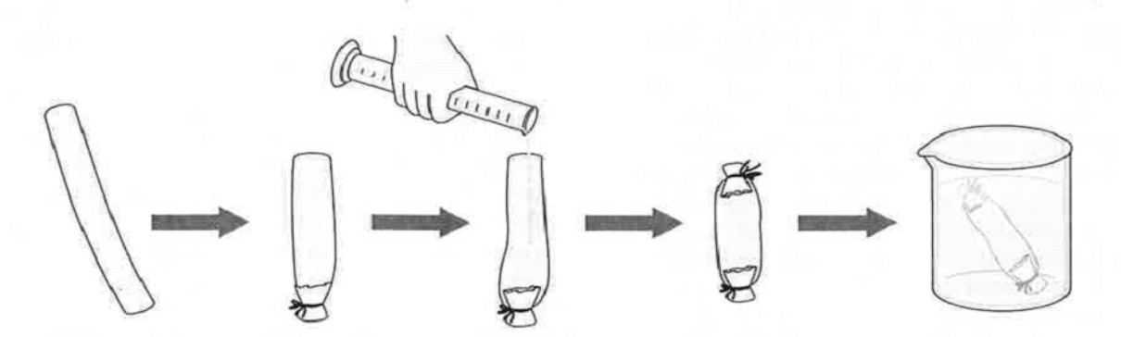

1. Fill cups/beakers with distilled water. There should be enough to cover the bags and give them room to grow. All cups/beakers should have the same amount of distilled water.
2. Carefully blot dry the outside of each dialysis bag. Measure and record the initial mass of each of your two bags in Table 1. (Are you keeping track of which bag contains which solution?)
3. Place each bag in one of the cups/beakers of distilled water and label the cup/beakers to indicate the solution in the dialysis bags.
4. Let sit for 15 minutes.
5. Remove the bags from the water and carefully blot and re-weigh them.
6. Place dialysis tubes back into their original cup/beaker.
7. Repeat #10 - #12 at 30 minutes, 45 minutes, and 60 minutes.
8. Record the final masses in Table 1 and calculate % change in mass.
9. Test the water in the cup/beaker with the Glucose tube. Dip the glucose test strip into the cup/beaker. Does it test positive?
10. Test the water in the cup/beaker with the NaCl (Salt) Solution tube. Take 3 mL of water from that cup/beaker and add 2 drops of silver nitrate to the solution. If NaCl (salt) is present, the water will become cloudy with a precipitate. Is NaCl (salt) present?
11. Examine the water from the cup/beaker with the Sucrose tube. Does it appear to have changed colors? Why would it change colors?

**O P T I O N B : O S M O S I S E G G S**

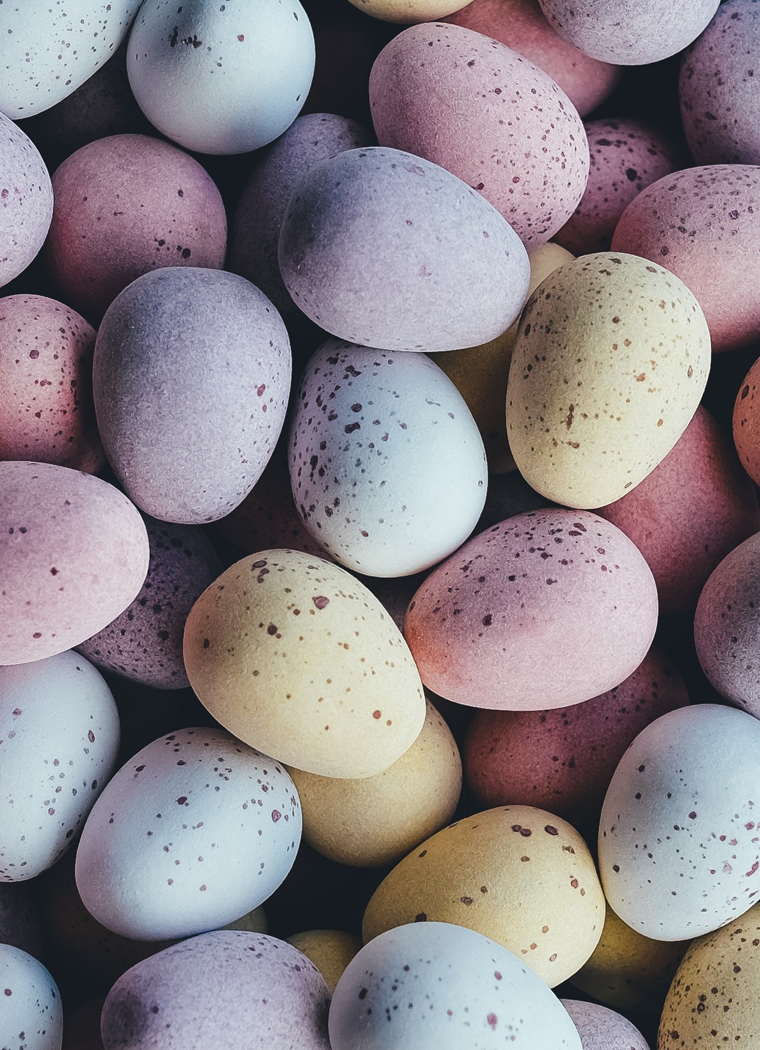Most cells are tiny – much too small to see without the help of a microscope. In contrast, an unfertilized chicken egg contains a large cell surrounded by egg white, a shell membrane, and an egg shell. You will investigate how egg size changes when the eggshell is removed and the egg is placed in different types of liquid.

### MATERIALS

#### Decalcified Eggs

Various Salt/Sugar/Other Solutions 4 Plastic Cups/Beakers

Distilled water Graduated Cylinder Timer

Scale Weighing Boat Paper Towels

**HYPOTHESIS FOR EXPERIMENT:**

*Formulate a hypothesis. You will have access to a number of solutions in the lab. You will need to decide which solutions you will be testing and why. Remember, you will also need a control (egg in distilled water). Make a prediction, pose a problem, or write an explanation (if.. then*…*because) statement.*

# Identify the Variables:

* + Independent Variable:
* Dependent Variable:

# Procedure:

1. Your group will be given four, decalcified eggs. To begin, carefully blot dry the outside of each egg. Then weigh each egg. Record the weight of each egg in the Part 1 Data Table. Remember to use a weighing boat and to zero the balance and weighing boat before weighing each egg. The egg without its shell is fragile, so you will need to handle your eggs very gently and carefully. (Are you keeping track of which egg will be placed in which solution?) *Caution: Because these are raw eggs, they may carry salmonella, so you should use gloves when handling the eggs.*
2. Fill each cup with 200 mL (or enough to cover the egg) of the solutions you are testing.
3. Test each cup with a Glucose test strip and record the results in the data table below.
4. Place each egg in one of the cups filled with the various solutions according to your experiment. Don’t forget to label the beakers to indicate the solution type.
5. Let stand for 15 minutes.
6. Remove the eggs from the solutions and carefully blot and re-weigh them. Place the new weight in Data Table 1. Keep track of which egg came from which cup! You’ll want to return the eggs to their original solution.
7. Place eggs back into their original cup/beaker.
8. Repeat #10 - #12 at 30 minutes, 45 minutes, and 60 minutes.
9. Record the final masses in Data Table 1 and calculate % change in mass.
10. Re-test each up with a Glucose test strip and record the results in the data table below.

### PART 1 DATA TABLE

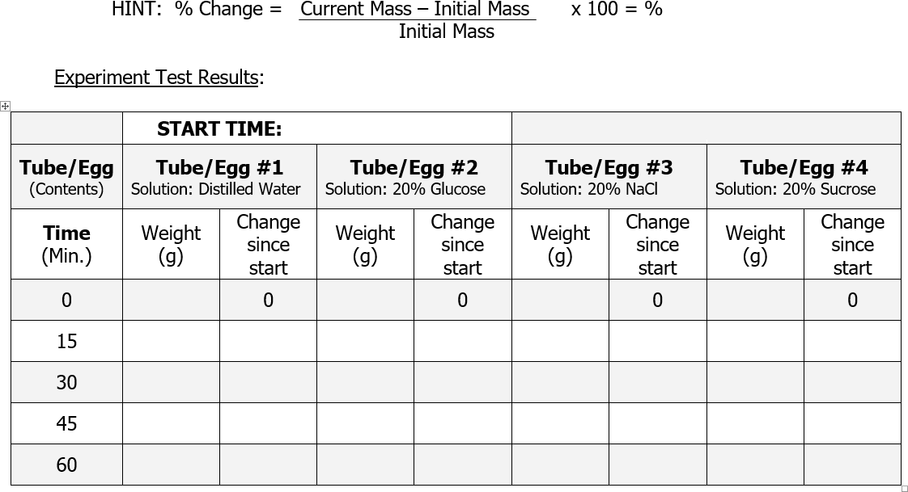

#### Why is tube/egg #1 included in this experiment?

1. Which tube/egg gained the most weight?
2. Based on your observations, which substance moved, the water or the sugar? How did you determine this?
3. Did your results match your hypothesis?
4. Graph your Results Below: Make a graph with the y axis the weight of the tubes/eggs and x axis the time in minutes.



P A R T T W O : D I F F U S I O N

In this experiment, we will observe the diffusion of different dye molecules through agar gel. Methylene blue has a molecular weight of ~320 g/mole, potassium permanganate has a molecular weight of 158 g/mole, and Janus green has a weight of 511 g/mole. The agar gel is a Jello-like substance, composed of ~98% water. Because of its high water content, the dye molecules will move freely through the gel.

### MATERIALS

#### Agar Plate Straw Methylene Blue

Potassium Permanganate Janus Green

Ruler Thermometer Timer/Stopwatch Dropper/Pipette

**HYPOTHESIS FOR EXPERIMENT:**

*Formulate a hypothesis. Make a prediction, pose a problem, or write an explanation (if.. then*…*because) statement.*

# Identify the Variables:

* + Independent Variable:
* Dependent Variable:

# Procedure:

1. Obtain a petri dish containing agar. These have been premade for you for this lab.
2. Using the straw provided, punch three, evenly spaced holes into the agar plate. These holes should be at least 6 cm apart and equally spaced from the edges.
3. Place 2-3 drops of methylene blue in one of the holes, being careful not to spill the dye or let it overflow onto the surface of the agar.
4. Place 2-3 drops of potassium permanganate in a different hole.
5. Place 2-3 drops of Janus green in the third hole.
6. Incubate the agar plate on your lab bench for an hour total, measuring every fifteen minutes. You will want to set a timer for this step.
7. Record the actual room temperature in the data section.
8. After every 15 minutes (15, 30, 45, 60 minutes), measure the distance (in mm) each dye has traveled in the agar. You will measure from the outside of the hole to the end of the dye front (to the right). Record your measurements in a table in the data section.
9. Calculate the diffusion rates of the three dyes. This can be done by taking the mm the dye has spread and dividing it by the number of minutes the dye has been diffusing.

### PART 2 DATA TABLE

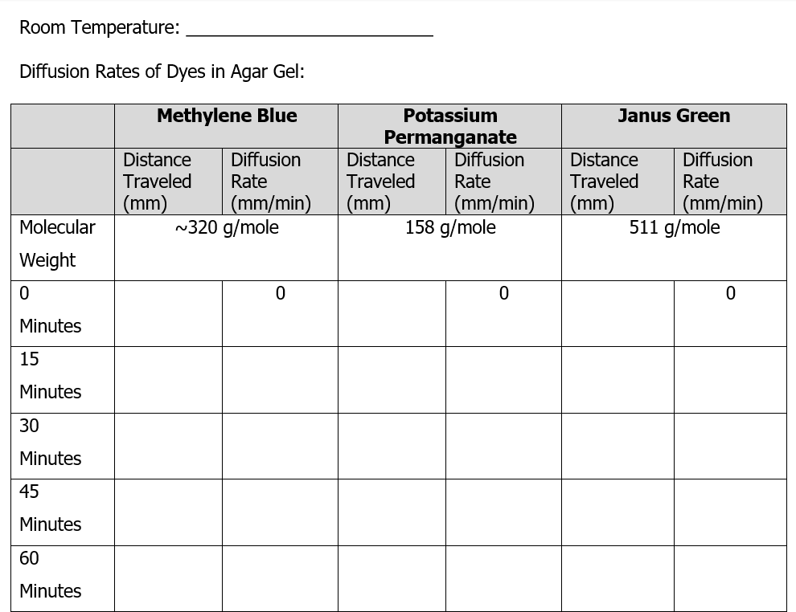

#### What effect does molecular weight have on the diffusion rate through agar?

1. Was your prediction supported?
2. Would the dyes diffuse more rapidly through water or the agar gel? Why?
3. Graph your Results Below: Make a graph with the y axis the distance the dye has traveled and x axis the time in minutes.



**POST-LAB QUESTIONS:**

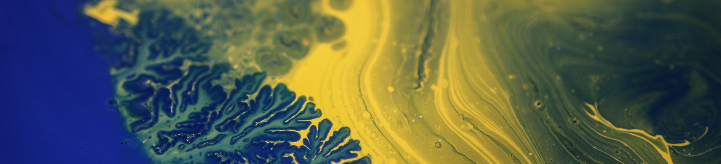The osmosis experiment demonstrated that when a selectively permeable membrane separates two solutions, more water molecules cross: **(circle one)**

**to** the solution with a **(higher) (lower)**

concentration of solutes and a **(higher) (lower)** concentration of water

**from** the solution with a **(higher) (lower)**

concentration of solutes and a **(higher) (lower)** concentration of water

Thus, there is a net movement of water across a selectively permeable membrane from a less concentrated solution to a more concentrated solution. This process is called osmosis.

The cell membrane is a selectively permeable membrane that separates the cytosol inside the cell from the surrounding solution. Osmosis affects cells differently, depending on whether the surrounding solution is:

* hypertonic = has a higher concentration of solutes than the cytosol
* hypotonic = has a lower concentration of solutes than the cytosol
* isotonic = has the same concentration of solutes as the cytosol

The following figures show the effects of osmosis on animal and plant cells that were put in three different types of surrounding fluid. Label them as either **hypertonic, hypotonic**, or **isotonic.**

1. Label the following as either hypertonic, hypotonic, or isotonic.

**Animal Cells**

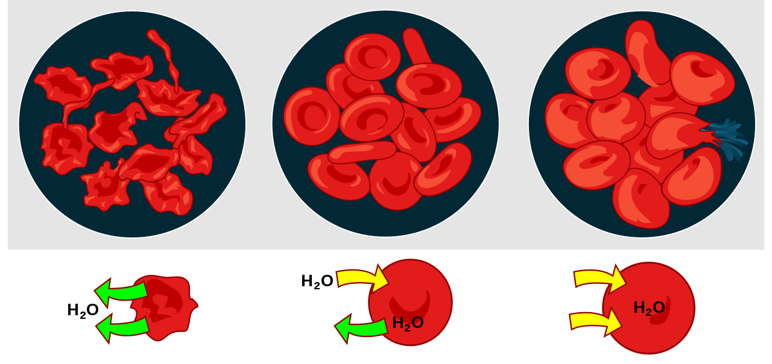

**Plant Cells**

Photo: Openstax Biology

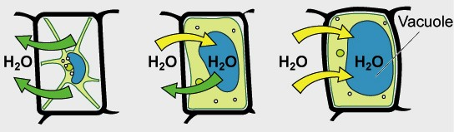

Photo: Openstax Biology

1. In an animal, each cell is surrounded by a layer of water with dissolved substances. For animal cells to function normally, there should be equal amounts of water moving into and out of the cell, as shown in the middle plant cell. Which type of surrounding fluid would result in equal amounts of water moving into and out of a cell?

hypertonic ___ hypotonic ___ isotonic ___

If a person drinks a very large amount of water in a short time without consuming any salt, this can result in abnormal functioning of nerve cells in the brain which can cause confusion, seizures, coma, or even death.

3a. When a person drinks too much water too quickly, the fluid surrounding a person’s cells changes from:

1. hypertonic to hypotonic
2. isotonic to hypertonic
3. isotonic to hypotonic 3b. Explain your reasoning.

3c. How could this change in the fluid surrounding brain cells cause confusion, seizures and coma?

4. You are stranded in a lifeboat in the middle of the ocean. You are very thirsty, but the only thing available to drink is ocean water. The concentration of salt in ocean water is about four times as high as the concentration of salt in your blood and other body fluids. Should you drink some ocean water? What effect would drinking ocean water have on your cells?

5a. If you took single cell organisms that normally live in ocean water and you moved them to the much more salty water of the Great Salt Lake or the Dead Sea, what do you think would happen to these single cell organisms? Explain why.

5b. Archaea are single-cell organisms. Some archaea live in extremely salty water such as the Great Salt Lake or the Dead Sea. How do you think the archaea cells prevent water loss while living in very salty water?

1. Foods can spoil when bacteria and molds grow in them. For thousands of years, people have preserved foods by adding salt. Explain how salting foods prevents them from spoiling.

In the Hebrew Bible, there are thirty-five verses which mention salt. ~King James Version

1. Diabetics have high levels of sugar in their blood. How does this experiment relate to what might happen in a diabetic’s body?
2. Why are dehydrated patients given saline intravenously instead of water?

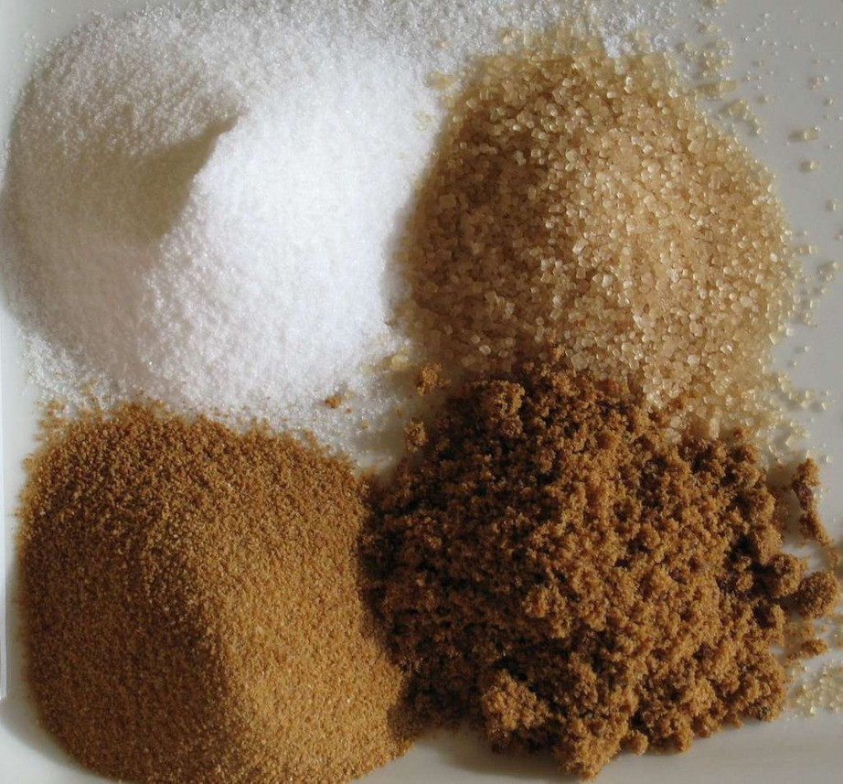

Sugars (clockwise from top-left): white refined, unrefined, unprocessed

cane, brown

Romain Behar [Public domain]

### CREDITS AND ATTRIBUTIONS

["Diffusion and Osmosis" by Dr. Ephanie DeBey is licensed under CC BY- NC 4.0](https://creativecommons.org/licenses/by-sa/4.0/)

[Portions of this lab are adapted from "Diffusion and Osmosis" by Drs. Ingrid Waldron, Jennifer Doherty, Scott Poethig, and Lori](https://creativecommons.org/licenses/by-sa/4.0/)

[Spindler, University of Pennsylvania is licensed under CC BY-NC 4.0 / A derivative from the original work.](https://creativecommons.org/licenses/by-sa/4.0/)



Unsplash Photos:

Photo by Joel Filipe on Unsplash Photo by Annie Spratt on Unsplash

Photo by Adrien Converse on Unsplash

Photo: Osmosis from CNX OpenStax is licensed under the Creative Commons Attribution 4.0 International license.

