## EVALUATING SOURCES

**Part I**



Alone or with your lab group, make a chart consisting of three columns on a separate sheet of paper. Label the columns as Fact, Opinion, Fiction. Next, visit one of the images in the lab links image gallery from NASA or NOAA). Your instructor may visit one of the images for the class to observe as a group. Observe it carefully. Then generate a list of at least three facts and three opinions about the image. For the fun of it, create a few “fictions” to complete the chart.

**We know that:**

A fact is considered something proven to be true.

An opinion is a personal belief that is not founded on proof or certainty.

With your lab group or as a class, examine one of each of the examples in the "Expectations for Science Source Materials" on the course guide. Circle or highlight and label what is fact, fiction, and opinion in each source. If you are working in groups, compare your answers with another group. Discuss your findings and record your observations.

# Part II

Select one set of sources to evaluate. Your instructor may print these for you or you may access one of the sets of sources on the course guide. Make sure you have reviewed the “Getting Started” portion of the guide and that you have reviewed and are familiar with Primary, Secondary, and Opinion/Advertisement sources. Make a table on a separate sheet of paper, and include the following information: the title and source number of each source, type of source (primary, secondary, or opinion/advertisement), the intended audience and purpose of the source, and a brief summary of each source.

Consult with your lab group. Did you get the same results? Discuss your findings and make any corrections to your table.

# Part III

Use the internet or your library’s databases to find an example of each type of source (primary, secondary, and opinion/advertisement).

Make a table on a separate sheet of paper, and include the following information for each source: where the source was located, the type of source (primary, secondary, or opinion/advertisement), the intended audience and purpose of the source, and a brief summary of the source.

## CREDITS AND ATTRIBUTIONS

### [Part One of this lab is adapted from "Fact Opinion or Just Fiction?" by Deanna Mayers, Bonnie Waltz, Tracy Rains is licensed under CC BY-NC 4.0/ A derivative from the original work](https://creativecommons.org/licenses/by-sa/4.0/)

[Part Two and Part Three of this Lab, "Evaluating Sources" by Dr. Ephanie DeBey and Jennifer Hulsey Campbell is licensed under CC BY-NC-SA 4.0](https://creativecommons.org/licenses/by-sa/4.0/)

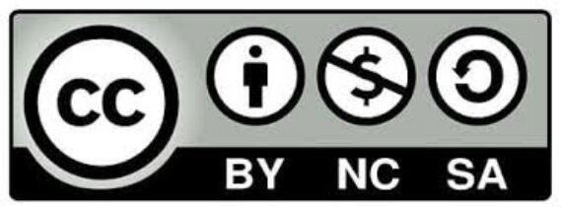

Photo Credits:

Photo by William Iven on Unsplash Photo by John Schnobrich on Unsplash